Standard Deviants Accelerate: States of Matter
Video Guide
As you view the video, fill in the guide.
- What is matter?
- Anything that has _______________ and takes up _________________

- Example of “non-matter” = ________________

- Matter can be divided into three categories ____________, ______________, _____________

- Solids, liquids, and gases are called the __________________ or ___________________
Solids & Liquids
- In most elements are ________________ in their natural state.

Shape | Solids | Liquids | Gases

- Phases of matter defined by:
  - ______________ between molecules
  - ______________ of each molecule

- __________ ____________ = the energy of objects in motion

Movement  (Kinetic Energy) | Solids | Liquids | Gases

Types of Solids
- _________________ = without shape (not strong)

- _________________ = arranged in a pattern

Phase Changes
- ________ have to be permanent

- The key to phases of matter is ___________

- The key to changing a substance from one phase to another is ______________

- Any substance can go from one phase to another if you can changes its _________ _______

- Condensation = __________ ____________

- Evaporation = ____________ ____________

- Sublimation = ____________ ____________

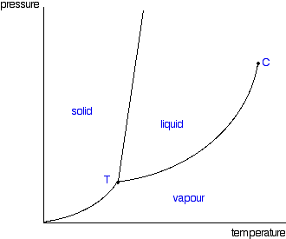
- Label the X & Y axis

- _____________ = the force exerted on the substance

- Every substance has a different __________________ __________________
Gases
- Gases are _____________; don’t gain or _____________ energy

- Gas molecules have _______________ masses because _________ made of have ______________ masses

- The way molecules move depends on _______________ , _______________ , ___________

