Figure 1
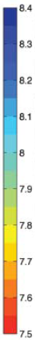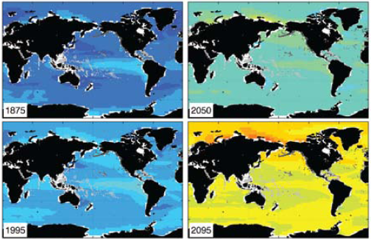
Fig 1: Ocean surface pH - historical values and projected future values based on current emission projections.

Figure 2
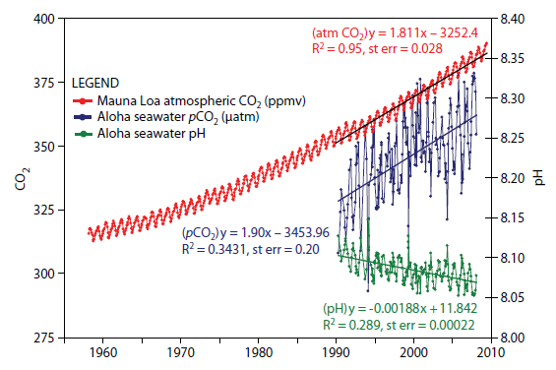
Fig 2: Annual variations in atmospheric CO₂, oceanic CO₂, and ocean surface pH. Strong trend lines for rising CO₂ and falling pH.

Figure 3
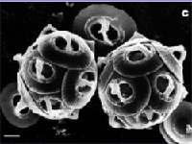
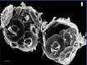
Fig 3: Healthy phytoplankton; same species with malformed shell plates as a result of damage by seawater with simulated end of century chemistry.
Source: Nature, Reduced Calcification of Marine Phytoplankton in Response to Increased Atmospheric CO2, Issue 407 p.364 -367

Figure 4
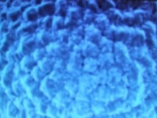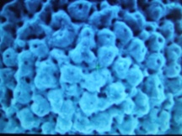
Fig 4. Pre-industrial and current samples of Globigerina bulloides from same location. Latter shows extensive erosion with a ten-fold increase in holes.
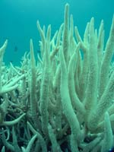
Source: Australian Broadcasting Corporation, Ocean Acidification – The Big Global Warming Story, 13 September 2007

Figure 5

Fig 5. Coral killed by above average ocean temperatures.

