**Earthquakes**

STATION A

An **earthquake** is sudden ground movement. This movement is caused by the sudden release of the energy stored in rocks. An earthquake happens when so much stress builds up in the rocks that the rocks break. An earthquake’s energy is transmitted by seismic waves. Each year, there are more than 150,000 earthquakes strong enough to be felt by people. An amazing 900,000 are recorded by seismometers.

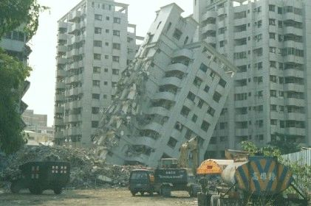

**Causes of Earthquakes**

Almost all earthquakes occur at plate boundaries. All types of plate boundaries have earthquakes. Convection within the Earth causes the plates to move. As the plates move, stresses build. When the stresses build too much, the rocks break. The break releases the energy that was stored in the rocks. The sudden release of energy creates an earthquake. During an earthquake the rocks usually move several centimeters or rarely as much as a few meters.

**Earthquake Focus and Epicenter**

STATION D

Where an earthquake takes place is described by its focus and epicenter.  
  
**Focus**

The point where the rock ruptures is the earthquake’s **focus**. The focus is below the Earth’s surface. A shallow earthquake has a focus less than 70 kilometers (45 miles). An intermediate-focus earthquake has a focus between 70 and 300 kilometers (45 to 200 miles). A deep-focus earthquake is greater than 300 kilometers (200 miles). About 75% of earthquakes have a focus in the top 10 to 15 kilometers (6 to 9 miles) of the crust. Shallow earthquakes cause the most damage. This is because the focus is near the Earth's surface, where people live.

**Epicenter**

The area just above the focus, on the land surface, is the earthquake’s **epicenter**. The towns or cities near the epicenter will be strongly affected by the earthquake.

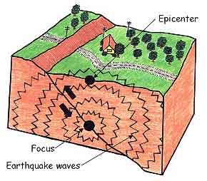

**Earthquake Zones**

STATION G

Nearly 95% of all earthquakes take place along one of the three types of plate boundaries. As you learned in the *Plate Tectonics* chapter, scientists use the location of earthquakes to draw plate boundaries.

The region around the Pacific Ocean is called the Pacific Ring of Fire. This is due to the volcanoes that line the region. The area also has the most earthquakes. About 80% of all earthquakes strike this area. The Pacific Ring of Fire is caused by the convergent and transform plate boundaries that line the Pacific Ocean basin.

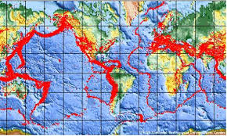

**Seismic Waves**

STATION I

Seismic waves are the energy from earthquakes. Seismic waves move outward in all directions away from their source. Each type of seismic wave travels at different speeds in different materials. All seismic waves travel through rock, but not all travel through liquid or gas. Geologists study seismic waves to learn about earthquakes and the Earth’s interior.

**Types of Seismic Waves**

There are two major types of seismic waves. **Body waves** travel through the Earth’s interior. **Surface waves** travel along the ground surface. In an earthquake, body waves are responsible for sharp jolts. Surface waves are responsible for rolling motions that do most of the damage in an earthquake.

**Body Waves**

**Primary waves (P-waves)** and **secondary waves (S-waves)** are the two types of body waves. Body waves move at different speeds through different materials.

P-waves are faster. They travel at about 6 to 7 kilometers (about 4 miles) per second. Primary waves are so named because they are the first waves to reach a seismometer. P-waves squeeze and release rocks as they travel. The material returns to its original size and shape after the P-wave goes by. For this reason, P-waves are not the most damaging earthquake waves. P-waves travel through solids, liquids and gases.

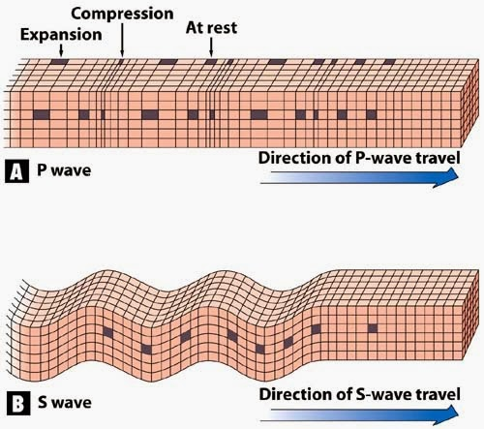S-waves are slower than P-waves. They are the second waves to reach a seismometer. S-waves move up and down. They change the rock’s shape as they travel. S-waves are about half as fast as P-waves, at about 3.5 km (2 miles) per second. S-waves can only move through solids. This is because liquids and gases don’t resist changing shape.

**Surface Waves**

STATION J

**Surface waves** travel along the ground outward from an earthquake’s epicenter. Surface waves are the slowest of all seismic waves. They travel at 2.5 km (1.5 miles) per second. Surface waves cause objects to fall and rise, while they are also swaying back and forth. These motions cause damage to rigid structures during an earthquake.

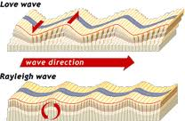

**The Power of Earthquakes**

STATION C

Earthquakes are a powerful force of nature. They occur every day somewhere in the world but aren’t always noticed by people. Mild earthquakes or ones that occur in remote areas are unlikely to cause much damage. Many people live in areas frequently hit by earthquakes. Powerful ones have the potential to cause billions of dollars in damage and kill thousands of people. Scientists study earthquakes not only to better understand how and why they occur, but also to devise ways to protect people and buildings.



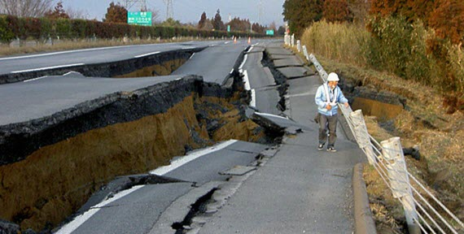

**Can Earthquake be Prevented?**

STATION E

**Past Experiments Preventing Earthquakes**

Scientists have tried various strategies for preventing earthquakes. One technique involves pumping water into the faults. This technique is based on the idea that the water will lubricate the rock materials and make it easier for the plates to slide past one another. Thus far, this technique has not been proven effective.

Other researchers have found evidence that nuclear explosions send waves of energy traveling through Earth’s crust and might cause earthquakes. Some researchers have considered using these explosions to induce small earthquakes and relieve pressure between tectonic plates.

The strategy has been dismissed, however, because the occurrence of an earthquake after such an explosion is not always predictable. While the explosion of nuclear weapons at some test sites has been linked with earthquakes, this result is not consistent. In fact, the largest explosion resulting from nuclear weapons testing did not create an earthquake.



