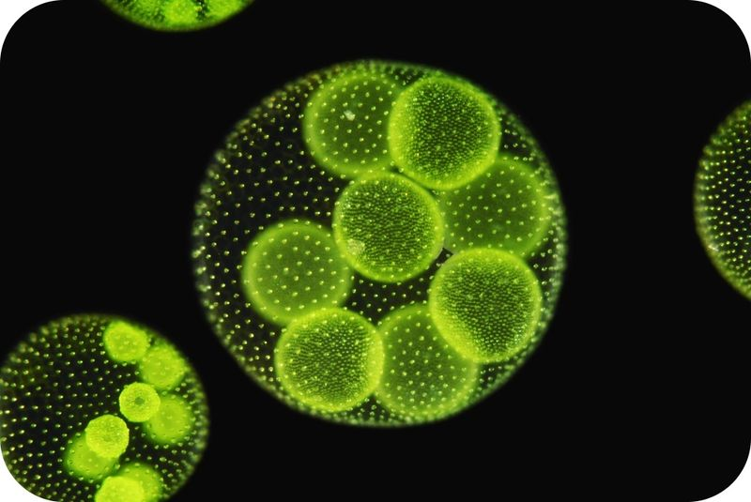
Are plants the only organisms that perform photosynthesis?
Although we generally discuss plants when learning about photosynthesis, keep in mind that plants are not the only organisms that can make their own food. Some bacteria and some protists, such as the algae pictured here, also perform photosynthesis. This alga has chloroplasts and photosynthesizes just like a plant.
The Process of Photosynthesis
In the Presence of Sunlight, Carbon Dioxide + Water → Glucose + Oxygen
6CO₂ + 6H₂O → C₆H₁₂O₆ + 6O₂
Photosynthesis is a process that uses light energy to produce sugar in plants which will be used to produce energy for the plant. Photosynthesis takes place in the organelle of the plant cell known as the chloroplasts. Chloroplasts are one of the main differences between plant and animal cells. Animal cells do not have chloroplasts, so they cannot photosynthesize. Photosynthesis occurs in two stages. During the first stage, the energy from sunlight is absorbed by the chloroplast. Water is used, and oxygen is produced during this part of the process. During the second stage, carbon dioxide is used, and glucose is produced.
Chloroplasts contain stacks of thylakoids, which are flattened sacs of membrane. Energy from sunlight is absorbed by the pigment chlorophyll in the thylakoid membrane. There are two separate parts of a chloroplast: the space inside the chloroplast itself and the space inside the thylakoids (Figure below).
- The inner compartments inside the thylakoids are called the thylakoid space (or lumen). This is the site of the first part of photosynthesis.
- The interior space that surrounds the thylakoids is filled with a fluid called stroma. This is where carbon dioxide is used to produce glucose, the second part of photosynthesis.
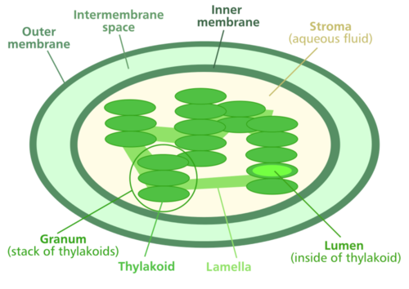
(The chloroplast is the photosynthesis factory of the plant)

The Reactants
What goes into the plant cell to start photosynthesis? The reactants of photosynthesis are carbon dioxide and water. These are the molecules necessary to begin the process. But one more item is necessary, and that is sunlight. All three components, carbon dioxide, water, and the sun's energy are necessary for photosynthesis to occur. These three components must meet in the chloroplast of the leaf cell for photosynthesis to occur. How do these three components get to the cells in the leaf?

- Chlorophyll is the green pigment in leaves that captures energy from the sun. Chlorophyll molecules are located in the thylakoid membranes.
- The veins in a plant carry water from the roots to the leaves.
- Carbon dioxide enters the leaf from the air through special openings called stomata (Figure below).

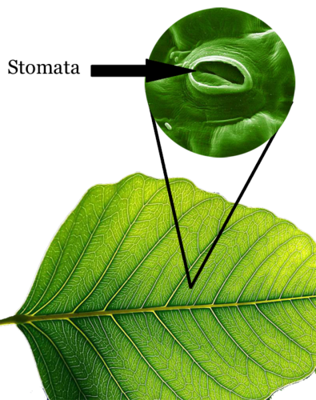
The Products
Stomata are special pores that allow gasses to enter and exit the leaf.

What is produced by the plant cell during photosynthesis? The products of photosynthesis are glucose and oxygen. This means they are produced at the end of photosynthesis. Glucose, the food of plants, can be used to store energy in the form of large carbohydrate molecules. Glucose is a simple sugar molecule which can be combined with other glucose molecules to form large carbohydrates, such as starch. Oxygen is a waste product of photosynthesis. It is released into the atmosphere through the stomata. As you know, animals need oxygen to live. Without photosynthetic organisms like plants, there would not be enough oxygen in the atmosphere for animals to survive.

The Chemical Reaction
The overall chemical reaction for photosynthesis is 6 molecules of carbon dioxide (CO₂) and 6 molecules of water (H₂O), with the addition of solar energy. This produces 1 molecule of glucose (C₆H₁₂O₆) and 6 molecules of oxygen (O₂). Using chemical symbols, the equation is represented as follows: 6CO₂ + 6H₂O → C₆H₁₂O₆+ 6O₂. Though this equation may not seem that complicated, photosynthesis is a series of chemical reactions divided into two stages, the light reactions and the Calvin cycle (Figure below).

The Light Reactions
Photosynthesis begins with the light reactions. It is during these reactions that the energy from sunlight is absorbed by the pigment chlorophyll in the thylakoid membranes of the chloroplast. The energy is then temporarily transferred to two molecules, ATP and NADPH, which are used in the second stage of photosynthesis. ATP and NADPH are generated by two electron transport chains. During the light reactions, water is used and oxygen is produced. These reactions can only occur during daylight.
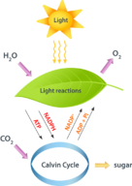
The Calvin Cycle

The second stage of photosynthesis is the production of glucose from carbon dioxide. This process occurs in a continuous cycle, named after its discover, Melvin Calvin. The Calvin cycle uses CO₂ and the energy temporarily stored in ATP and NADPH to make the sugar glucose.

Photosynthesis is a two stage process. As is depicted here, the energy from sunlight is needed to start photosynthesis. The initial stage is called the light reactions as they occur only in the presence of light. During these initial reactions, water is used and oxygen is released. The energy from sunlight is converted into a small amount of ATP and an energy carrier called NADPH. Together with carbon dioxide, these are used to make glucose (sugar) through a process called the Calvin Cycle. NADP⁺ and ADP (and Pi, inorganic phosphate) are regenerated to complete the process.

