**Core**

Made up of ______________ & _________

2 parts…

* **__________ CORE** – layer of ______________ that ______________ the inner core
* **___________ CORE** – dense ball of __________
  + ______________ squeezes the atoms of ___________________ so much to where they __________________, so they ______________
* Scientists think the___________ _______________outer core create ___________________

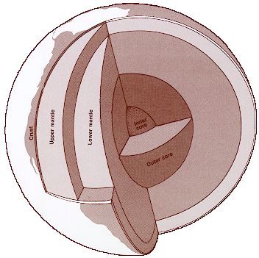

**Mantle**

* Over _____________
* Divided into ______________
  1. ____________
     1. **______________** – _______ and uppermost part of the ______; about 100 km thick
     2. **______________** – __________ just below the lithosphere
        1. _______and under more pressure
        2. _________ like plastic (but still solid)
  2. __________________

**Crust**

* Includes_________________________________________________
* Also ________________________ ____________________________
* Thin layer
* ____________under mountains; thinnest beneath ocean
* Between ________________
* Crust beneath oceans = _________________
  + Made up of _________ – dark rock/fine texture
* Crust that forms continents = ________________________
  + Made mainly of ______________ – light color/coarse texture

**Lower Mantle**

**Crust**

**Upper Mantle**