Name:__________________________ Pd: _____ Date:_________________

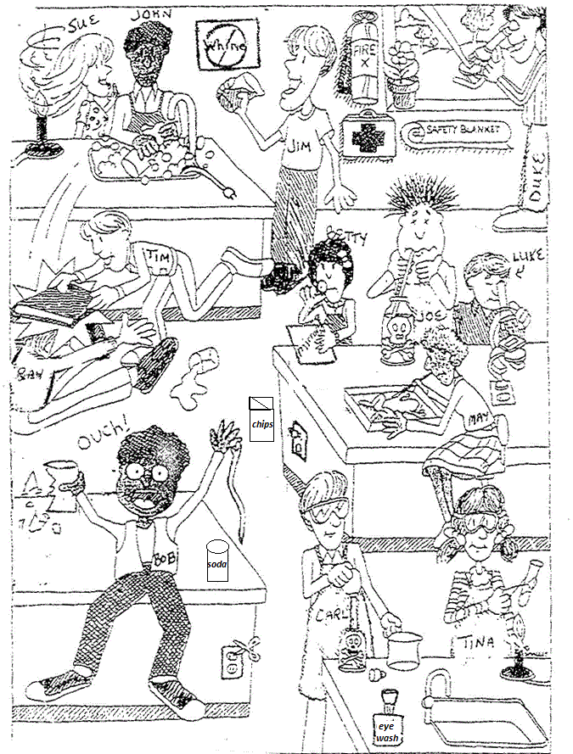
Lab Safety

Questions:
- List 3 unsafe activities shown in the illustration and explain why each is unsafe.

- List 3 correct lab procedures depicted in the illustration.

- What should Bob do after the accident?

- What should Sue have done to avoid an accident?

- Compare Luke and Duke's lab techniques. Who is following the rules?

- What are three things shown in the lab that should not be there?

- Compare Joe and Carl's lab techniques. Who is doing it the correct way?

- What will happen to Ray and Tim when the teacher catches them?

- List three items in the illustration that are there for the safety of the students in the lab.

- What is Betty doing wrong?

