Sound is - _____________ waves that travel through a ____________ & can be __________ when they reach a person’s or animal’s ________
  - Also called __________ _________
Remember:
  - ___________measures ___________ (volume/loudness of sound)
  - ___________ measures ___________ (pitch of sound)
Function:
- The ears gather __________ __________ and send information about sound to your ________.
- The three main sections, all with different functions, are:
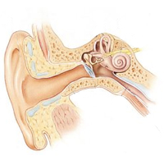
1.) __________ ______
2.) __________ ______
3.) __________ ______

Outer Ear:
- The part of the ear you _________.
- It acts like a ____________, collecting sound waves, and directing them into the narrow region called _____ _______.
- Only a few cm long and ends at the ______________ .
Eardrum – small, tightly stretched, ________ like membrane
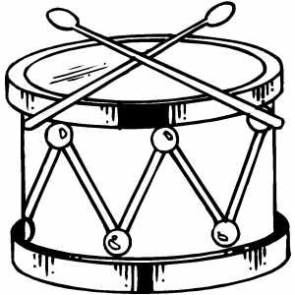
- Sound waves make the eardrum ______________ .

Middle Ear:
- Located behind the eardrum.
- HAS 3 smallest __________________ in the body
- _________________, ______________, _________________
- The hammer is attached to the eardrum.
- When __________________ vibrates, _________________ does too
- Transmits vibrations first to ______________ then __________________ .
Inner Ear:
- There is a membrane that __________________ the middle ear from the inner ear.
- When the stirrup vibrates against the membrane, vibrations pass into the ____________
- __________ is a fluid filled cavity shaped like a ________ shell.
- Contains more than 10,000 tiny ________ cells.
- Hair-like projections float in a ________ in the cochlea.
- When vibrations move through the fluid, hair cells _______, causing messages to be sent to the brain through the ________________ nerve.
- The brain processes messages and tells you what you heard.
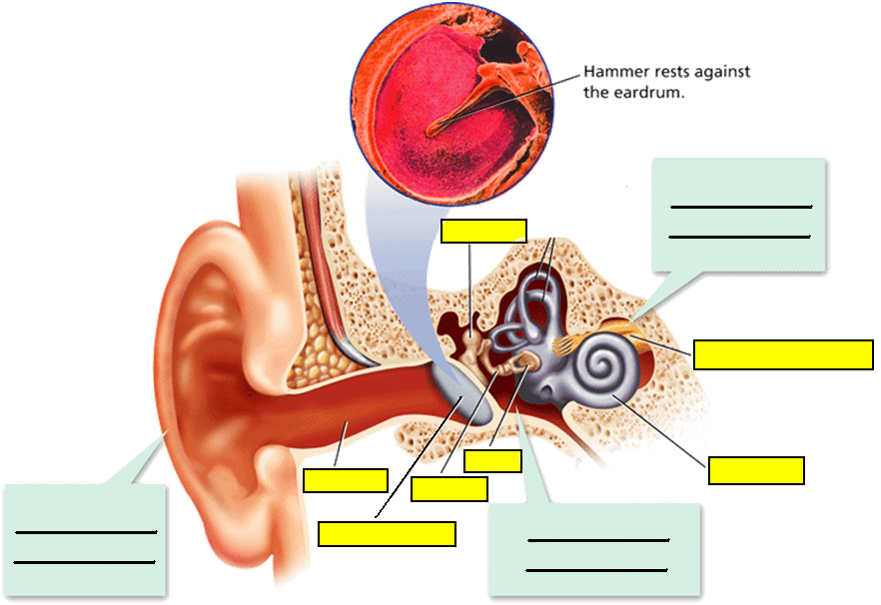

Hearing Loss:
- If hearing is damaged it may cause a difficult time hearing ________ sounds or _______-pitched sounds.
- Can be caused by
- ____________
- ________________
- Exposure to ________ ____________
- __________

Causes of Hearing Loss:
- Can occur if the eardrum is ______________ or ________________ .
- ____________________ can damage the inner ear.
- Excessive ________ music can ____________ hair cells so __________ can no longer be sent to the brain.
- With age, some hair cells ______ in the cochlea and are never ________________ .

