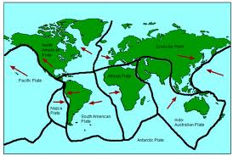Name:___________________________ Pd:_____ Date:_________________

**Graham Cracker Model of Plate Tectonics  
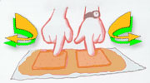Data Collection Sheet**

**Part I : Divergent Plate Boundaries-Oceanic vs. Oceanic**

Observations of the crackers and the icing (picture & written explanation)

**Questions:**

1. What happened to the frosting between the crackers?
2. What do the graham crackers represent?
3. What does the frosting represent?
4. Provide an example of a location where this type of boundary is found on Earth.
5. What type of feature is produced by this type of plate movement?
6. Explain how the formation would be different if the movement was occurring along a continental plate.

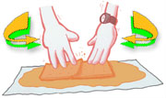

**Part II : Convergent Plate Boundaries-Oceanic vs. Continental**

The graham cracker represents the ___________, _____________ dense _______________ ___________. The index card represents the __________, __________ dense ____________ ___________.

Observations of the crackers and the icing (picture & written explanation)

**Questions:**

1. Explain why the graham cracker and index card represent the type of crust they do.
2. What happens when the graham cracker and index card meet?
3. What happens when a piece of Earth’s crust is subducted?
4. Provide an example of a location where this type of boundary is found on Earth.
5. What features are formed along the subduction zone?

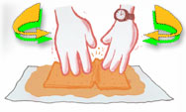

**Part III: Converging Plate Boundaries-Continental vs. Continental**

Observations of the crackers and the icing (picture & written explanation)

**Questions:**

1. Explain what happens to the wet ends of the graham crackers.
2. In what way do the wet graham crackers act more like real crustal plates than dry crackers?
3. What feature do the ends of the wet graham crackers represent?
4. 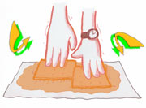Provide an example of a location where this type of boundary is found on Earth.

**Part IV : Transform (Lateral) Plate Boundaries**

Observations of the crackers and the icing (picture & written explanation)

**Questions:**

1. Provide an example of a location where this type of boundary is found on Earth.
2. Nothing happens to the crackers in the beginning, but as the pressure is increased, the crackers finally break. Explain how this is similar to the situation along the San Andreas Fault.