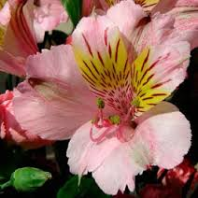
Flower Dissection

Objectives:
To learn the parts of the flower.
To compare male and female flower anatomy

Procedure:
1. You and your partner will be given one Alstroemeria flower. This flower resembles a miniature lily.
2. In Figure 1, draw your flower. Write down the flower color. Label the sepals and petals. Note: You may not be able to see the sepals, they may have fallen off. Your figure should cover half of the page.
3. Take your flower to your teacher who will use a scalpel or blade to carefully make a vertical incision to open up the flower.
4. Take your flower back to your desk.
5. Gently pull apart the flower.
6. In Figure 2, draw your flower spread open. Be sure to label: Sepals (if present), Anther, Stamen, Filament, Pistil, Stigma, Style, Ovary, baby seeds. This figure should cover half of your page.

Data:
Figure 1(Below): Drawing of Alstroemeria Flower (half page)

Color: __________________

Figure 2(below): Alstroemeria Flower Pinned Open (half page)

Analysis:
Name the female parts of your flower.

Name the male parts of your flower.

Conclusion:
Write 3-5 sentences on what you learned.

Elaboration:
Pollen doesn’t have legs. How does pollen mover from anthers to stigma?

