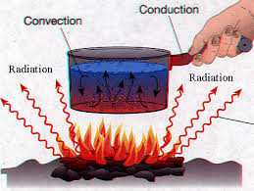
Everyday Energy Transfer
Energy transfer is all around us, happening at all times, and, I bet, we don’t take the time to think about this cool science! Think about some of the examples we shared in class (sand on our toes, walking at the pool, etc…). Now I want you to put on your “Van Gogh” hats and get creative. Create a drawing/scene that happens day-to-day that shows ALL three types of energy transfer. Remember…
CONDUCTION – energy transfer through matter (direct contact; touching)
CONVECTION – energy transfer through the movement of mass in fluids (currents)
RADIATION – energy transfer through the emptiness of space by electromagnetic waves
Use the rubric below to ensure successful completion of your art masterpiece.
***YOU MAY NOT USE THE EXAMPLES SHOWN OR DISCUSSED FROM THIS SHEET***
CRITERIA | Points Possible | Points Earned
Content  - Scene clearly represents ALL three types of energy transfer (conduction, convection, radiation)  - Scene shows an “everyday” scenario | 40
Drawing  - Color is used for the entire masterpiece  - Covers the entire 8.5x11 sheet of paper  - Three types of energy transferred clearly labeled | 30
Paragraph (5-7 sentences minimum) (place on back of drawing)  - Detailed description of what is occurring in your drawing  - Explanation of how the three types of energy transfer are occurring  - Complete sentences and free of grammatical errors | 15
Neatness  - Clearly shows effort (something we could sell at Ligon’s Art’s Festival)  - Paragraph easy to read | 10
Rubric  - Attached to the final product | 5
TOTAL | 100

