**Density Notes**

All forms of _____________ have ______________ and _____________ properties.

Physical properties include:

* + _____________________
  + _____________________
  + _____________________
  + _____________________

**Density**: A measure of how much __________ is contained in a given ____________.

**Formula**…..

**Simplified Formula**

**We LOVE density**

Why is density important?

* Density is a _____________ that can be used to _____________ a substance.
* Density tells whether an __________________________________
  + An object _____________ if it is _________ dense than the liquid _______________.

Density is made up of two measurements

* _______________ & ______________
* Density is expressed as a _________________________:
* grams per cubic centimeter __________ and grams per milliliter __________
* Remember ______________________

**Water**

* Water’s density is _____________________

**Practice Problems**

1. What is the density of a wood block with a volume of 100 cm3 and a mass of 25 g?
2. What is the density of a liquid with a mass of 45 g and a volume of 48 mL?
3. A cube has a mass of 2.8g and occupies a volume of 3.67mL. Would this object float or sink in water? Why?
4. A liquid has a mass of 25.6 g and a volume of 31.6 mL. Calculate its density.

What is the identity of the liquid? ______________________

*Use the information below for reference.

|  |  |
| --- | --- |
| **Substance** | **Density (g/mL)** |
| Mercury | 13.6 |
| Water | 1.0 |
| Ethanol | 0.81 |



5.

6.

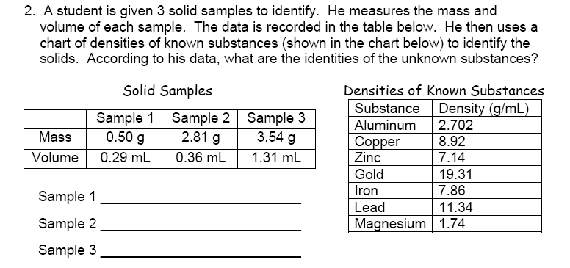

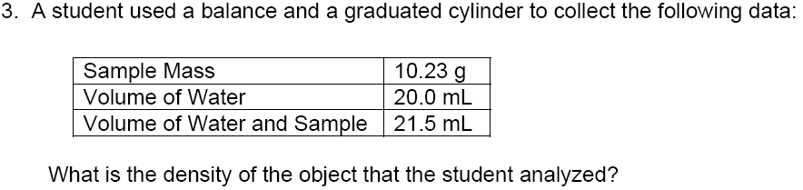

7.