Change of State Equations
(Directions)
- Cut out all 18 pieces
  - Leave the words (i.e. melting) attached to the pictures.
- On the blank sheet of computer paper arrange the “States of Matter” squares (solid, liquid, gas) to create a phase change
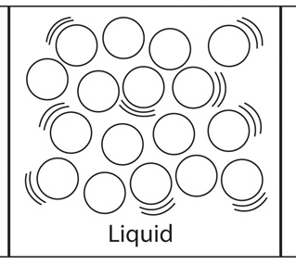
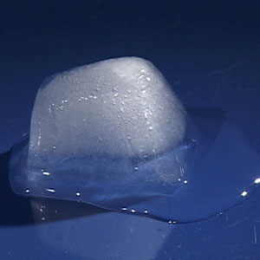
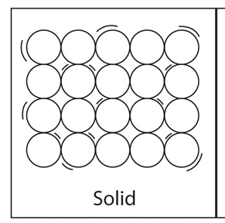
  - EXAMPLE -
=
Melting

- Now think about the energy transfer taking place. Is energy being added or subtracted? Include this information in your phase change equation.
  - EXAMPLE – (the word “energy” or “heat” can be used)
=
+ Energy
(+ Heat)
Melting

- Glue each piece to the computer paper.

