6E13 Summarize Space Exploration and the understandings gained from them.

About NASA (National Aeronautics Space Administration, a government agency responsible for the civilian space program as well as aeronautics and aerospace research.
- What Does NASA Do?
NASA's vision: To reach for new heights and reveal the unknown so that what we do and learn will benefit all humankind.
To do that, thousands of people have been working around the world -- and off of it -- for more than 50 years, trying to answer some basic questions. What's out there in space? How do we get there? What will we find? What can we learn there, or learn just by trying to get there, that will make life better here on Earth?
A Little History
President Dwight D. Eisenhower established the National Aeronautics and Space Administration in 1958, partially in response to the Soviet Union's launch of the first artificial satellite the previous year (Sputnik). NASA grew out of the National Advisory Committee on Aeronautics (NACA), which had been researching flight technology for more than 40 years.
President John F. Kennedy focused NASA and the nation on sending astronauts to the moon by the end of the 1960s. Through the Mercury and Gemini projects, NASA developed the technology and skills it needed for the journey. On July 20, 1969, Neil Armstrong and Buzz Aldrin became the first of 12 men to walk on the moon, meeting Kennedy's challenge.
Meanwhile, NASA was continuing the aeronautics research pioneered by NACA. It also conducted purely scientific research and worked on developing applications for space technology, combining both pursuits in developing the first weather and communications satellites.
- After Apollo, NASA focused on creating a reusable ship to provide regular access to space: the space shuttle. First launched in 1981, the space shuttle flew more than 130 successful missions before being retired in 2011. In 2000, the United States and Russia established permanent human presence in space aboard the International Space Station (ISS), a multinational project representing the work of 15 nations.

The International Space Station (ISS) Construction of the International Space Station began on 20 November 1998 when the American-funded, Russian-built Zarya module was launched into orbit around Earth. The ISS orbits 220 miles above the earth and was manned by a crew in October 2000. The ISS may continue to be in service until 2024.
NASA also has continued its scientific research. In 1997, Mars Pathfinder became the first in a fleet of spacecraft that will explore Mars in the next decade, as we try to determine whether life ever existed there. The Terra, Aqua and Aura Earth Observing System satellites are flagships of a different fleet, this one in Earth orbit, designed to help us understand how our home world is changing. NASA's aeronautics teams are focused on improving aviation, so it meets the explosive growth in global demand for air services.
Throughout its history, NASA has conducted or funded research that has led to numerous improvements to life here on Earth.
Organization
NASA Headquarters, in Washington, provides overall guidance and direction to the agency, under the leadership of the administrator. Ten field centers and a variety of installations conduct the day-to-day work, in laboratories, on air fields, in wind tunnels and in control rooms.
NASA conducts its work in four principal organizations, called mission directorates:
- Aeronautics: manages research focused on meeting global demand for air mobility in ways that are more environmentally friendly and sustainable, while also embracing revolutionary technology from outside aviation.
- Human Exploration and Operations: focuses on International Space Station operations, development of commercial spaceflight capabilities and human exploration beyond low-Earth orbit.
- Science: explores the Earth, solar system and universe beyond; charts the best route of discovery; and reaps the benefits of Earth and space exploration for society.
- Space Technology: rapidly develops, innovates, demonstrates, and infuses revolutionary, high-payoff technologies that enable NASA's future missions while providing economic benefit to the nation.
Our Work Today
In the early 21st century, NASA is extending our senses to see the farthest reaches of the universe, while pushing the boundaries of human spaceflight farther from Earth than ever before.
Humankind is poised to take its Next Giant Leap, far beyond the frontiers of exploration we've reached to date. On Earth and in space, the agency is developing new capabilities to send future human missions to an asteroid and Mars. Mars once had conditions suitable for life. Future exploration on our Journey to Mars could uncover evidence of past life, answering one of the fundamental mysteries of the cosmos: Does life exist beyond Earth?
The Journey to Mars begins aboard the International Space Station, where astronauts are extending permanent human presence in space and performing research that will help us understand how humans can live and work off Earth for long periods. U.S. commercial companies are supplying cargo to the space station, and will soon launch astronauts once again from U.S. soil., helping foster development of private-sector aerospace. Part of the U.S. portion of the space station has been designated as a national laboratory, and NASA is committed to using this unique resource for wide-ranging scientific research.
To send astronauts deeper into the solar system, NASA is developing the most advanced rocket and spacecraft ever designed.NASA's Orion spacecraft will carry four astronauts to missions beyond the moon, launched from Florida aboard the Space Launch System (SLS) -- an advanced heavy-lift rocket that will provide an entirely new national capability for human exploration beyond Earth's orbit.
To help test other spaceflight capabilities to meet the goal of sending humans to Mars, including advanced propulsion and spacesuits, NASA is developing the Asteroid Redirect Mission first-ever mission to identify, capture and redirect a near-Earth asteroid to a stable orbit around the moon, where astronauts will explore it in the 2020s, returning with samples.
An unprecedented array of science missions is seeking new knowledge and understanding of Earth, the solar system and the universe.
We're studying Earth right now through current and future spacecraft helping answer critical challenges facing our planet: climate change, sea level rise, freshwater resources and extreme weather events.
NASA's aeronautics team is working with other government organizations, universities, and industry to fundamentally improve the air transportation experience and retain our nation's leadership in global aviation.
A fleet of robotic explorers is on and around Mars, dramatically increasing our knowledge about the Red Planet, paving the way for future human explorers.
Multiple NASA missions are studying our sun and the solar system, unraveling mysteries about their origin and evolution. By understanding variations of the sun in real-time, we can better characterize space weather, which can impact exploration and technology on Earth.
The New Horizons spacecraft nears Pluto for a July 2015 rendezvous, which will provide the closest views we've ever had of the dwarf planet. The Juno spacecraft is poised to reach Jupiter in 2016, and will peer beneath its dense gas to reveal the mysteries of its core.
NASA telescopes also are peering into the farthest reaches of the universe and back to its earliest moments of existence, helping us understand the universe's origin, evolution, and destiny. Entering its 25th year, the Hubble Space Telescope continues to explore as NASA develops its successor, the James Webb Space Telescope, which will capture light from the universe's earliest stars.
It's an exciting time at NASA as we reach for new heights to reveal the unknown and benefit humankind. See a list of NASA'scurrent missions and find out what we're launching next!
Updated November 2014

2) Why We Explore

Human Space Exploration
Humanity's interest in the heavens has been universal and enduring. Humans are driven to explore the unknown, discover new worlds, push the boundaries of our scientific and technical limits, and then push further. The intangible desire to explore and challenge the boundaries of what we know and where we have been has provided benefits to our society for centuries.
Human space exploration helps to address fundamental questions about our place in the Universe and the history of our solar system. Through addressing the challenges related to human space exploration we expand technology, create new industries, and help to foster a peaceful connection with other nations. Curiosity and exploration are vital to the human spirit and accepting the challenge of going deeper into space will invite the citizens of the world today and the generations of tomorrow to join NASA on this exciting journey.

A Flexible Path
This is the beginning of a new era in space exploration in which NASA has been challenged to develop systems and capabilities required to explore beyond low-Earth orbit, including destinations such as translunar space, near-Earth asteroids and eventually Mars.
NASA will use the International Space Station as a test-bed and stepping stone for the challenging journey ahead. By building upon what we learn there we will prepare astronauts for the challenges of long-duration flight and the permanent expansion of human exploration beyond where we have been before. Explorers may visit near-Earth asteroids where we may get answers to the questions humans have always asked. Visiting an asteroid will provide valuable mission experience and prepare us for the next steps–possibly for the first humans to step on Mars.
Robotic exploration continues to deliver profound answers about our Universe by visiting far-off destinations, providing reconnaissance and collecting scientific data. When combining both human and robotic exploration methods we will use technology and our senses to increase our ability to observe, adapt, and uncover new knowledge.
SPACE PROBE: An unmanned exploratory spacecraft designed to transmit information about its environment. These spacecraft may orbit planets, continue into the far regions of the universe or land on planets, moons, asteroids, etc…)

Why the International Space Station?
The first step in embarking on a long and challenging journey involves laying solid groundwork for a successful endeavor. The International Space Station serves as a national laboratory for human health, biological, and materials research, as a technology test-bed, and as a stepping stone for going further into the solar system. On the International Space Station we will improve and learn new ways to ensure astronauts are safe, healthy and productive while exploring, and we will continue expand our knowledge about how materials and biological systems behave outside of the influence of gravity.
NASA will continue its unprecedented work with the commercial industry and expand an entire industry as private companies develop and operate safe, reliable and affordable commercial systems to transport crew and cargo to and from the International Space Station and low Earth orbit.

Why Translunar Space?
Translunar space is vast expanse surrounding the Earth-moon system, extending far beyond the moon’s orbit and dominated by the two bodies’ gravity fields. Exploring in translunar space, beyond the protection of the Earth’s geomagnetic field, will provide unprecedented experience in deep-space operations. Operating in translunar space, NASA can research galactic cosmic radiation–potentially the most threatening element to humans exploring deep space–and develop mitigation strategies that may also lead to medical advancements on Earth.
The Lagrange points–places in cislunar space where the gravitational influences of the Earth and moon cancel each other out–are advantageous areas for exploration and research in which almost no propulsion is required to keep an object or spacecraft stationary. The Lagrange point on the far side of the Earth-Moon system, called L2, also provides a “radio silence” zone for astronomical observations.
Missions to translunar space will give NASA and its partners the opportunity to develop tools and operational techniques to support decades of future exploration, while remaining in relative proximity to Earth.

Why Asteroids?
Asteroids are believed to have formed early in our solar system's history–about 4.5 billion years ago–when a cloud of gas and dust called the solar nebula collapsed and formed our sun and the planets. By visiting these near Earth objects to study the material that came from the solar nebula, we can look for answers to some of humankind's most compelling questions, such as: how did the solar system form and where did the Earth's water and other organic materials such as carbon come from?
In addition to unlocking clues about our solar system, asteroids may provide clues about our Earth. By understanding more about asteroids we may learn more about past Earth impacts and possibly find ways to reduce the threat of future impacts.
Future robotic missions to asteroids will prepare humans for long-duration space travel and the eventual journey to Mars. Robotic missions will provide reconnaissance information about asteroid orbits, surface composition, and even return samples to Earth for further evaluation. These robotic missions are a critical step in preparing humans to visit asteroids where we will learn about the valuable resources available in space, and further develop ways to use them in our quest for more efficient and affordable exploration.

Why Mars?
Mars has always been a source of inspiration for explorers and scientists. Robotic missions have found evidence of water, but if life exists beyond Earth still remains a mystery. Robotic and scientific robotic missions have shown that Mars has characteristics and a history similar to Earth's, but we know that there are striking differences that we have yet to begin to understand. Humans can build upon this knowledge and look for signs of life and investigate Mars' geological evolution, resulting in research and methods that could be applied here on Earth.
A mission to our nearest planetary neighbor provides the best opportunity to demonstrate that humans can live for extended, even permanent, stays beyond low Earth orbit. The technology and space systems required to transport and sustain explorers will drive innovation and encourage creative ways to address challenges. As previous space endeavors have demonstrated, the resulting ingenuity and technologies will have long lasting benefits and applications.
The challenge of traveling to Mars and learning how to live there will encourage nations around the world to work together to achieve such an ambitious undertaking. The International Space station has shown that opportunities for collaboration will highlight our common interests and provide a global sense of community.

- What Are The Benefits Of Space Exploration?
by ELIZABETH HOWELL on JANUARY 26, 2015
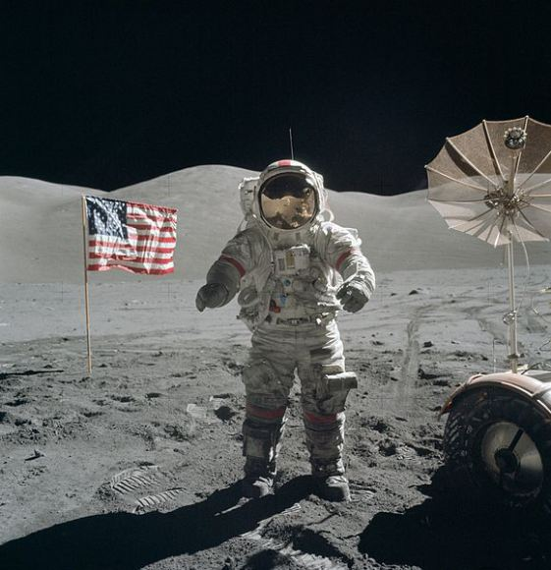
Eugene Cernan on the lunar surface, December 13, 1972. Credit: NASA.
Why explore space? It’s an expensive arena to play in, between the fuel costs and the technological challenge of operating in a hostile environment. For humans, a small mistake can quickly become fatal — something that we have seen several times in space history. And for NASA’s budget, there are projects that come in late and over budget, drawing the ire of Congress and the public.
These are some of the drawbacks. But for the rest of this article, we will focus on some of the benefits of going where few humans have gone before.
Spinoffs

Definition of Spinoff: A spinoff is a commercialized product that incorporates NASA technology or NASA "know how" and benefits the public. Spinoffs promote commercial activity, encourages economic growth, and stimulates innovation in business and commerce.
Definition of intangible: Unable to be touched or grasped; not having physical presence. Abstract.
GO TO: https://spinoff.nasa.gov/Spinoff2008/tech_benefits.html FOR SPINOFF ARTICLE

Perhaps the most direct benefit comes from technologies used on Earth that were first pioneered in space exploration. This is something that all agencies talk about, but we’ll focus on the NASA Spinoff program as an example. (NASA will be used as the prime example for most of this article, but many of these cited benefits are also quoted by other space agencies.)
The program arose from NASA’s desire to showcase spinoffs at congressional budget hearings, according to its website. This began with a “Technology Utilization Program Report” in 1973, which began as a black-and-white circular and progressed to color in 1976 following public interest. Since that year, NASA has published more than 1,800 reports on spinoffs.
The agency has several goals in doing this. “Dispelling the myth of wasted taxpayer dollars” is one NASA cites, along with encouraging the public to follow space exploration and showing how American ingenuity can work in space.
There are many commercialized advances the program says it contributed to, including “memory foam” (first used for airline crash protection), magnetic resonance imaging and smoke detection. In many cases, NASA did not invent the technology itself, but just pushed it along, the agency says.
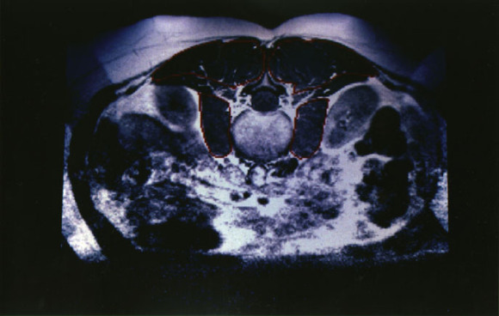
An MRI image of the lower back. Credit: NASA
But as counterpoint to NASA’s arguments, some critics argue the technology would have been developed anyway without space exploration, or that the money spent on exploration itself does not justify the spinoff.
Job creation (jobs were created by space exploration)
Another popularly cited benefit of space exploration is “job creation”, or the fact that a space agency and its network of contractors, universities and other entities help people stay employed. From time to time, NASA puts out figures concerning how many associated jobs a particular project generates, or the economic impact.
Here’s an example: in 2012, NASA administrator Charles Bolden published a blog post about the Curiosity Mars rover landing, which was picked up by the White House website. “It’s also important to remember that the $2.5 billion investment made in this project was not spent on Mars, but right here on Earth, supporting more than 7,000 jobs in at least 31 states,” he wrote.
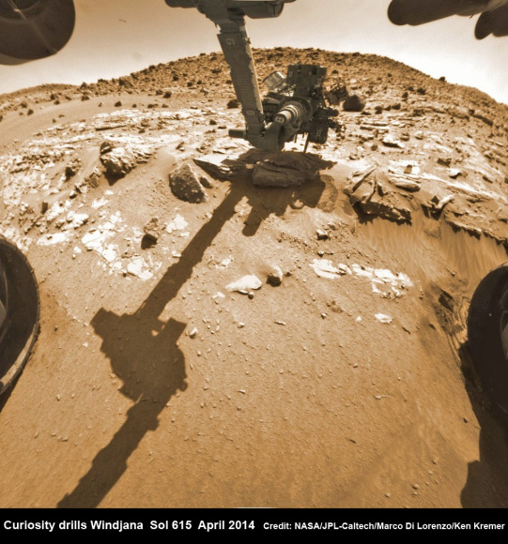
Hazcam fisheye camera image shows Curiosity drilling into “Windjana” rock target on April 29, 2014 (Sol 615). Flattened and colorized image shows Mount Remarkable butte backdrop. Credit: NASA/JPL/Marco Di Lorenzo/Ken Kremer – kenkremer.com
But the benefit can cut in a negative way, too. NASA’s budget is allocated by Congress, which means that the amount of money it has available for employment fluctuates. There are also some programs that are highly dependent on grants, which can make stable jobs challenging in those fields. Finally, as the priorities of Congress/NASA change, jobs can evaporate with it. One example was the space shuttle’s retirement, which prompted a job loss so massive that NASA had a “transition strategy” for its employees and contractors.
It’s also unclear what constitutes a “job” under NASA parlance. Some universities have researchers working on multiple projects — NASA-related or not. Employment can also be full-time, part-time or occasional. So while “job creation” is cited as a benefit, more details about those jobs are needed to make an informed decision about how much good it does.
Education
Teaching has a high priority for NASA, so much so that it has flown astronaut educators in space. (The first one, Christa McAuliffe, died aboard the space shuttle Challenger during launch in 1986. Her backup, Barbara Morgan, was selected as an educator/mission specialist in 1998 and flew aboard STS-118 in 2007.) And to this day, astronauts regularly do in-flight conferences with students from space, ostensibly to inspire them to pursue careers in the field.
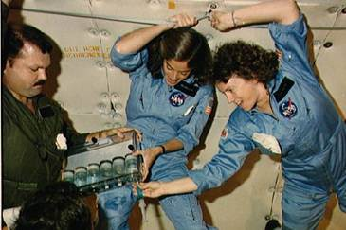
Christa McAuliffe and Barbara Morgan practice teaching from space. Credit: “The Lost Lessons”
NASA’s education office has three goals: making the workforce stronger, encouraging students to pursue STEM careers (science, technology, engineering and mathematics), and “engaging Americans in NASA’s mission.” Other space agencies also have education components to assist with requirements in their own countries. It’s also fair to say the public affairs office for NASA and other agencies play roles in education, although they also talk about topics such as missions in progress.
But it’s hard to figure out how well the education efforts translate into inspiring students, according to a National Research Council report on NASA’s primary and secondary education program in 2008. Among other criticisms, the program was cited as unstable (as it needs to change with political priorities) and there was little “rigorous evaluation” of its effectiveness. But NASA’s emphasis on science and discovery was also praised.
Anecdotally, however, many astronauts and people within NASA have spoken about being inspired by watching missions such as Apollo take place. And the same is true of people who are peripherally involved in the field, too. (A personal example: this author first became interested in space in the mid-1990s through the movie Apollo 13, which led to her watching the space shuttle program more closely.)
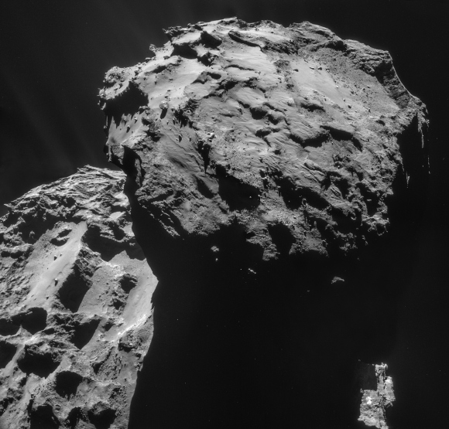
New Rosetta mission findings do not exclude comets as a source of water in and on the Earth’s crust but does indicate comets were a minor contribution. A four-image mosaic comprises images taken by Rosetta’s navigation camera on 7 December from a distance of 19.7 km from the centre of Comet 67P/Churyumov-Gerasimenko. (Credit: ESA/Rosetta/Navcam Imager)
Intangible benefits
Added to this host of business-like benefits, of course, are the intangibles. What sort of value can you place on better understanding the universe? Think of finding methane on Mars, or discovering an exoplanet, or constructing the International Space Station to do long-term exploration studies. Each has a cost associated with it, but with each also comes a smidgeon of knowledge we can add to the encyclopedia of the human race.
Space can also inspire art, which is something seen heavily in 2014 following the arrival of the European Space Agency Rosetta mission at Comet 67P/Churyumov–Gerasimenko. It inspired songs, short videos and many other works of art. NASA’s missions, particularly those early space explorers of the 1950s and 1960s, inspired creations from people as famous as Norman Rockwell.
There also are benefits that maybe we cannot anticipate ahead of time. The Search for Extraterrestrial Intelligence (SETI) is a network that advocates looking for life around the universe, likely because communicating with beings outside of Earth could bring us some benefit. And perhaps there is another space-related discovery just around the corner that will change our lives drastically.

