**Waves**

This immense wall of moving water gives the surfer an amazing ride. The swelling surf will raise him up and push him forward as though he’s as light as a feather. All he needs to do is keep his balance on the surfboard. The incredible power of the wave will do the rest. When you think of waves, ocean waves like this one probably come to mind. But there are many other examples of waves, some that affect all of us in our daily lives. What are waves, and what causes them? What are some other examples of waves? Read on to find out.

|  |  |
| --- | --- |
| **Lesson Objectives**  • Define mechanical wave.  • Describe transverse waves.  • Identify longitudinal waves.  • Describe surface waves. | **Lesson Vocabulary**  • longitudinal wave  • mechanical wave  • surface wave  • transverse wave |

**Introduction**

Ocean waves are among the most impressive waves in the world. They clearly show that waves transfer energy. In the case of ocean waves, energy is transferred through matter. But some waves, called electromagnetic waves, can transfer energy without traveling through matter. These waves can travel through space. You can read more about electromagnetic waves in the chapter "Electromagnetic Radiation." Waves that transfer energy through matter are the focus of the present chapter. These waves are called mechanical waves.

**Mechanical Waves**

A **mechanical wave** is a disturbance in matter that **transfers energy from place to place**. A mechanical wave starts when matter is disturbed. An example of a mechanical wave is pictured in Figure 1.1. A drop of water falls into a pond. This disturbs the water in the pond. What happens next? The disturbance travels outward from the drop in all directions. This is the wave. A source of energy is needed to start a mechanical wave. In this case, the energy comes from the falling drop of water.

**The Medium**

|  |
| --- |
| **FIGUIRE 1.1**  A drop of water causes a disturbance that travels through the pond as a wave. |

The **energy of a mechanical wave can travel only through matter**. This matter is called the medium (plural, media). The medium in Figure 1.1 is a liquid — the water in the pond. But the medium of a mechanical wave can be any state of matter, including a solid or a gas. It’s important to note that particles of matter in the medium don’t actually travel along with the wave. **Only the energy travels**. The particles of the medium just vibrate, or move back-and-forth or up-and-down in one spot, always returning to their original positions. As the particles vibrate, they pass the energy of the disturbance to the particles next to them, which pass the energy to the particles next to them, and soon.

**Types of Mechanical Waves**

There are three types of mechanical waves. They differ in how they travel through a medium. The three types are transverse, longitudinal, and surface waves. All three types are described in detail below.

**Transverse Waves**

A transverse **wave is a wave in which the medium vibrates at right angles to the direction that the wave travels**. An example of a transverse wave is a wave in a rope, like the one pictured in Figure 1.2. In this wave, energy is provided by a person’s hand moving one end of the rope up and down. The direction of the wave is down the length of the rope away from the person’s hand. The rope itself moves up and down as the wave passes through it.

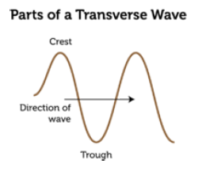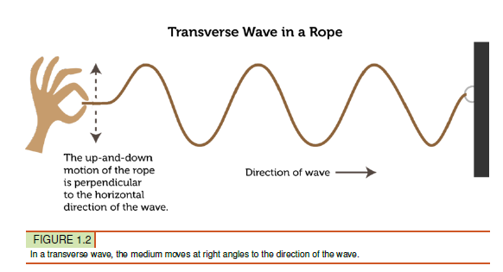

**Crests and Troughs**

A transverse wave can be characterized by the high and low points reached by particles of the medium as the wave passes through. This is illustrated in Figure 1.3. The high points are called crests, and the low points are called troughs.

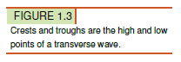

**S Waves**

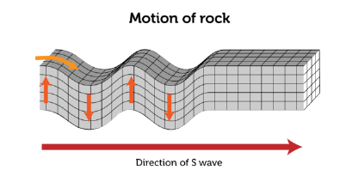Another example of transverse waves occurs with earthquakes. The disturbance that causes an earthquake sends transverse waves through underground rocks in all directions from the disturbance. Earthquake waves that travel this way are called secondary, or S, waves. An S wave is illustrated in Figure 1.4.

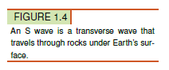

**Longitudinal Waves**

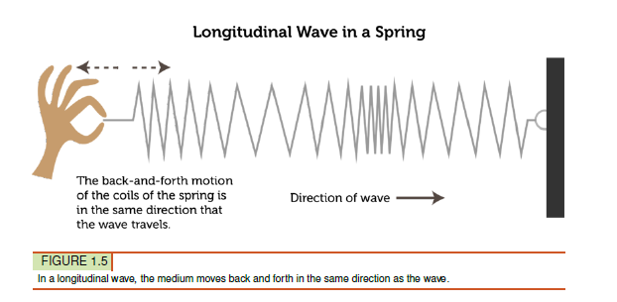A **longitudinal wave** is a wave in which the medium vibrates in the same direction that the wave travels. An example of a longitudinal wave is a wave in a spring, like the one in Figure 1.5. In this wave, the energy is provided by a person’s hand pushing and pulling the spring. The coils of the spring first crowd closer together and then spread farther apart as the disturbance passes through them. The direction of the wave is down the length of the spring, or the same direction in which the coils move.

**Compressions and Rarefactions**

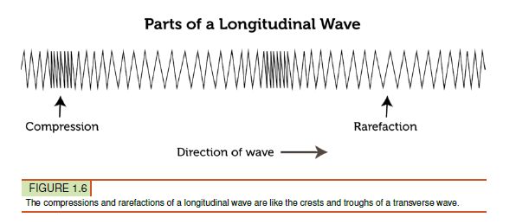A longitudinal wave can be characterized by the compressions and rarefactions of the medium. This is illustrated in Figure 1.6. Compressions are the places where the coils are crowded together, and rarefactions are the places where the coils are spread apart.

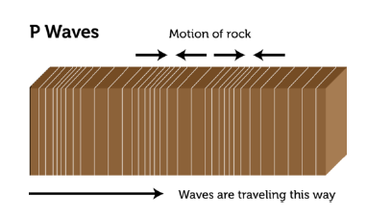

**P Waves**

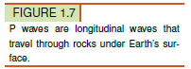Earthquakes cause longitudinal waves as well as transverse waves. The disturbance that causes an earthquake sends longitudinal waves through underground rocks in all directions from the disturbance. Earthquake waves that travel this way are called primary, or P, waves. They are illustrated in Figure 1.7.

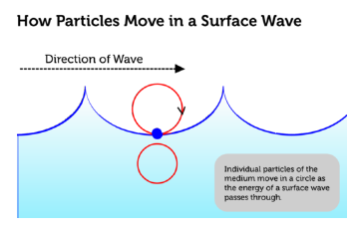**Surface Waves**

A surface wave is a wave that travels along the surface of a medium. It combines a transverse wave and a longitudinal wave. Ocean waves are surface waves. They travel on the surface of the water between the ocean and the air. In a surface wave, particles of the medium move up and down as well as back and forth. This gives them an overall circular motion.

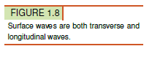In deep water, particles of water just move in circles. They don’t actually move closer to shore with the energy of the waves. However, near the shore where the water is shallow, the waves behave differently. They start to drag on the bottom, creating friction (see Figure 1.9). The friction slows down the bottoms of the waves, while the tops of the waves keep moving at the same speed. This causes the waves to get steeper until they topple over and crash on the shore. The crashing waves carry water onto the shore as surf.

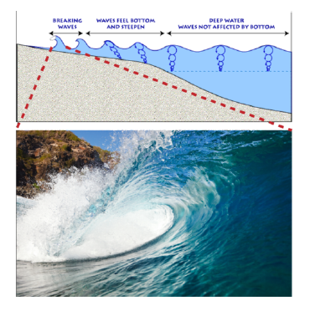

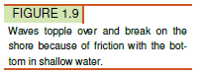

**Summary**

* Mechanical waves are waves that transfer energy through matter, called the medium. Mechanical waves start when a source of energy causes a disturbance in the medium. Types of mechanical waves include transverse, longitudinal, and surface waves.
* In a transverse wave, such as a wave in a rope, the medium vibrates at right angles to the direction that the wave travels. The high points of transverse waves are called crests, and the low points are called troughs.
* In a longitudinal wave, such as a wave in a spring, the medium vibrates in the same direction that the wave travels. Places where the particles of the medium are closer together are called compressions, and places