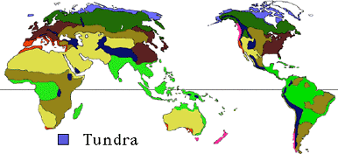
Where is the Tundra Located?
The tundra is located at the top of the world, near the North Pole. This enormous biome, extremely uniform in appearance, covers a fifth of the earth's surface.

The most distinctive characteristic of tundra soil is its permafrost, a permanently frozen layer of ground. During the brief summers, the top section of the soil may thaw out allowing plants and microorganisms to grow and reproduce. However, these plants and microorganisms become dormant during the cold winter months.
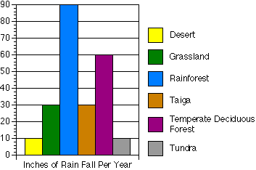
There is another region called alpine tundra, which is found on the tops of tall, cold mountains.
Tundra Facts
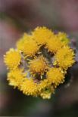
The arctic tundra is at the top of the world -- around the North Pole.
Animals are adapted to handle cold winters and to breed and raise young quickly in the very short and cool summers.
Temperatures during the arctic winter can dip to -60 F (-51 C)! The average temperature of the warmest month is between 50 F (10 C) and 32 F (0 C). Sometimes as few as 55 days per year have a mean temperature higher than 32 F (0 C). The average annual temperature is only 10 to 20F (-12C to -6C).
The soil is often frozen. Permafrost, or permanent ice, usually exists within a meter of the surface. Water is unavailable during most of the year.
Annual precipitation is very low, usually less than 10 inches (25 centimeters).
Tundra Plants
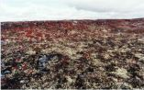
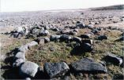
During the short-growing season in the summer, the tundra blooms with a variety of low-growing plants. So what plant life is found there?
The tundra landscape is a stark and barren place. The plants growing in the tundra are often small and grow close to the ground.
Where soil accumulates in pockets or cracks in rocks, small shrubs may grow. The tundra landscape is often covered with rocks, such as in this picture. The constant freezing and thawing in the tundra helps to break the rocks into smaller pieces.

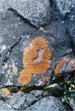
Lichen
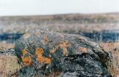
Growing on the surface of this rock is a lichen. Lichens are unusual organisms that often grow on exposed rock surfaces. They are composed of a fungus and an algae living and growing together. There are several varieties of lichen, and in the autumn lichen turn various colors.
Lichen is the favorite food of caribou and musk oxen.
Dark Red Leaves
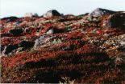
Many plants, such as this one, have leaves that are dark red. Dark leaves allow the plant to absorb more heat from the sun in the cold tundra climate.
Cushion Plants
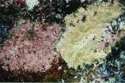
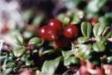
Many tundra plants, such as this one, are called cushion plants. That means they grow in a low, tight clump and look like a little cushion. Cushion plants are more common in the tundra where their growth habit helps protect them from the cold.

Seeds
Tundra birds help distribute seeds. When they eat brightly colored berries, the birds carry seeds to other places and leave the seeds to grow.
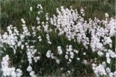
Cotton Grass
Cotton grass has seeds that are dispersed across the tundra when they are caught by the wind.

Tundra Animals
The frigid cold and deep snow makes life in the tundra very difficult.
Class: Aves: Birds | Diet: Small mammals
Order: Strigiformes: Owls
Size: 52 - 65 cm (20 1/2 - 25 1/2 in)
Family: Strigidae: Owls | Conservation Status: Non-threatened
Scientific Name: Nyctea scandiaca | Habitat: tundra, marshes, coasts
Range: Circumpolar: arctic Canada, Greenland, Northern Eurasia
Every animal must adapt in order to survive. Some have grown thick fur which turns white in the winter. Others find a place to hibernate during the winter months.
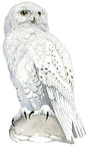
Snowy Owl
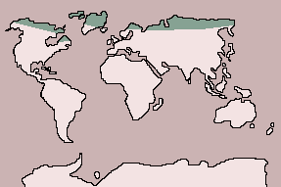
The snowy owl is a large species with distinctive, mainly white plumage; females have darker, barred markings than males. It usually hunts during the day and takes prey up to the size of arctic hares and lemmings, as well as smaller rodents and birds such as ducks and gulls. The snowy owl begins nesting in mid-May. It makes a shallow scrape in the ground or on a rock, lines it with moss and feathers and lays 4 to 10 eggs. Up to 15 eggs may be laid if food supplies are particularly good. The male brings food to the female while she incubates the eggs for 32 or 33 days.
Class: Aves: Birds | Diet: Leaves
Order: Galliformes: Gamebirds
Size: 33 - 39 cm (13 - 15 1/2 in)
Family: Tetraonianae: Grouse | Conservation Status: Non-threatened
Scientific Name: Lagopus muta | Habitat: forest, tundra
Range: Holarctic
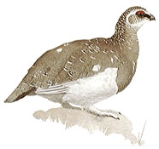
Rock Ptarmigan
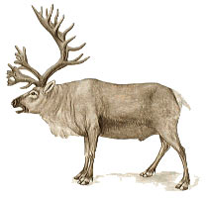
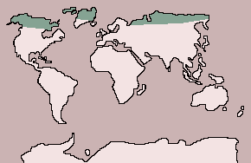
The ground-dwelling rock ptarmigans depend on camouflage for defense, and to achieve this in the changing background of their northerly range, they adopt different plumages. The summer plumage is mottled to blend with the forest, while during the winter snows ptarmigans have white plumage, only the tail feathers remaining dark. Rock ptarmigans feed on leaves, buds, fruits and seeds and on some insects in the summer. They are monogamous birds; the male defends a small territory at the breeding grounds. The female lays 6 to 9 eggs in a leaf-lined hollow on the ground and incubates them for 24 to 26 days. The cygnets must make the long migration south when only 80 to 90 days old.
Class: Mammalia: Mammals | Diet: Lichen
Order: Artiodactyla: Even-toed Ungulates
Size: body:1.2 - 2.2 m (4 - 7 1/4 ft), tail: 10 - 21 cm (4 - 8 1/4 in)
Family: Cervidae: Deer | Conservation Status: Non-threatened
Scientific Name: Rangifer tarandus | Habitat: tundra
Range: Northern Europe and Asia: Scandinavia to Siberia; Alaska, Canada, Greenland
Caribou
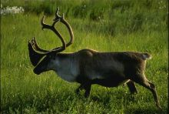
Once divided into several species, all caribou and reindeer, including the domesticated reindeer, are now considered races of a single species. The races vary in coloration from almost black to brown, gray and almost white.
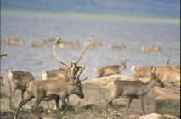
The caribou is the only deer in which both sexes have antlers, although those of the female are smaller. The antlers are unique in that the lowest, forward-pointing tine is itself branched.
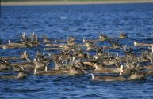
Females are gregarious and gather in herds with their young, but adult males are often solitary. In autumn, males fight to gather harems of 5 to 40 or so females. The female produces 1, occasionally 2, young after a gestation of about 240 days. Young caribou are able to run with the herd within a few hours of birth.
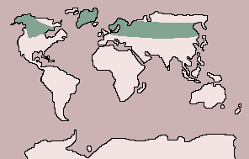
Some populations migrate hundreds of miles between their breeding grounds on the tundra and winter feeding grounds farther south. Grass and other tundra plants are their main food in summer, but in winter caribou feed mainly on lichens, scraping away the snow with their hoofs to expose the plants.

Class: Mammalia: Mammals | Diet: Large and small mammals, fish, birds, berries, leaves
Order: Carnivora: Carnivores
Size: body:12.2 - 2.5 m (7 1/4 - 8 1/4 ft), tail: 7.5 - 12.5 cm (3 - 5 in)
Family: Ursidae: Bears | Conservation Status: Vulnerable
Scientific Name: Ursus maritimus | Habitat: coasts, ice floes
Range: Arctic Ocean to southern limits of ice floes
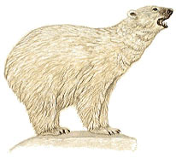
Polar Bear

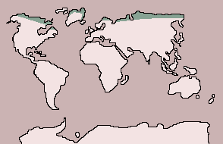
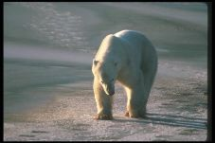
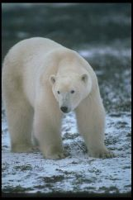
A huge bear with an unmistakable creamy-white coat, the polar bear is surprisingly fast and can easily outrun a caribou over a short distance. It wanders over a larger area than any other bear and, of course, swims well.
Class: Mammalia: Mammals | Diet: Grass
Order: Rodentia: Rodents
Size: body:13 - 15 cm (5 - 6 in), tail: 2 cm (3/4 in)
Family: Microtinae: Voles and Lemmings | Conservation Status: Non-threatened
Scientific Name: Lemmus lemmus | Habitat: tundra, grassland
Range: Scandinavia
Seals, fish, seabirds, arctic hares, caribou, and musk oxen are the polar bear's main prey, and in the summer it also eats berries and leaves of tundra plants.
Normally solitary animals outside the breeding season, polar bears mate in midsummer. A litter of 1 to 4 young is born after a gestation of about 9 months, and the young bears remain with their mother for about a year. Thus females breed only every other year.
Norway Lemming
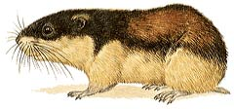
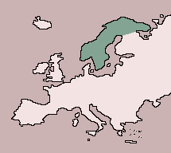
The boldly patterned Norway lemming is active day and night, alternating periods of activity with short spells of rest. Grasses, shrubs and particularly mosses make up its diet; in winter it clears runways under the snow on the ground surface in its search for food. These lemmings start to breed in spring, under the snow, and may produce as many as eight litters of 6 young each throughout the summer.
Lemmings are fabled for their dramatic population explosions, which occur approximately every three or four years. It is still not known what causes these, but a fine, warm spring following two or three years of low population usually triggers an explosion that year or the next. As local populations swell, lemmings are forced into surrounding areas. Gradually more and more are driven out, down the mountains and into the valleys. Many are eaten by predators, and more lose their lives crossing rivers and lakes. Lemmings do not deliberately commit suicide.

