Rainforest
Did you know there are two types of Rainforest -- the temperate and the tropical? Tropical rainforests are found close to the equator. Temperate rainforests are found along coasts in the temperate zone, such as the Pacific Northwest of the USA. Both are endangered!
Types of Rainforests
There are two types of rainforests -- tropical and temperate. Tropical and temperate rainforests share certain characteristics. For example, most trees flare at the base. Vegetation is dense, tall and very green. Both types of rainforests are rich in plant and animal species, although the diversity is greater in the tropical rainforest.
Montane forests are found in mountainous areas and may contain plants such as oaks, rhododendrons, and pines, which are characteristic of temperate deciduous forests. At higher altitudes, temperatures are cooler. Even close to the equator, frost and snow can occur.
Precipitation and Climate
Both tropical and temperate rainforests are very lush and wet. Rainfall falls regularly throughout the year. The tropical rainforest receives 80-400 inches of rainfall per year. It rains a lot in the temperate rainforest, too -- about 100 inches per year. And even more moisture comes from the coastal fog that hovers among the trees.
Tropical rainforests are warm and moist; while temperate rainforests are cool.
 | Tropical | Temperate
Temperatures | warm | cool
Number of tree species | many (hundreds) | few (10-20)
Types of leaves | broadleaf | needles
Age of trees | 50-100 years | 500-1000 years
Epiphytes | lots of different kinds including orchids and bromeliads | mostly mosses and ferns
Decomposition rate | rapid | slow
Are all Tropical Forests, Rainforests?
Only a small percentage of the tropical forests are rainforests. To be a tropical rainforest, forested areas must:
- Lie between the Tropic of Cancer and the Tropic of Capricorn.
- Receive rainfall regularly throughout the year (80-400 inches per year).
- Remain warm and frost free all year long (mean temperatures are between 70° and 85°F) with very little daily fluctuation.
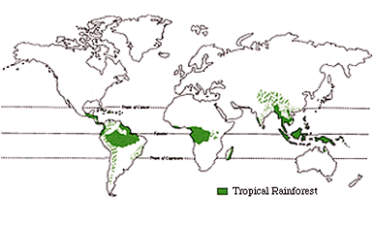
Consequently, many forested areas in the tropics are not rainforests. Forests that receive irregular rainfall (monsoons followed by a dry season) are moist deciduous forests. Trees in these forests may drop their leaves in the dry season.

Rainforests Endangered!
Today only about three percent of the original temperate rainforest in the U.S.A. remains, mostly inside Olympic National Park in Washington State. Prior to the arrival of homesteaders just over a century ago, the Olympic Peninsula contained more than a million acres of old-growth spruce and hemlock. Because of habitat destruction, many plants and animals have become "island dwellers" inside the park now.
Tropical rainforests comprise only 40% of the world's tropical forests and only 20% of the world's total forests. They cover 6-7% of the Earth's land surface. Half of the world's plant and animal species live in the tropical rainforests of the world. Thirty acres of trees are cut in the tropical rainforests every minute. As you read this, tropical rainforests are shrinking. Each second a portion of rainforest the size of a football field is destroyed or damaged. What can you do to help save the tropical rainforest?
Where Are Rainforests Located?
Tropical rainforests are located near the equator. Fifty seven percent of all tropical rainforests are found in Latin America. One third of the world's tropical rainforests are in Brazil. Other tropical rainforests are located in Southeast Asia and the Pacific Islands (25% of the world's tropical rainforests) and West Africa (18%).
Temperate rainforests are found along some coasts in temperate zones. The largest temperate rainforests are found on the Pacific coast of North America. They stretch from Oregon to Alaska for 1,200 miles. Smaller temperate rainforests can be found on the southeast coast of Chile in South America. There are a few other coastal strips with temperate rainforests, including small areas in the United Kingdom, Norway, Japan, New Zealand, and southern Australia.
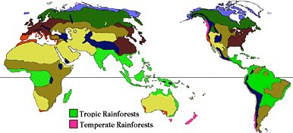

Temperate Rain Forest

Robyn, Sarah, and a group of students from Olympia, Washington visited the ancient temperate rainforests of the Pacific Northwest.

The Quinault Rainforest is found in the southern part of the Olympia National Forest. The forest stretches 1,200 miles along the Pacific coast. Temperate rainforests cover only 75 million acres of earth. That's not much... and two-thirds of all temperate rainforests are here in the Pacific Northwest.
Temperate rainforests are very ancient and rare; there is usually a fine mist in the air. The forest is always damp with water dripping from the tree branches.
Temperate rainforests -- like the Quinault -- get about 100 inches or more of rain each year.
You don't see lots of broadleaf plants like you find in the tropical rainforests. There are huge conifer trees here. Some can grow taller than 300 feet tall! Some of these trees may be up to 500 and even 1000 years old and the trunk can be more than 100 feet around!
The conifers form a canopy over the top of the forest, creating a shady forest floor. We thought the forest looked like a sparkling fairyland! Light filtered through the branches of the conifer trees and bounced off water droplets here and there.
The beautiful forest floor was covered with ferns. We also found oxalis leaves that fold up tight in the summer heat. There were lots of mosses and wildflowers,too. Needles decay very, very slowly because the temperatures are cool.
We were fascinated with the forest! We saw fallen logs that made a moist, soggy habitat for mosses, ferns, lichens, and new tree seedlings. Theses fallen logs are called nurse logs, because young trees grow on the top mossy surface of the fallen trees.
We looked closely at the nurse log and found tiny seedlings that germinated. They were growing from crevices in the bark. In time, many of the seedlings become saplings. As the saplings grow big and strong, they send roots around the nurse log and into the ground below.
Look closely at some of the bigger trees in the forest. See the stilts? We discovered that these stilts were made as the roots of the saplings grew stronger and stronger and the nurse log finally rotted away. It take years and years for nurse logs to rot in the rainforest, because the climate is cool. So once the nurse log is gone, the new trees are often left on stilts.
At the end of the day, the kids sent us on our way. Next stop an hour away -- the Hoh Rainforest!
Temperate rainforests are found on the west coast of the United States from northern California to Alaska. The climate is caused by ocean currents, which bring in rain, fog, and clouds.
Because the Olympic rainforests are close to the Pacific, coastal fog is very common in summer. It supplies the about 7-12 inches of rain each summer. The temperate rainforests has mild, wet winters and cool, foggy or cloudy summers.
About an hour from the ocean, we entered the Hoh. Because the climate is not freezing in the winter, the conifers are able to grow year around. They are very tall and hundreds of years old.
Some of these species live past 500 years (Douglas Fir) and others over 1000 years (Sitka Spruce and Western Red Cedar). The Western Hemlock lives the shortest life span of 300 years.
Many epiphytes are found in the temperate rainforests. Epiphytes are plants that grow on other plants. The maple trees have more epiphytes than any other tree and researchers cannot yet explain why. The maples here are covered with club mosses...
...And other trees have ferns, lichen, and mosses hanging from their branches
The wildlife of the temperate rainforest ranges from beavers and raccoons to cougars and black bears.
But the elk may be the most important animal of all. The elk are called the "landscape gardeners" of the Olympic National Forest. Their foraging and trampling provide the balance that is necessary. If the elk were not there, the rainforest would become a thicket. The elk were once hunted and became endangered. Now the herd is now steady and the forest is well balanced again.

Plants can be found from streambanks and the forest floor to the trunks of trees...
Lichens, called reindeer moss, grow high in the canopy and fall to the ground when the breezes blow. These lichens are the favorite food of many animals that live in the forest, particularly the 3,500 elk that forage for food on the forest floor.
Tropical Rain Forest
The following plant adaptations enable tropical plants to live in the hot, humid, and wet conditions of the tropical rainforest. Plant Adaptations
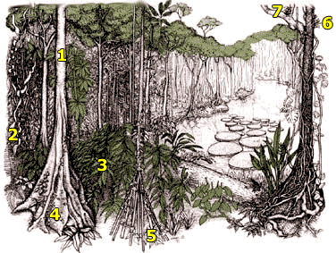
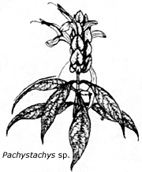
1. Bark
In drier, temperate deciduous forests a thick bark helps to limit moisture evaporation from the tree's trunk. Since this is not a concern in the high humidity of tropical rainforests, most trees have a thin, smooth bark. The smoothness of the bark may also make it difficult for other plants to grow on their surface.
2. Lianas
Lianas are climbing woody vines that drape rainforest trees. They have adapted to life in the rainforest by having their roots in the ground and climbing high into the tree canopy to reach available sunlight. Many lianas start life in the rainforest canopy and send roots down to the ground.
3. Drip Tips
The leaves of forest trees have adapted to cope with exceptionally high rainfall. Many tropical rainforest leaves have a drip tip. It is thought that these drip tips enable rain drops to run off quickly. Plants need to shed water to avoid growth of fungus and bacteria in the warm, wet tropical rainforest.
4. Buttresses
Many large trees have massive ridges near the base that can rise 30 feet high before blending into the trunk. Why do they form? Buttress roots provide extra stability, especially since roots of tropical rainforest trees are not typically as deep as those of trees in temperate zones.
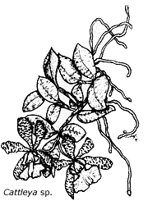
5. Prop and Stilt Roots
Prop and stilt roots help give support and are characteristic of tropical palms growing in shallow, wet soils. Although the tree grows fairly slowly, these above-ground roots can grow 28 inches a month.
6. Epiphytes
Epiphytes are plants that live on the surface of other plants, especially the trunk and branches. They grow on trees to take advantage of the sunlight in the canopy. Most are orchids, bromeliads, ferns, and Philodendron relatives. Tiny plants called epiphylls, mostly mosses, liverworts and lichens, live on the surface of leaves.
7. Bromeliads
Bromeliads are found almost exclusively in the Americas. Some grow in the ground, like pineapple, but most species grow on the branches of trees. Their leaves form a vase or tank that holds water. Small roots anchor plants to supporting branches, and their broad leaf bases form a water-holding tank or cup. The tank's capacity ranges from half a pint to 12 gallons or more. The tanks support a thriving eco-system of bacteria, protozoa, tiny crustaceans, mosquito and dragonfly larvae, tadpoles, birds, salamanders and frogs.
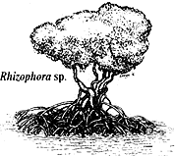
Mangroves
On tropical deltas and along ocean edges and river estuaries, trees have adapted to living in wet, marshy conditions. These trees, called mangroves, have wide-spreading stilt roots that support the trees in the tidal mud and trap nutritious organic matter.

Nepenthes
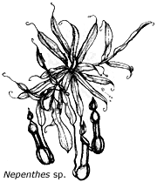
Pitcher plant vines in the family Nepenthaceae have leaves that form a pitcher, complete with a lid. Sweet or foul-smelling nectar in the pitcher attracts insects, especially ants and flies, that lose their grip on the slick sides and fall into the liquid. Downward-pointing hairs inside the pitcher prevent the insects' escape. The insects are digested by the plants and provide nutrients. Pitcher plants are not epiphytes but climbers rooted in the soil.
Interesting Plants 1
Tropical plants comprise about 160,000 of the estimated 250,000 species of plants on Earth. Following is a sample of the many interesting plants that grow in the tropics.
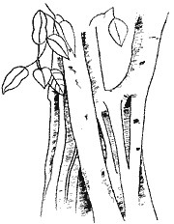
Double Coconut
Lodoicea maldivica
Palm family
The largest seed in the plant kingdom looks like two coconuts fused together, giving rise to this fan palm's common name. The plant is tender and very slow-growing, especially when young (for instance, the nut takes a year to germinate and another year to form its first leaf); hence, it is rarely cultivated. Eventually, it can attain heights of 100 feet and leaf blades to 20 feet in length and 12 feet in diameter. The fan palm is native to only a few islands in the Seychelles, located off the east coast of Africa in the Indian Ocean. For centuries its nuts were mistakenly thought to come from the Maldive Islands, an error preserved in its Latin name.
Banyan Tree
Ficus benghalensis
Mulberry family
One of the wonders of the plant kingdom, the banyan, begins life as an epiphyte, growing on another plant and taking its moisture and nutrients from the air and rain. The banyan sends down aerial roots which become accessory "trunks," supporting the tree's immense crown and allowing it to extend over several acres. Widely cultivated in the tropics, the banyan is native to India and Pakistan, where it is considered sacred.
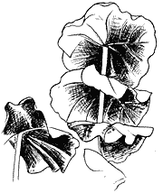
Coccoloba
Coccoloba pubescens
Buckwheat family
Sometimes referred to as "Eve's umbrella," coccoloba can grow to 80 feet but in its juvenile stage is grown as a pot plant for its large, veined ornamental leaves.
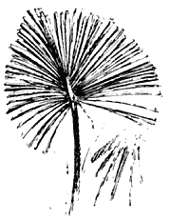
Talipot Palm
Corypha umbraculifera
Palm family
"Umbraculifera" means "bears an umbrella," an appropriate name for this ornamental. The talipot palm's flower clusters are the largest in the plant kingdom. Specimens can easily grow trunks to 80 feet in height and 3 feet in diameter and leaf blades to 16 feet in diameter. The plant dies after flowering and fruiting.
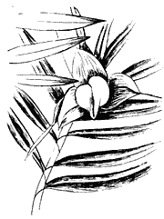
Freycinetia
Freycinetia multiflora
Pandanus family
The orange growths on this male specimen are actually leaves which will slowly peel off to expose small green male flowers.
Interesting Plants 2
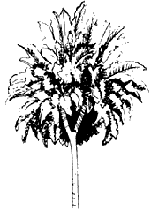
Phillipine Fig
Ficus pseudopalma
Mulberry family
This plant's unusual leaf formations, giving the appearance of a pompon on a pole, could lead you to mistake it for a palm, hence the name "pseudopalma."
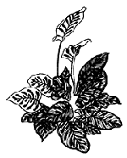
Peacock Plant
Calathea makoyana
Maranta family
The peacock plant is well adapted to the low light of the forest floor. Its broad leaves help capture the limited light and the red-purple pigment on the underside of the leaves is a special adaptation which captures the greenish light present at the forest floor. It has striking markings on the upper surface of the leaf. These markings occur naturally; it is not a cultivar. Like the prayer plant (Maranta sp.) the leaves of the peacock plant fold up at night.
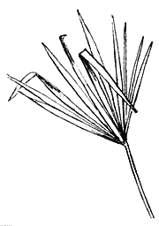
Panama-Hat Plant
Carludovica palmata
Cyclanthus family
Often cultivated in tropical gardens as an ornamental or as a source of fiber, this plant is palm-like but is not a palm. In Ecuador, the leaves are woven into the famous Panama hats, a name conferred during the days of the California Gold Rush, when the hats were shipped to the state from Ecuador indirectly by way of Panama.
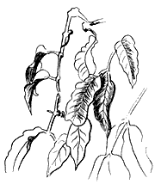
Gnetum
Gnetum leyboldii
Gnetum family
This vine is not a flowering plant but one of the gymnosperms, vascular plants that bear exposed seeds ("gymnosperm" literally means "naked seed"). Other kinds of gymnosperms are the cycads, gingkos, and conifers. Gnetum is uncharacteristic in that it is a vine and has large, broad
leaves.
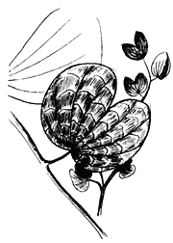
Bauhinia
Bauhinia blakeana
Pea family
This evergreen tree, which can grow to 40 feet or more, bears curious, bi-lobed leaves reminiscent of bull hooves. Its showy, reddish purple flowers are very orchid-like in appearance. All plants in cultivation originated from a single tree discovered in Canton, China.
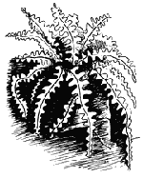
Fishbone Cactus
Epiphyllum anguliger
Cactus family
Sometimes called the "fishbone cactus," this plant lives in the tropical rainforests of southern Mexico. It is an epiphyte and so is adapted to the relatively dry conditions of life in the forest canopy. Spineless, its branches resemble leaves but are actually modified stems. It flowers for just a few nights each year, with fragrant pale yellow blooms.
Interesting Plants 3
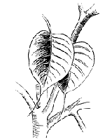
Sacred Fig
Ficus religiosa
Mulberry family
This large, fast-growing tree begins life as an epiphyte. Its leaves are excellent, if exaggerated, examples of drip tips, which allow rapid shedding of water. Widely planted in the tropics, in India the tree is sacred to Hindus and Buddhists.
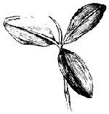
American Mangrove
Rhizophora mangle
Mangrove family
The mangroves are widely distributed throughout the tropics and in southern Florida, growing in areas of salt water, such as tidal shores and marshes. The many arching aerial roots make dense tangles that stabilize the surrounding soil, prop the tree, and assist in absorbing water and minerals. Seeds germinate while still attached to the parent plant, giving them a head start on growth when they fall and lodge in the mud. Mangrove bark is an important source of tannin, used in tanning, dyeing, making ink, and medicine. American mangrove is also referred to as red mangrove.
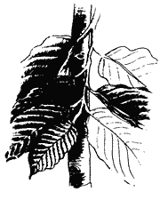
Ilang-Ilang
Cananga odorata
Annona family
This southeast Asian tree, which can grow to 80 feet, is also sometimes spelled "ylang-ylang." Its greenish yellow, drooping flowers are exceedingly fragrant, and their oils are distilled for use in some of the world's most expensive perfumes.

Life inside the wet and bustling tropical rainforest is filled with danger. Cougars and pumas stand ready to pounce; snakes sliver unseen between feet to administer a lethal bite; while exotic birds chirp overhead. An animal must be both smart and strong to survive in this environment. The intense competition from other species makes rainforest species the most interesting
The rainforests of the world are being destroyed by loggers and development. Many species found in the rainforest are endangered. Once they disappear, they are gone forever!
Bearded Pig
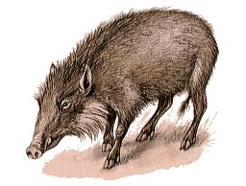
Class: Mammalia: Mammals | Diet: Fruit
Order: Artiodactyla: Even-toed Ungulates
Size: body:11.6 - 1.8 m (5 1/4 - 6 ft), tail: 20 - 30 cm (7 3/4 - 11 3/4 in)
Family: Suidae: Pigs | Conservation Status: Non-threatened
Scientific Name: Sus barbatus | Habitat: rainforest, scrub, mangrove swamps
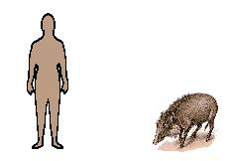
Range: Malaysia, Sumatra, Borneo
A large pig with an elongated head and a narrow body, the bearded pig has abundant whiskers on its chin and a bristly, wartlike protuberance beneath each eye. These warts are more conspicuous in males than in females. Fallen fruit, roots, shoots and insect larvae are the bearded pig's staple foods, and it also invades fields of root crops. It often follows gibbons and macaques to pick up the fruit they drop. After a gestation of about 4 months, the female makes a nest of plant material and gives birth to 2 or 3 young, which stay with her for about a year.

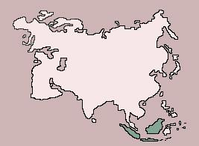

Flying Dragon
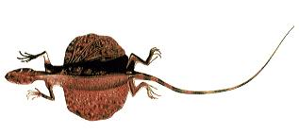
Class: Reptilia: Reptiles | Diet: Ants, termites
Order: Squamata: Lizards and Snakes
Size: body: 19 - 22 cm (7 1/2 - 8 1/2 in)
Family: Agamidae: Agamid Lizards | Conservation Status: Non-threatened
Scientific Name: Draco volans | Habitat: rainforest, rubber plantations
Range: Philippines to Malaysia and Indonesia
An arboreal lizard, the so-called flying dragon actually glides from tree to tree on winglike skin flaps. At each side of its body, between front and hind limbs, there is a large flap of skin, supported by extended movable ribs. Usually these flaps are held folded at the sides of the body, but they can be extended to carry the lizard in an almost horizontal glide for many meters. The flying dragon feeds on insects, particularly ants. To breed, the flying dragon descends to the ground and buries its 1 to 4 eggs in the soil.
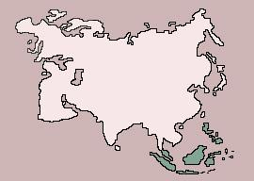

Gorilla
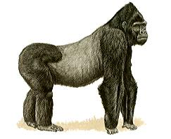
Class: Mammalia: Mammals | Diet: Plants (leaves, buds, stalks, berries, bark, ferns)
Order: Primates: Primates
Size: body: Male height: 1.7 - 1.8 m (5 1/2 - 6 ft), Female height: 1.4 - 1.5 m (4 1/2 - 5 ft), tail: absent
Family: Hominidae | Conservation Status: Endangered
Scientific Name: Gorilla gorilla | Habitat: rainforest up to 3,000 m (10,000 ft)
Range: Africa: Southeastern Nigeria to Western Zaire; Eastern Zaire into adjacent countries
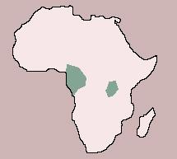
The largest and most robust of the primates, the gorilla is also a gentle, intelligent and sociable animal which lives a peaceful, quiet existence if undisturbed. Its body, covered with coarse black hair, is massive, with a short, broad trunk and wide chest and shoulders. The head is large, with a short muzzle, and the eyes and ears small; old males have high crowns. The muscular arms are longer than the short, thick legs, and the broad hands are equipped with short fingers and thumbs. Males are bigger and heavier than females, and those over 10 years old have silvery-gray hair on their backs -- hence the name silverback, given to old males. There are two races: the lowland and the mountain gorilla, also referred to as the western and eastern races, respectively. On the ground, gorillas normally move in a stooped posture, with the knuckles of the hands resting on the ground, but they do stand erect on occasion. Females and juveniles climb trees, but males rarely do so because of their great bulk.
Gorillas live in a close-knit group of a dominant male, 1 or 2 other males, several females and young; some groups may contain only the dominant male, 2 or 3 females and young. The group wanders in a home range of 10 to 40 sq km (4 to 15 1/2 sq mi), which is not defended or marked at the boundaries. There may be some conflict with neighboring groups, but encounters are generally avoided by communications such as drumming on the ground from a distance. Old males will threaten rivals by standing erect and beating the chest while roaring and barking and sometimes by tearing up and throwing plants. When the leader of a troop dies, younger males contest for dominance. Gorillas are active in the daytime. The troop rises between 6 A.M. and 8 A.M., feeds for a while on plant material, such as leaves, buds, stalks, berries, bark and ferns, and then has a period of rest and relaxation. Gorillas do not appear to drink but get the water they need from their juicy diet. They feed again in the afternoon and then retire for the night in nests made of twigs and leaves. Young gorillas under 3 years old sleep with their mothers, but all others have their own nests. Breeding appears to take place at any time of year. The female gives birth to a single young after a gestation of more than 9 months. The young is completely dependent and clings to its mother's fur at first, but it is able to sit up at 3 months and to walk and climb at 5 months. It suckles for 12 to 18 months and remains with its mother for about 3 years.
Orangutan
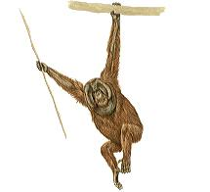
Class: Mammalia: Mammals | Diet: Fruit, also leaves, seeds, young birds, and eggs.
Order: Primates: Primates
Size: body:1.2 - 1.5 m (4 - 5 ft), tail: absent
Family: Hominidae | Conservation Status: Endangered
Scientific Name: Pongo pygmaeus | Habitat: rainforest
Range: Sumatra, Borneo
The orangutan, with its reddish-brown, shaggy hair, has a strong, heavily built body, and is the second-largest primate. The arms are long and powerful and reach to the ankles when the animal stands erect; there is a small thumb on each broad hand that is opposable to the first digit. The orangutan's legs are relatively short and weaker than the arms. Males are much larger and heavier than females and are also identified by the cheek flaps that surround the face of the mature adult. All adults have fatty throat pouches. Orangutans live alone, in pairs or in small family groups and are active in the daytime at all levels of the trees. They walk along large branches on all fours or erect and sometimes swing by their hands from branch to branch. On the ground, they walk on all fours or stand erect. Fruit is their staple diet, but they also feed on leaves, seeds, young birds and eggs. The orangutan sleeps in the trees in a platform nest made of sticks; it may make a new nest every night. After a gestation period of more than 9 months, the female gives birth to a single young. She cares for her offspring for some time -- one captive young was suckled for 6 years -- and it clings to her fur as she moves around in the trees.
