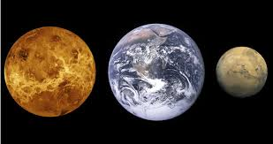
The Goldilocks Principle
Problem: How does the earth’s atmosphere compare with that of Venus and Mars?
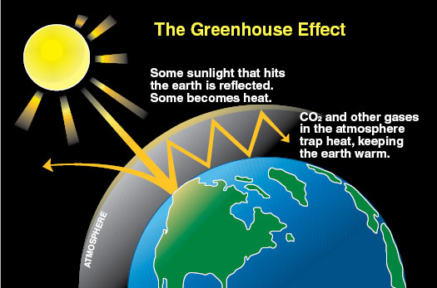
Background:
On Earth, two elements, nitrogen () and oxygen (), make up almost 99% of the volume of clean, dry air. Most of the remaining 1% is accounted for by the inert gaseous element, argon (Ar). Argon and the tiny percentage of remaining gases are referred to as trace gases. Certain trace atmospheric gases help to heat up our planet because they appear transparent to incoming visible (shortwave) light but act as a barrier to outgoing infrared (long wave) radiation. These special trace gases are often referred to as "greenhouse gases" because a scientist in the early 19th century suggested that they function much like the glass plates found on a greenhouse used for growing plants.
The earth's atmosphere is composed of gases (for example, and) of just the right types and in just the right amounts to warm the earth to temperatures suitable for life. The effect of the atmosphere to trap heat is the true "greenhouse effect."
We can evaluate the effect of greenhouse gases by comparing Earth with its nearest planetary neighbors, Venus and Mars. These planets either have too much greenhouse effect or too little to be able to sustain life as we know it. The differences between the three planets have been termed the "Goldilocks Principle" (Venus is too hot, Mars is too cold, but Earth is just right).
Many scientists believe that the composition of our atmosphere is due to the presence of life. Life acts to keep Earth's atmosphere in a dynamic balance. In other words, if life were to completely disappear, eventually our atmospheric composition could come to closely resemble Mars or Venus. Only with life continually producing oxygen through photosynthesis and removing and re-circulating does Earth's atmosphere remain fairly stable.
Do to the differences in their atmospheric densities; Mars and Venus have very different temperatures, despite the fact that these two planets have basically the same types and percentages of gases in their atmospheres.
- Venus has a very dense (tightly packed) atmosphere. So the concentration of CO₂ creates a “runaway” greenhouse effect, resulting in very high surface temperatures.
- Mars has almost no atmosphere, combined with the fact that mars is much further from the sun than Venus, the CO₂ is unable to create a warming effect and the temperatures on the surface of Mars are very low.
 | Venus | Earth | Mars
Surface Pressure relative to Earth | 90 | 1 | 0.007
Major Greenhouse gases | CO₂ | H₂O, CO₂ | CO₂
Temperature without Greenhouse gases (°C) | -46 | -18 | -57
Actual Temperature (°C) | 477 | 15 | -47
Temperature change due to greenhouse gases (°C) | +523 | +33 | +10

The Goldilocks Principle Name: ___________________________________ Pd. _______

Problem: How does the atmosphere of Earth compare to that of Venus and Mars?
Procedure:
- Using the materials provided, you will be building a sample of the atmosphere of Earth, Venus, or Mars. Each gas will be represented by a different colored material as listed below:
Gas | Color
Carbon Dioxide | Natural Color
Nitrogen | Green
Oxygen | Blue
Argon | Red
Methane | Purple

- You will fill your bag to represent the atmosphere of your planet; each bag will have 100 macaroni.

- You will use Table below to select the correct number and color of macaroni to place into the bag to show the percentage of each gas. If the amount of a gas is less than 1%, you have to add less than one whole macaroni.
 | Venus | Earth | Mars
Carbon Dioxide | 96.5% | 0.03% | 95%
Nitrogen | 3.5 | 78% | 2.7%
Oxygen | Trace | 21% | 0.13%
Argon | 0.007% | 0.9% | 1.6%
Methane | 0 | 0.002% | 0

- Remember that each bag will have the same total number of macaroni. Since Venus has an atmosphere 90 times denser (thicker) than Earth’s and Mars has an atmosphere 100 times thinner, your Venus bag would have to have 9000 macaroni and your Mars bag would have less than 1 macaroni.

Analysis: Answer in complete sentences
- Name at least two ways that the atmospheres of Venus and Mars are similar to each other.

- Name one way that the atmosphere of Venus and Mars differ from Earth’s.

- Describe the atmospheric conditions you might encounter as an astronaut setting foot on Venus and Mars.

- Using the information gathered from this activity, how is life sustained on Earth, while other planets like Venus and Mars cannot support life? (Refer to data gathered from this activity within your answer)

Challenge
- Looking at the background information, the idea of the “greenhouse effect” is important to sustaining life here on Earth. How can the relationship between the process of the “greenhouse effect” and sustaining life turn into a negative process?

