Temperate Deciduous Forest
The Temperate Deciduous Forest biome has four seasons of winter, spring, summer, and fall. Animals and plants have special adaptations to cope with these yearly changes.
What's A Temperate Deciduous Forest Like?
One of the most interesting features of the temperate deciduous forest is its changing seasons.
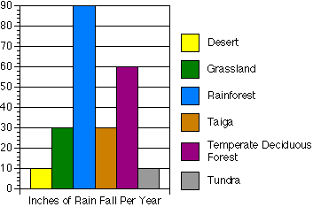
The word "deciduous" means exactly what the leaves on these trees do: change color in autumn, fall off in the winter, and grow back again in the spring. This adaptation helps trees in the forest survive winter.
If you look at the graph to the left, you'll see that next to the rainforest, the temperate deciduous gets the second-most amount of rainfall per year. In the winter, precipitation (rainfall) is in the form of sleet, snow, and hail. The average rainfall is 30 to 60 inches per year. The average temperature of the forest is about 50 degrees Fahrenheit.
How do deciduous trees and plants survive the changing seasons?
Like all living things, deciduous trees and plants have special adaptations to stay alive.
Summer is a busy time for deciduous trees. Their broad leaves capture energy from the sun and convert it to food by photosynthesis. Some of the food is used for growth and some is stored in the roots for next spring.
During the shorter days and cooler weather of autumn, green chlorophyll in the leaves begins to decompose, revealing brilliant oranges, yellows, and reds. Actually, these colors were present in the leaves all year long, but had been hidden by the green pigment of the chlorophyll.
To prepare for winter, deciduous trees and plants become dormant. They lose their leaves and seal the places where leaves were attached with a protective covering called a leaf scar. If they kept their leaves, the water in the leaves would freeze into ice, damaging the leaves and leaving the plant vulnerable to bacteria or fungi. Plants also make a concentrated sugar solution to stop water from freezing in their stems.
The longer days and warmer weather of spring signal to the trees to grow new leaves and begin photosynthesis again.

Where Are They Located?
Looking closely at the biome map below, you'll see that the temperate deciduous forests are located primarily in the eastern half of the United States, Canada, Europe, parts of Russia, China, and Japan.
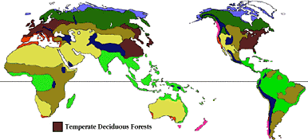

What Causes the Four Seasons?
The temperate deciduous forest has four changing seasons. These forests have hot summers and cold winters. As the seasons change, so do the colors of the leaves of the deciduous trees. Deciduous means that these plants lose their leaves every year and grow them back.
Reasons for Seasons
The four seasons happen because of the tilt of the Earth's axis. At different times of the year, the sun's rays hit different parts of the globe more directly. The angle of the Earth's axis tilts the Northern Hemisphere towards the sun during the summer.
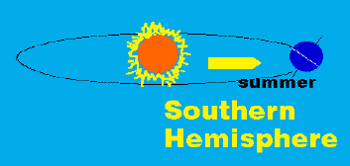
Without the tilt of the earth's axis, we wouldn't have seasons. Instead, the areas around the equator would receive the most sun and the northern and southern hemispheres would be stuck in a gradual gradient of hot to cold. The seasons would not change, it would be about the same temperature year round and there would be no seasons.
Is it true that the earth is closer to the sun in winter?
Because of its elliptical orbit, the earth is closer to the sun during the northern hemisphere's winter. However, distance from the sun does not affect the seasons. The tilt of the earth's axis causes the seasons to change.
What Color Are Leaves in The Fall?
Black walnut and butternut | Drop leaves before they turn
Locust | Stays green until leaves drop
Ash | Plum purple
Red maple, dogwood, sassafras, and scarlet oak | Dark red
Sugar maple and sumac | Flame red and orange
Oak, beech, larch, elm, hickory, and sycamore | Tan or brown
Poplar, birch, tulip tree, willow | Yellow
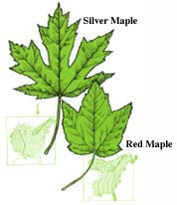
This mini-guide will help you identify particular trees by the shape of their leaves. All the leaves discussed are found on the North American continent. Remember, these are all deciduous trees, which means that their leaves change color and fall off in the winter. Even though the leaves are green, they'll be different colors in the fall. The tiny green maps of North America near each leaf tell you where you can find the particular trees.
The top leaf is from the Silver Maple, Acer saccharinum, which is usually found near the banks of ponds and lakes. It tolerates moderate shade from other trees around it. The other leaf is from the Red Maple, Acer rubrum, which is found on the prairie edge and northeast part of the U.S. and Canada. Its leaf surface is smooth and its leaf margin has irregularly sized teeth.
Leaf Identification / II
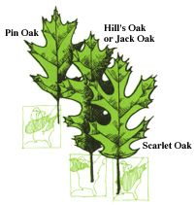
Oaks
To the left, you can see leaves from three different types of oak trees. The Pin Oak, Quercus palustris, is found in the northern part of the U.S. and southern Canada, in lowland areas with moderate shade. Its leaves are usually 3" to 4" with 5 lobes and a wedge-shaped base. The Jack Oak, Quercus ellipsoidalis, is found on higher ground and its lower branches are usually dead. It has dark green leaves and the tree has an overall untidy look. The Scarlet Oak, Quercus coccinea, grows in sandy or gravelly areas. Looking at its leaves you will find a thin, delicate blade with lobes that sometimes almost enclose oval spaces. The mid-rib of the leaf is yellow.
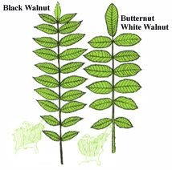
Walnuts
To the right you can see two leaves from walnut trees. Leaflets arranged along opposite sides of the stem like these are called pinnate compound leaves (for more information, see Leaf Terms). The Black Walnut, Juglans nigra, is found on high ground over a vast majority of the United States. It is somtimes missing the end leaflet, and all the side leaflets are attached to the stem at an angle. The Butternut White Walnut, Juglans cinerea, has an end leaflet, and its side leaflets are attached to the stem perpendicularly.

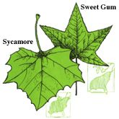
Sycamore and Sweet Gum
These two fairly common trees are easily identifiable by their leaf shapes. The Sycamore, Platanus occidentalis, is found almost everywhere in the deciduous forest areas of the United States. You can find them in cities, parks, and near the shores of small ponds and lakes. The Sweet Gum, Liquidambar Styraciflua, gets its name from the smell of its leaves. These leaves are star-shaped with 5 main lobes.
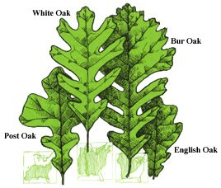
More Oaks
The last four leaves that we're going to look at are from four oak trees from around the country. The English Oak, Quercus Robur, has a small leaf that ranges from 2" to 4" with ear-like lobes. It has a very short stem. These trees got their name because colonists that settled in America during the 17th and 18th centuries brought them over from England. The Post Oak, Quercus stellata, is found on the edges of forests in the south and southeastern parts of the United States. You will usually find them in rocky or gravelly ground. It tolerates moderate shade. Notice that the three end lobes of its leaf are much larger than the other types of oak. An interesting characteristic of the Bur Oak, Quercus macrocarpa, is that the leaf is cut nearly to the midrib in the middle of the leaf. The upper-half of this leaf is not as deeply lobed as the bottom half, as seen in the illustration. The White Oak, Quercus alba, is also found throughout the deciduous forests of the United States.
Precipitation in the temperate deciduous forest falls throughout the year. However, during the winter months it is usually frozen and less is available for animals to drink. Animals living within this biome must adjust to cold winters and hot summers by hibernating, migrating, or keeping active all winter. Leaves fall off trees here in the fall, leaving animals with less cover to hide themselves from predators.
Black Bear
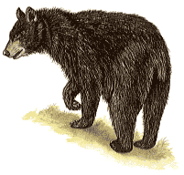
Class: Mammalia: Mammals | Diet: Fruit, nuts, roots, honey, insects, fish, small mammals
Order: Carnivora: Carnivores
Size: body: 1.5 - 1.8 m (5 - 6 ft), tail: 12 cm (4 3/4 in)
Family: Ursidae: Bears | Conservation Status: Non-threatened
Scientific Name: Ursus americanus | Habitat: wooded areas, swamps, national parks
Range: Alaska; Canada; USA: patchy distribution in New England through Pennsylvania to Tennessee, Florida to Louisiana, mountainous areas of the west; Northern Mexico
Black bears actually vary in color from glossy black to dark brown, reddish-brown or almost white. There is often a small white patch on the chest. Originally found throughout much of the USA, this bear now lives only in the wilder, uninhabited areas and in national parks, where it is thriving and on the increase. Occasionally seen in daytime, black bears are usually active at night, when they roam for long distances in search of food such as fruit, berries, nuts, roots and honey. They also feed on insects, rodents and other small mammals, stranded fish and even carrion and refuse. Their sense of smell is good, but their hearing and eyesight are only fair. In autumn, black bears gorge on the ample supplies of fruit to fatten themselves for their long sleep during the coldest weather. After mating, pairs separate, and except for females with cubs, black bears are usually solitary. A litter of 1 to 4 young is born in January or February after a gestation of about 7 months.
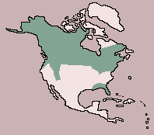

Gray Squirrel
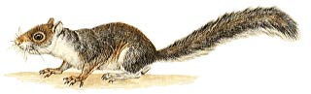
Class: Mammalia: Mammals | Diet: Seeds, nuts
Order: Rodentia: Rodents
Size: body:23 - 30 cm (9 - 11 3/4 in), tail: 21 - 23 cm (8 1/4 - 9 in)
Family: Sciuridae: Squirrels | Conservation Status: Non-threatened
Scientific Name: Sciurus carolinensis | Habitat: hardwood forest
Range: S.E. Canada, E. U.S.A.; introduced in Britain and South Africa
The gray squirrel's natural home is the oak, hickory and walnut forests of eastern North America, where its numbers are controlled by owls, foxes and bobcats. It feeds on seeds and nuts -- an adult squirrel takes about 80 g (2 3/4 oz) of shelled nuts each day -- and on eggs, young birds and insects. Occasionally gray squirrels strip the bark from young trees to gain access to the nutritious sap beneath. Two litters are produced each year, in early spring and summer. There are up to 7 young in a litter, but usually only 3 or 4 survive. Males are excluded from the nest and take no part in rearing the young. In the south of England, the introduced gray squirrel is ousting the native red squirrel.
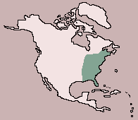

Wild Boar
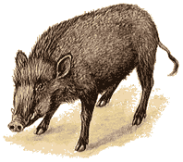
Class: Mammalia: Mammals | Diet: Roots & Tubers
Order: Artiodactyla: Even-toed Ungulates
Size: body: 1.1 - 1.3 m (3 1/2 - 4 1/2 ft), tail: 15 - 20 cm (6 - 7 3/4 in)
Family: Suidae: Pigs | Conservation Status: Non-threatened
Scientific Name: Sus scrofa | Habitat: forest, woodland
Range: Southern and central Europe, Northwestern Africa; through Asia to Siberia, south to Sri Lanka, Taiwan and Southeast Asia; introduced in USA
The ancestor of the domestic pig, the wild boar has a heavy body covered with dense, bristly hair, thin legs and a long snout. The male has prominent tusks derived from the canine teeth. Wild boars live alone or in small groups of up to 20, with males separate from, but remaining close to, the females. Active at night and in the morning, they forage over a wide area for food, digging for bulbs and tubers and also eating nuts and a variety of other plant material, as well as insect larvae and, occasionally, carrion.
An agile, fast-moving animal, the wild boar is aggressive if alarmed; males use their strong tusks for defense. The breeding season varies according to regional climate, but in Europe, wild boars mate in winter and give birth to a litter of up to 10 striped young in spring or early summer after a gestation of about 115 days.
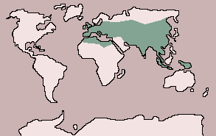

Turkey
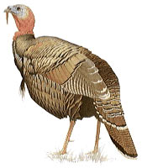
Class: Aves: Birds | Diet: Seeds, nuts, berries, insects
Order: Galliformes: Gamebirds
Size: body:91 - 122 cm (36 - 48 in)
Family: Meleagridinae: Turkeys | Conservation Status: Non-threatened
Scientific Name: Meleagris gallopavo | Habitat: wooded country
Range: U.S.A., Mexico
The wild turkey has a lighter, slimmer body and longer legs than the domesticated version. Turkeys are strong fliers over short distances. They roost in trees but find most of their food on the ground and eat plant matter, such as seeds, nuts and berries, as well as some insects and small reptiles. A breeding male has a harem of several females. Each female lays her eggs in a shallow, leaf-lined nest on the ground; sometimes two or more females use the same nest. The female incubates the clutch of 8 to 15 eggs for about 28 days and cares for the young. The sexes segregate after breeding.
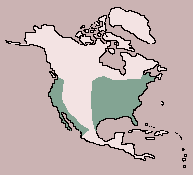

Rat Snake
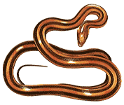
Class: Reptilia: Reptiles | Diet: Small mammals
Order: Squamata: Lizards and Snakes
Size: 86 cm - 2.5 m (33 3/4 in - 8 1/4 ft)
Family: Colubridae: Colubrine Snakes | Conservation Status: Non-threatened
Scientific Name: Elaphe obsoleta | Habitat: forest, swamps, farmland, wooded slopes
Range: Southern Canada; USA: Vermont to Minnesota, south to Texas and Florida; Northern Mexico
A large, powerful species, the rat snake tolerates a variety of habitats in wet and dry situations. There are 6 or more subspecies, which occur in one of three main color patterns: plain, blotched or striped. It is an agile snake, good at climbing, and hunts rodents and other small mammals, birds and lizards in trees and in barns or ruined buildings. Usually active during the day, it may tend to be nocturnal in summer. In much of its range, it hibernates throughout the winter. Rat snakes mate in spring and autumn. The female lays 5 to 30 eggs in leaf debris or under a rock or log. The eggs hatch in 2 to 4 months, depending on the temperature: the warmer the weather, the quicker they hatch.
