The Taiga biome stretches across a large portion of Canada, Europe and Asia. It is the largest biome in the world. Winters are cold. Summers are warm. Lots of conifers grow here.
Where is the Taiga Located?
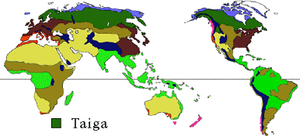
The taiga is the largest biome. The taiga is primarily a coniferous forest (evergreen trees with needles) like the temperate rainforest, but the taiga is located between 50 degrees latitude north and the Arctic Circle. Many coniferous trees (evergreens with needles) grow in the taiga. The taiga has fewer animal species than the tropical or temperate deciduous forests.
The taiga is very, very cold in the winter. But when the warm summer comes, the ice and snow melt. The sun shines for days in the summer, because the taiga is near the top of the world. Insects breed in the melting water. Birds come to the taiga to nest and lay their eggs in the spring and to eat the plentiful insects.
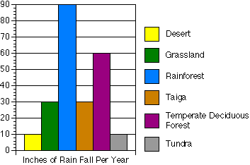
Taiga Facts
In the taiga, the average temperature is below freezing for six months of the year. Total yearly precipitation in the taiga is 12 - 33 inches (30 - 85 centimeters). Although the cold winters have some snowfall, most of the precipitation comes during the warm, humid summer months.
Taiga Temperatures
 | Low | High
Winter | -65 F (-54 C) | 30 F (-1 C)
Summer | 20 F (-7 C) | 70 F (21 C)
Because of the tilt of the earth on its axis, in the taiga you'll find long nights in the winter and long days in the summer.
During the summer months, the taiga fills up with millions of insects. Birds, who eat insects, migrate every year for the plentiful food supply.
The taiga is prone to wildfires. Many trees have adapted to this by growing thick bark, which can protect a tree from a mild fire.
Decomposition
Because of cool temperatures decomposition is slow in the taiga. Undecayed vegetation builds up on the forest floor, making it feel like a sponge. Since decomposition is slow, the soil is thin and lacking in nutrients. Trees grow taller where warmer temperatures allow for faster decomposition or by streams and rivers which carry nutrients from higher ground.

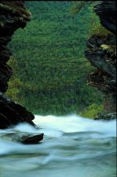
Taiga Plants
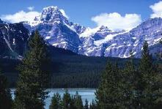
The taiga is large and seemingly homogeneous. Acres and acres of the exact same tree species are often the case. The lack of diversity is pretty amazing, especially when compared to other biomes such as the rainforest.
Yet within the endless sea of similar conifers, lies hearty trees that adapted to life in the harsh and frozen taiga. Very few species can survive, let alone thrive in such an environment. Learn more about these adaptations in the following pages.
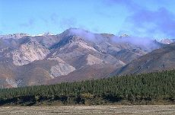
What Grows Here?
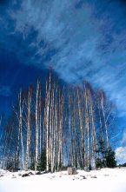
There is not much diversity in the taiga. Evergreen trees reign supreme -- miles upon miles of the exact same species are tree is often the case in the taiga. Most trees in this biome tend to grow in dense patches of one or a few species. Spruce, hemlock and fir are the primary trees of the taiga.
There are a few broad leaf trees in the taiga: birch, poplar, and aspen. These species lose their leaves in the fall. By shedding their leaves, these deciduous trees save energy during the winter months. But in the spring, these trees have to grow back new leaves.
In contrast, evergreen trees do not have to regrow leaves in the spring. However, they risk a chance of breakage from heavy snow falls.
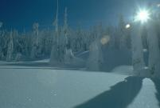
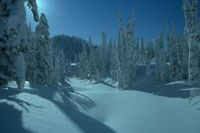
Life in the Taiga
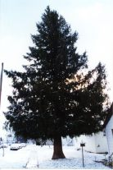
Life in the taiga is cold; really cold; and it snows.
Over many years, evergreen species have gained adaptations to improve their chances of surviving the taiga.
Trees in the temperate deciduous biome drop their leaves in the fall. That way they can survive a heavy snowstorm without risking their branches. Evergreen trees in the taiga keep their leaves, but their cone shape helps prevent damage. Branches droop downward, which helps shed excess snow. If the branches held more snow it would increase the chance of them breaking during a heavy storm. The needles help keep the trees warm during the winter.

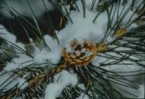
Conifers
Taiga trees tend to be conifers. Conifers, many of which are evergreen, produce cones in late winter or early fall. If a cone becomes fertilized, it grows bigger. Only then do the seeds inside develop. Once the seeds ripen, the cone dries up and the seed falls out.
It can take up to two years to produce a mature seed. Squirrels like to feed on these seeds.

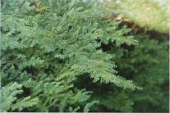
Needles
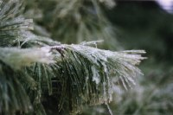
Needles on evergreen trees of the taiga are thin and wax-covered. They do not fall off in the fall.
Needles are leaves. Most taiga conifers, with the exception of the tamarack and a few other species, keep their leaves in the winter. Most conifers keep their leaves for 2 - 3 years. A spruce can keep its needles for 15 years! Conifers lose their leaves a few at a time, so the change is not always noticeable.
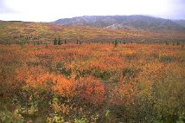
Needles are adapted to the taiga environment. Needles lose less water and shed snow more easily than broad leaves.
Fall in the Taiga

In the temperate deciduous forest most leaves fall off in autumn. In the taiga, the change is much more subtle. Leaves slow down the chemical process for winter.
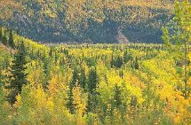
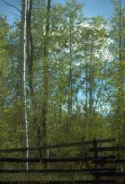
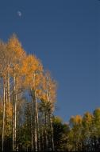
The tamarack's leaves turn brown and drop. It is one of only a handful of evergreen species that drop their leaves for the fall. The leaves of many shrubs turn deep red. Aspen and birch, deciduous trees, have leaves that turn golden before falling for the winter. All in all, the taiga fall show is less dramatic than the temperate deciduous show.
Taiga Animals
Life in the taiga can be cold and dreary. Snow, cold, and a scarcity of food makes life very difficult, especially in the winter. Some taiga animals migrate south, others go into hibernation, while others simply cope with the environment.
Class: Aves: Birds | Diet: Small mammals
Order: Strigiformes: Owls
Size: 36 - 43 cm (14 1/4 - 17 in)
Family: Strigidae: Owls | Conservation Status: Non-threatened
Scientific Name: Surnia ulula | Habitat: open areas in coniferous forest
Range: Canada, extreme Northern USA, Northern Asia, Scandinavia
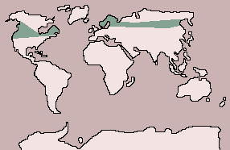
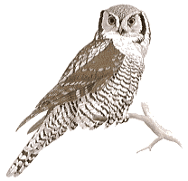
Hawk Owl
The hawk owl is easily recognized by its tail, which is longer than usual for owls, and by its pale facial disk, bordered with black. Its wings are fairly short and pointed, giving it a hawklike appearance in flight. It hunts by day, watching from a perch in the trees then flying down after prey. It feeds on mice, lemmings, squirrels and other small mammals, as well as on birds and some insects. Nesting takes place from April to June, depending on the area, and the clutch size varies annually according to the food supply. The female lays her eggs, usually 5 or 6 but sometimes up to 9, in the hollow top of a tree stump or in an abandoned nest or woodpecker hole. The eggs are incubated for 25 to 30 days, mostly by the female.

Class: Mammalia: Mammals | Diet: Conifer cones, fungi, fruit
Order: Rodentia: Rodents
Size: body: 20 - 24 cm (7 3/4 - 9 1/2 in), tail: 15 - 20 cm (6 - 7 3/4 in)
Family: Sciuridae: Squirrels | Conservation Status: Near threatened
Scientific Name: Sciurus vulgaris | Habitat: evergreen forest
Range: Europe, east to China, Korea and Japan: Hokkaido
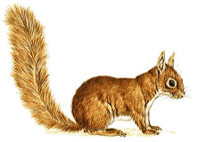
European Red Squirrel
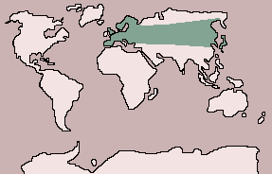
Until the arrival of the North American gray squirrel in Britain at the beginning of this century, the only European species was the red squirrel. Populations are now declining in Britain, but red squirrels are still abundant in Europe and Asia. Conifer cones are their main food, although in summer they also eat fungi and fruit. The length of the breeding season is dictated by local climate: in a good year a female may produce two litters of about 3 young each. The young are born in a tree nest, called a drey, which also doubles as winter quarters.

Class: Mammalia: Mammals | Diet: small-medium mammals, ground-dwelling birds
Order: Carnivora: Carnivores
Size: body: 80 cm - 1.3 m (31 1/2 in - 4 1/4 ft), tail: 4 - 8 cm (1 1/2 - 3 in)
Family: Felidae: Cats | Conservation Status: Non-threatened
Scientific Name: Felis lynx | Habitat: coniferous forest, scrub
Range: Europe: Scandinavia to Spain and Portugal, east through Asia to Siberia; Alaska, Canada, Northern USA
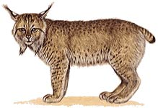
Lynx
The lynx is recognized by its short tail and its tufted ears and cheeks. Its coat varies in coloration over its wide range, particularly in the degree of spotting, which may be faint or conspicuous. Although strictly protected in most countries, lynx are becoming scarce, and some races are in danger of extinction. A solitary, nocturnal animal, the lynx stalks its prey on the ground or lies in wait for it in low vegetation. Hares, rodents, young deer and ground-living birds, such as grouse, are its main prey. Breeding normally starts in the spring, and a litter of 2 or 3 young is born in a den among rocks or in a hollow tree after a gestation of about 63 days. The cubs remain with their mother throughout their first winter.

Class: Mammalia: Mammals | Diet: Plants
Order: Rodentia: Rodents
Size: 73 cm - 1.3 m (28 3/4 in - 4 1/4 ft), tail: 21 - 30 cm (8 1/4 - 11 3/4 in)
Family: Castoridae: Beavers | Conservation Status: Near threatened
Scientific Name: Castor fiber | Habitat: rivers, lakes, with wooded banks
Range: Now only in parts of Scandinavia, Poland, France, Southern Germany, Austria and Russia
Eurasian Beaver
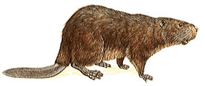
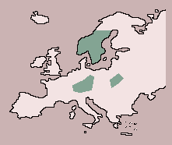
The largest European rodent, the Eurasian beaver has the same habits and much the same appearance as the American beaver, and they are considered by some experts to be only one species. Like its American counterpart, this beaver builds complex dams and lodges but, where conditions are right, may simply dig a burrow in the riverbank which it enters underwater. It feeds on bark and twigs in the winter and on all kinds of vegetation in summer. Beavers are monogamous animals, and females are believed to mate for life: the male may mate with females other than his partner. Pairs produce litters of up to 8, usually 2 to 4, young in the spring.

Class: Mammalia: Mammals | Diet: Small mammals
Order: Carnivora: Carnivores
Size: body: 35.5 - 43 cm (14 - 17 in), tail: 18 - 23 cm (7 - 9 in)
Family: Mustelidae: Mustelids | Conservation Status: Non-threatened
Scientific Name: Martes americana | Habitat: forest, woodland
Range: Canada, Northern USA
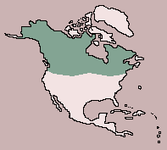
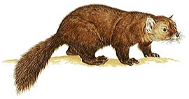
Marten
An agile, acrobatic creature with a bushy tail, the marten spends much of its time in trees, where it preys on squirrels. It also hunts on the ground and eats small animals and insects, fruit and nuts. Martens den in hollow trees and produce a yearly litter of 2 to 4 young, usually in April. The young are blind and helpless at birth; their eyes open at 6 weeks, and they attain adult weight at about 3 months. The closely related fisher, M. pennanti, is one of the few creatures that preys on American porcupines.

Wolverine
Class: Mammalia: Mammals | Diet: Mammals, small
Order: Carnivora: Carnivores
Size: body: 65 - 87 cm (25 1/2 - 34 1/4 in), tail: 17 - 26 cm (6 1/2 - 10 in)
Family: Mustelidae: Mustelids | Conservation Status: Vulnerable
Scientific Name: Gulo gulo | Habitat: coniferous forest, tundra
Range: Scandinavia, Siberia, Alaska, Canada, Northern U.S.A.

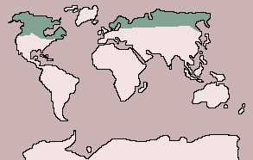
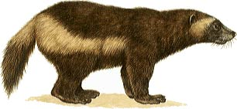
The single species of wolverine is a heavily built animal, immensely strong for its size and capable of killing animals larger than itself. Although largely carnivorous, wolverines also feed on berries. They are solitary animals, mainly ground-dwelling, but they can climb trees. Each male holds a large territory with 2 or 3 females and mates in the summer. The female wolverine bears 2 or 3 young in the following spring, usually after a period of delayed implantation. Delayed implantation is an interesting phenomenon allowing animals to mate at the ideal time and bear young at the ideal time, even though the intervening period is longer than their actual gestation. The fertilized egg remains in a suspended state in the womb, and development starts only after the required period of dormancy. The young suckle for about 2 months and remain with their mother for up to 2 years, at which time they are driven out of her territory. They become sexually mature at about 4 years of age.

