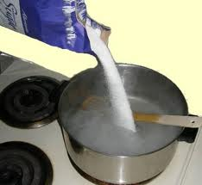
- ______________ is a__________ property that measures the __________ of a substance to _______________.
  - It can be used to help identify a substance.

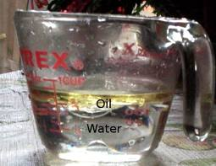
- ______________: When one substance _______ __________ into ___________ substance.
  - For example ______ is insoluble in _________.

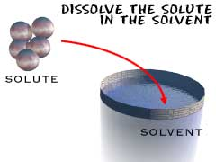
- ____________: A ___________ that forms when _______ substance ___________ another.
  - A ___________ has the _______ properties throughout.
  - Contains a ___________ and at least one _________
- ____________: A substance that ________ _________ substance
  - Typically a ___________
  - Present in the _________ amount in a solution.
  - Example: ________ dissolves salt.
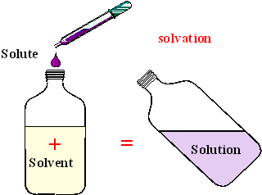
- ___________: The part of a solution present in the _____________ amount
  - Can be a ________, _________ or _________.
  - The ________ is _________ by the __________.
  - Example: _______ is dissolved by water.

