Name ______________________________ Date _______________
Textbook Guide: Rotation, Revolution & Seasons

Use the following guide to complete the textbook reading.
D= Discuss with your group or partner Map= Complete a semantic map to represent
WR= Write a Response w/ the information Skim= Read quickly; discuss if needed
PP= Predict with partner or group

1. Skim- (p.224-231) with your partner, list all the headings and sub-headings found on these pages. (Hint= headings in red; subheadings in blue)
________________________________________________________________________________________________________________________________________________________________________________________________________________________________________________________________________________________________________________________________________________________________________________________________________________________________________________________________________________________________

2. WR, Map – (p225) Define rotation and revolution. Make sure to include a picture!
Rotation | Revolution

2. D, WR-(p. 225) - Why does the earth have day and night?
________________________________________________________________________________________________________________________________________________________________________________________________________________________________________________________________________________________________________________________________

3. D, WR – (p. 225-229) - Why does the Earth have seasons?
________________________________________________________________________________________________________________________________________________________________________________________________________________________________________________________________________________________________________________________________________________________________________________________________________________________________________________________________________________________________

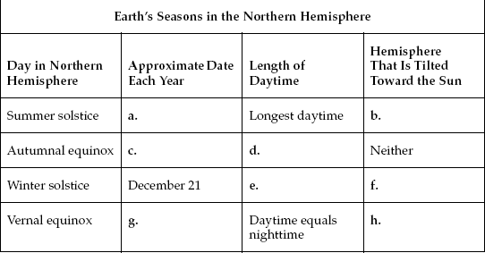
4. WR - (p. 230-231) Fill in the chart.

Textbook Guide: Phases, Eclipses, & Tides

5. Skim, PP- (p.238-245) with your partner, list all the headings and sub-headings found on these pages. (Hint= headings in red; subheadings in blue). Predict why we always see the same side of the moon.
________________________________________________________________________________________________________________________________________________________________________________________________________________________________________________________________________________________________________________________________________________________________________________________________________________________________________________________________________________________________

6. D, WR – (p. 238) How long does it take for the moon to rotate once on its axis? How long does it take to revolve once around the Earth?

Rotate = ___________________ Revolve =____________________

7. D, WR – (p. 238) Why do we always see the same side of the moon?
________________________________________________________________________________________________________________________________________________________________________________________________________________________________________________

8. Map, (p. 240-241) – Fill in the chart.
Phases of the Moon
Phase | What you see | Drawing
New Moon
Waxing Cresent
First Quarter
Waxing Gibbous
Full Moon
Waning Gibbous
Third Quarter
Waning Cresent

9. D, WR – (240-241) – Explain the difference between a “waxing” moon and a “waning” moon.
________________________________________________________________________________________________________________________________________________________________________________________________________________________________________________________________________

10. Map – (p242-243) - Define solar eclipse and lunar eclipse. Make sure to include a picture that includes the Earth, moon and Sun!
Solar Eclipse | Lunar Eclipse

11. PP – what is the main cause of tides on Earth? ______________________________________________ ________________________________________________________________________________________________________________________________________________________________________________
12. D, WR (p. 244) Explain why there are two high tides and two low tides.
________________________________________________________________________________________________________________________________________________________________________________________________________________________________________________________________________________________________________________________________
13. Map (p. 244) Draw the diagram of figure 16 below, label the earth, the moon, and the four tide points. Explain, in your own words, what is occurring in this diagram.

