Name ______________________________ Date _______________
Rotation, Revolution & Seasons
Directions: Use any reliable and academic source (.edu/.org websites ONLY) to answer these questions. You will need a source reference for each answer (i.e stardate.org/nightsky/moon).

- Define rotation and revolution. Make sure to include a picture!

Rotation | Revolution
Picture | Picture

Reference: _______________________________________________________________________

2. Why does the earth have day and night?
________________________________________________________________________________________________________________________________________________________________________________________________________________________________________________________________________________________________________________________________

Reference: _______________________________________________________________________

3. Why does the Earth have seasons?
________________________________________________________________________________________________________________________________________________________________________________________________________________________________________________________________________________________________________________________________________________________________________________________________________________________________________________________________________________________________

Reference: _______________________________________________________________________

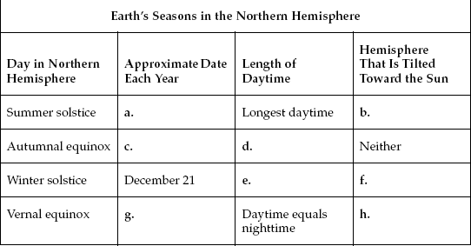
4. Fill in the chart.

Reference: ________________________

Phases, Eclipses, & Tides
- How long does it take for the moon to rotate once on its axis? How long does it take to revolve once around the Earth?

Rotate = ___________________ Revolve =____________________

Reference: _______________________________________________________________________

- Why do we always see the same side of the moon?
________________________________________________________________________________________________________________________________________________________________________________________________________________________________________________
Reference: _______________________________________________________________________

- Fill in the chart. Reference: ______________________________________________________

Phases of the Moon
Phase | What you see | Drawing
New Moon
Waxing Cresent
First Quarter
Waxing Gibbous
Full Moon
Waning Gibbous
Third Quarter
Waning Cresent
- Explain the difference between a “waxing” moon and a “waning” moon.
________________________________________________________________________________________________________________________________________________________________________________________________________________________________________________________________________
Reference: _______________________________________________________________________

- Define solar eclipse and lunar eclipse. Make sure to include a picture that includes the Earth, moon and Sun!
Solar Eclipse | Lunar Eclipse

Reference: _______________________________________________________________________

10. What is the main cause of tides on Earth? ___________________________________________________ ________________________________________________________________________________________________________________________________________________________________________________
Reference: _______________________________________________________________________

- Explain why there are two high tides and two low tides.
________________________________________________________________________________________________________________________________________________________________________________________________________________________________________________________________________________________________________________________________
Reference: _______________________________________________________________________

- Looking at the diagram below, label the earth, the moon, and the four tide points (high tide vs. low tide). Explain, in your own words, what is occurring in this diagram.

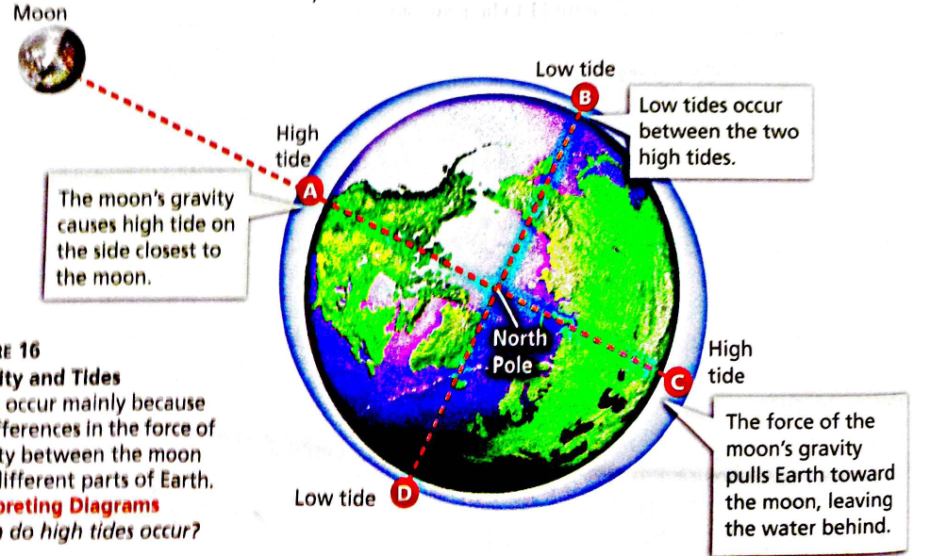

Reference: _______________________________________________________________________

