[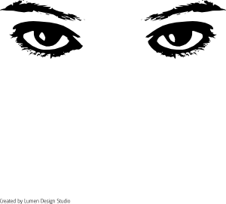](http://www.clker.com/clipart-2412.html)…

Allows you to _________________

See light when a _________ occurs that involves _____________ ____________

Enters eye through **_________________**

* + _____________________; _______________
  + Acts as a ________________________

After passing through cornea, light enters the **________________**

* + __________________________________
    - Appears ________ to let more light in
    - Appears ________ to let less light in

**____________** is a ___________ that __________ & ____________ to change size of pupil

_ controls how much light ________________

* + _________________

After entering pupil, ______________________________

* + _____________________ that refracts light to form image on lining of your eyeball
  + ________________ hold lens ________ behind pupil
    - When focus on distant object, ____________ and lens becomes __________________
    - When focus on nearby object, _____________ and lens becomes ___________________

When cornea & lens ___________, an _____________ forms on **____________** = ___________________________ ________________________________________________

* + Made up of tiny, _______________ called rods & cones
    - **________** – cells that contain a __________ that responds to _________amounts of light
      * All to see dim light (______________________)
    - **___________** – cells that respond to __________
      * May detect red, green or blue light
      * Respond best in _______________
    - Rods & cones help _________________ into signals that travel to brain

Rods & Cones ____________________ along short, thick nerve called the **_________________**

* + Begins at ____________ (area of retina that has ___________________________)
  + Brain ______________ signals as an ___________ image
  + Combines images from _________ into a __________ ____________________________________________

[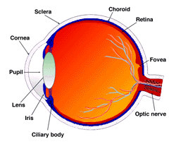](http://webvision.med.utah.edu/imageswv/sagitta2.jpeg)

[](http://webvision.med.utah.edu/imageswv/sagitta2.jpeg)

**Refraction of Light**

* **When light rays ______________ at an angle, the change in __________ causes the rays to *__________*, or change _______________**
* Some mediums cause light to bend _________________________
* A material’s **____________________** is a ____________ of how much a ray of light _________when it enters that material
  + ________ the index the more it _____

