Name:____________________________ Period:_____ Date:_______________

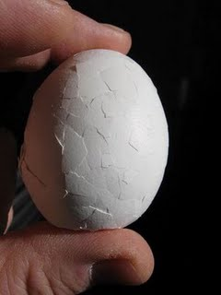

_______________________ is **NOT** ________________

It is like _________________________________

* Broken _________________________________________

separated ______________________________________

________________ or _________________plates are segments of the Earth's _________ that move relative to _______________. These plates are characterized by ______________ and ______________seismic activity around the ___________.

The ___________ is broken into separate sections called **____________** that move over the _______________ carrying pieces of ______________and ___________ crust.

HOW PLATES MOVE

The theory of _________________________________ states: ___________________

_____________________________________________________________________

* j0078622This explains the _____________________, ______________________ & ___________________________ of Earth’s plates

How can Earth’s plates move? What force is great enough to move the heavy continents?

j0082283

**By Geologists…I think you’ve got it!**

The movement_______________________________________________________

_______________________________________________

* + As plates moves, ________________, ______________, or ______________________
    - This creates ___________________________________ (volcanoes, mountain ranges, trenches)

Plate Boundaries

* ____________________________ meet at **_________________________** 
  + Extend deep ______________________________
* **__________________** – are ____________________________ where rocks have _______________________________________________________
* 3 kinds of _______________________________
  1. ___________________________
  2. ___________________________
  3. ___________________________
* A different type of movement occurs ___________________________________
* Plates move _______________; from ________________ (about as fast as your fingernails grow)