Nature of Earthquakes (Class Set DO NOT MARK)

Introduction
An earthquake is sudden ground movement caused by the sudden release of the energy stored in rocks. An earthquake happens when so much stress builds up in the rocks that the rocks break. An earthquake’s energy is transmitted by seismic waves. Each year, there are more than 150,000 earthquakes strong enough to be felt by people. An amazing 900,000 are recorded by seismometers.

Causes of Earthquakes
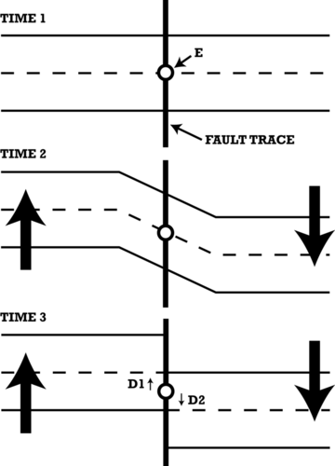
Almost all earthquakes occur all types of plate boundaries. Convection within the Earth causes the plates to move. As the plates move, stresses build. When the stresses build too much, the rocks break. The break releases the energy that was stored in the rocks. The sudden release of energy creates an earthquake. During an earthquake the rocks usually move several centimeters or rarely as much as a few meters. Elastic rebound theory describes how earthquakes occur (Figure below).

Elastic rebound theory. Stresses build on both sides of a fault. The rocks deform plastically as seen in Time 2. When the stresses become too great, the rocks return to their original shape. To do this, the rocks move, as seen in Time 3. This movement releases energy, creating an earthquake.

Earthquake Focus and Epicenter
Where an earthquake takes place is described by its focus and epicenter.
Focus
The focus is the point below the earth’s surface where the rock breaks. A shallow earthquake has a focus less than 70 kilometers (45 miles). An intermediate-focus earthquake has a focus between 70 and 300 kilometers (45 to 200 miles). A deep-focus earthquake is greater than 300 kilometers (200 miles). About 75% of earthquakes have a focus in the top 10 to 15 kilometers (6 to 9 miles) of the crust. Shallow earthquakes that happen near the earth’s surface cause the most damage. This is because the focus is near the Earth's surface, where people live.

Epicenter
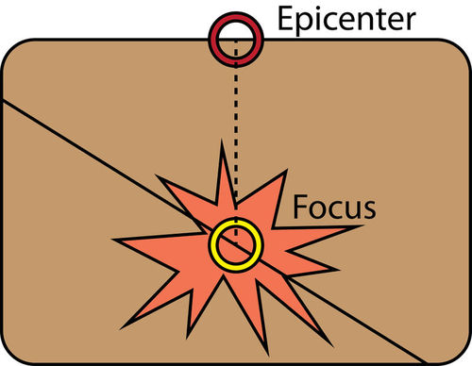
The epicenter is the area just above the focus, on the land’s surface. (Figure below). The towns or cities near the epicenter will be strongly affected by the earthquake.

The focus of an earthquake is in the ground where the ground breaks. The epicenter is the point at the surface just above the focus.

Earthquake Zones
Nearly 95% of all earthquakes take place along one of the three types of plate boundaries. As you learned in the Plate Tectonics chapter, scientists use the location of earthquakes to draw plate boundaries.
The Ring of Fire is a region of the Pacific that has lots of volcanoes.. This is due to the volcanoes that line the region. The Ring of Fire has the most earthquakes. About 80% of all earthquakes strike this area. The Pacific Ring of Fire is caused by the convergent and transform plate boundaries that line the Pacific Ocean basin.
About 15% of all earthquakes take place in the Mediterranean-Asiatic belt. The convergent plate boundaries in the region are shrinking the Mediterranean Sea. The convergence is also causing the Himalayas to grow. The remaining 5% of earthquakes are scattered around the other plate boundaries. A few earthquakes take place in the middle of a plate, away from plate boundaries.
Transform Plate Boundaries
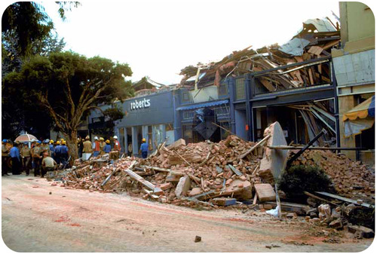
Transform plate boundaries produce large earthquakes. These quakes at transform faults have shallow focus. This is because the plates slide past each other without moving up or down. The largest earthquake on the San Andreas Fault occurred in 1906 in San Francisco. Other significant earthquakes in California include the 1989 Loma Prieta earthquake near Santa Cruz (Figure below) and the 1994 Northridge earthquake near Los Angeles.
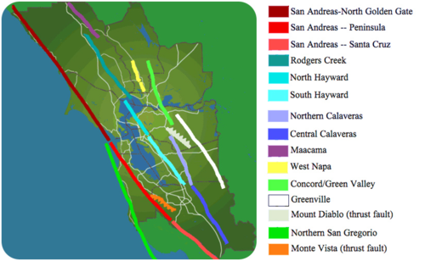
Three people died in this mall in Santa Cruz during the 1989 Loma Prieta earthquake.

There are many other faults spreading off the San Andreas, which produce around 10,000 earthquakes a year (Figure below). While most of those earthquakes cannot even be felt by people nearby, occasionally one is very strong.
The San Andreas Fault runs through the San Francisco Bay Area. Other related faults cross the region. Lines indicate strike slip faults. Lines with hatches are thrust faults.
Subduction Zones
Convergent plate boundaries also large earthquakes. Earthquakes mark the motions of colliding plates and the locations where plates plunge into the mantle. These earthquakes can be shallow, intermediate or deep focus.

The Philippine plate and the Pacific plate subduct beneath Japan, creating as many as 1,500 earthquakes every year. In March 2011, the 9.0 magnitude Tōhoku earthquake struck off of northeastern Japan. Damage from the quake was severe. More severe was the damage from the tsunami generated by the quake (Figure below). In all, 25,000 people were known dead or missing.
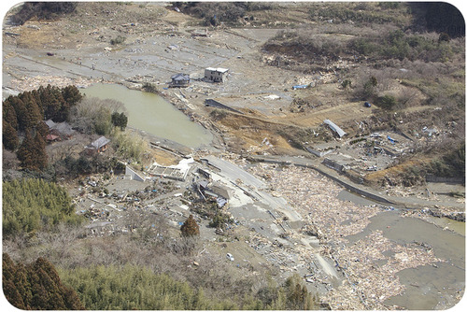
The damage in Minato, Japan after a 9.0 magnitude earthquake and the massive tsunami it generated struck in March, 2011.
The Cascades Volcanoes line the Pacific Northwest of the United States. Here, the Juan de Fuca plate subducts beneath the North American plate. The Cascades volcanoes are active and include Mount Saint Helens. Major earthquakes occur here approximately every 300 to 600 years. The last was in 1700. Its magnitude was between 8.7 and 9.2. It has now been more than 300 years since that earthquake. The next massive earthquake could strike the Pacific Northwest at any time.
Continent-Continent Collisions
The collision of two continents also creates massive earthquakes. Many earthquakes happen in the region in and around the Himalayan Mountains. The 2001 Gujarat, India earthquake is responsible for about 20,000 deaths, with many more people injured or made homeless.
Divergent Plate Boundaries
Earthquakes also occur at divergent plate boundaries. Divergent plate boundaries usually have small earthquakes. At mid-ocean ridges, these earthquakes tend to be small and shallow focus because the plates are thin, young, and hot. Earthquakes in the oceans are usually far from land, so they have little effect on peoples’ lives. On land, where continents are rifting apart, earthquakes are larger and stronger.
Intraplate Earthquakes
About 5% of earthquakes take place within a plate, away from plate boundaries. These intraplate earthquakes are caused by stresses within a plate. The plate moves over a spherical surface, creating zones of weakness. Intraplate earthquakes happen along these zones of weakness.
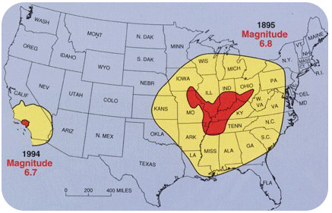
A large intraplate earthquake occurred in 1812. A magnitude 7.5 earthquake struck near New Madrid, Missouri. This is a region not usually known for earthquakes. Because very few people lived here at the time, only 20 people died. The New Madrid Seismic Zone continues to be active (Figure below). Many more people live here today.

The range of damage in the 1895 New Madrid earthquake and the 1994 Los Angeles earthquake. New Madrid activity affected a much larger area.

Seismic Waves
Seismic waves are the energy from earthquakes. Seismic waves move outward in all directions away from their source. Each type of seismic wave travels at different speeds in different materials. All seismic waves travel through rock, but not all travel through liquid or gas. Geologists study seismic waves to learn about earthquakes and the Earth’s interior.
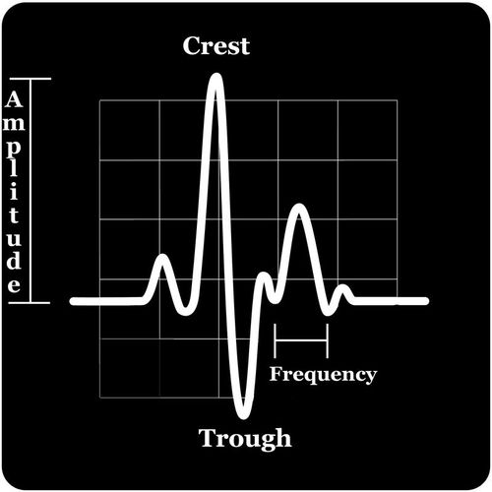
Wave Structure
Seismic waves are just one type of wave. Sound and light also travel in waves. Every wave has a high point called a crest and a low point called a trough. The height of a wave from the center line to its crest is its amplitude. The horizontal distance between waves from crest to crest (or trough to trough) is its wavelength (Figure below).

The energy from earthquakes travels in waves, such as the one shown in this diagram.
Types of Seismic Waves
There are two major types of seismic waves: Body waves and Surface Waves. Body waves travel through the Earth’s interior. Surface waves travel along the ground surface. In an earthquake, body waves are responsible for sharp jolts. Surface waves are responsible for rolling motions that do most of the damage in an earthquake.

Body Waves
The 2 types of body waves are Primary waves (P-waves) and secondary waves (S-waves) (Figure below). Body waves move at different speeds through different materials.
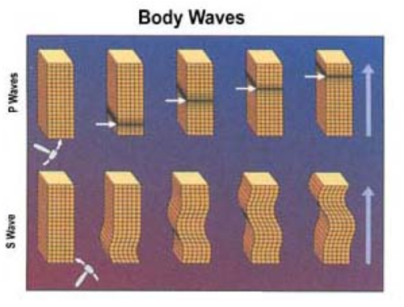
P-waves are faster. They travel at about 6 to 7 kilometers (about 4 miles) per second. Primary waves are so named because they are the first waves to reach a seismometer. P-waves squeeze and release rocks as they travel. The material returns to its original size and shape after the P-wave goes by. For this reason, P-waves are not the most damaging earthquake waves. P-waves travel through solids, liquids and gases.
S-waves are slower than P-waves. They are the second waves to reach a seismometer. S-waves move up and down. They change the rock’s shape as they travel. S-waves are about half as fast as P-waves, at about 3.5 km (2 miles) per second. S-waves can only move through solids. This is because liquids and gases don’t resist changing shape. S-waves do the most damage
during earthquakes. P-waves and S-waves are the two types of body waves.
Surface Waves
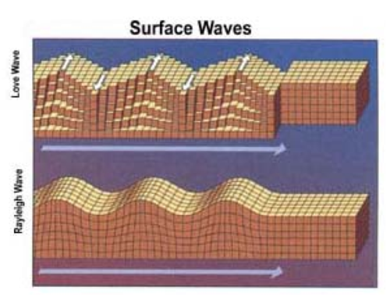
Love waves and Rayleigh waves are the two types of surface waves.
Surface waves travel along the ground outward from an earthquake’s epicenter. Surface waves are the slowest of all seismic waves. They travel at 2.5 km (1.5 miles) per second. There are two types of surface waves. Love waves move side-to-side, much like a snake. Rayleigh waves produce a rolling motion as they move up and backwards (Figure above). Surface waves cause objects to fall and rise, while they are also swaying back and forth. These motions cause damage to rigid structures during an earthquake.

Tsunami
Earthquakes can cause tsunami. These deadly ocean waves may result from any shock to ocean water. A shock could be a meteorite impact, landslide, or a nuclear explosion.
An underwater earthquake creates a tsunami this way: The movement of the crust displaces water. The displacement forms a set of waves. The waves travel at jet speed through the ocean. Since the waves have low amplitudes and long wavelengths, they are unnoticed in deep water. As the waves reach shore they compress. They are also pushed upward by the shore. For these reasons, tsunami can grow to enormous wave heights. Tsunami waves can cause tremendous destruction and loss of life. Fortunately, few undersea earthquakes generate tsunami.

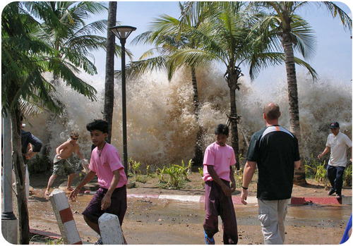
The Boxing Day Tsunami, 2004
The Boxing Day Tsunami struck on December 26, 2004. This tsunami was by far the deadliest of all time (Figure below). The tsunami was caused by the second largest earthquake ever recorded. The Indian Ocean Earthquake registered magnitude 9.1. The quake struck near Sumatra, Indonesia, where the Indian plate is subducting beneath the Burma plate. It released about 550 million times the energy of the atomic bomb dropped on Hiroshima.
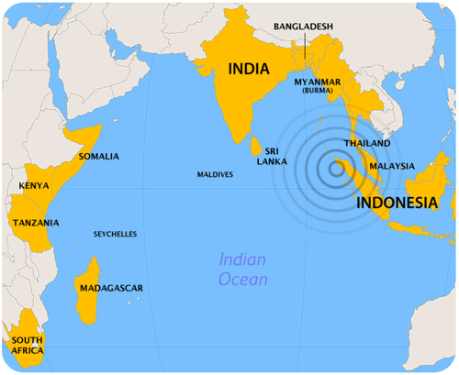
This dramatic image shows the Boxing Day Tsunami of 2004 coming ashore.
Several tsunami waves were created. The tsunami struck eight countries around the Indian Ocean (Figure below).
This map shows the countries struck by the Boxing Day tsunami.
About 230,000 people died. More than 1.2 million people lost their homes. Many more lost their way of making a living. Fishermen lost their boats, and businesspeople lost their restaurants and shops. Many marine animals washed onshore, including dolphins, turtles, and sharks.
Tilly Smith, Hero
Like other waves, a tsunami wave has a crest and a trough. When the wave hits the beach, the crest or the trough may come ashore first. When the trough comes in first, water is sucked out to sea. The seafloor just offshore from the beach is exposed. Curious people often walk out onto the beach to see the unusual sight. They drown when the wave crest hits.
One amazing story from the Indian Ocean tsunami is that of Tilly Smith. Tilly was a 10-year-old British girl who was visiting Maikhao Beach in Thailand with her parents. Tilly had learned about tsunami in school two weeks before the earthquake. She knew that the receding water and the frothy bubbles at the sea surface meant a tsunami was coming. Tilly told her parents, who told other tourists and the staff at their hotel. The beach was evacuated and no one on Maikhao Beach died. Tilly is credited with saving nearly 100 people!
Tsunami Warning Systems
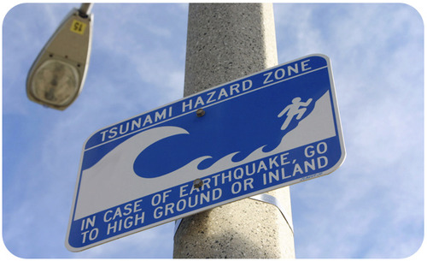
Most of the Indian Ocean tragedy could have been avoided if a warning system had been in place (Figure below). As of June 2006, the Indian Ocean now has a warning system. Since tsunamis are much more common in the Pacific, communities around the Pacific have had a tsunami warning system since 1948.
This sign is part of the tsunami warning system used in communities around the Pacific Ocean since 1948.
Warning systems aren’t always helpful. People in communities very close to the earthquake do not have enough time to move inland or uphill. Farther away from the quake, evacuation of low-lying areas saves lives.

