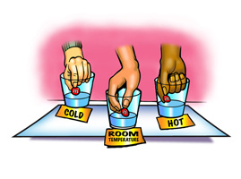

Problem: Does the temperature of the water affect how fast the colored coating dissolves from an M&M?
Materials: Each group will have…
3 same color M&M’s | Hot Water | Cold Water | Room Temp Water
3 White Plastic or foam dessert plates | Crayons/colored pencils | Paper towels
Day 1
- Restate the title on your lab report.

- Restate the problem on your lab report.
- Record the materials you will use in your lab report. Hint – look above ;-)

- Record any background information and/or prior knowledge that may be beneficial for the completion of this lab on the lab report.

- Talk with your group about how you might design an experiment to investigate the problem. Think about the materials that you will be provided. These are the ONLY materials available. Think about the different variables that need to remain constant. What variable needs to change? What should your procedure include?

- On your lab report, make sure to label your independent variable, dependent variable and control variables.

- Based off of the problem, write a hypothesis. Record this on your lab report.

- On your lab report, create a step-by-step procedure that explains how to complete your experiment. Remember, another student should be able to take your procedure and successfully complete this experiment.

- Draw a data table on your lab report that effectively shows how you will collect your data. When performing your experiment you will write your data/observations in this table. Make sure this table can easily be read and understood by your classmates.
Day 2

- Perform the experiment.

- Write a 5-7 sentence conclusion. In your conclusion, be sure to discuss your hypothesis and data. Did your results support your hypothesis? Why do you think your data turned out as it did? Based off of your data, what can you infer about the relationship between temperature and dissolving?

