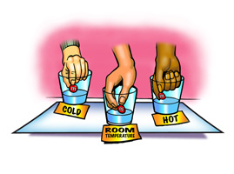

Problem: Does the temperature of the water affect how fast the colored coating dissolves from an M&M?
Materials: Each group will have…
3 same color M&M’s | Hot Water | Cold Water | Room Temp Water
3 Plastic or foam dessert plates | Crayons/colored pencils | Paper towels

Procedure:
- Identify the independent variable and dependent variable.
  - Independent Variable: ______________________________

  - Dependent Variable: _______________________________

- Based off of the problem, write a hypothesis.
  - HYPOTHESIS: If_____________________________________________________________________
then__________________________________________________________________

- Retrieve 3 cups of water from the teacher (cold, room temp, hot).

- Pour cold, room-temperature, and hot water into their labeled plates so that the water covers the bottom of the entire plate.

- Place a same colored M&M in the center of each plate.

- Observe the plate/M&M for 1 minute.

- As you observe the plate/M&M, record your observations in the chart below. Include a description of what is occurring along with drawings.

DATA TABLE
Cold Water | Room Temp. Water | Hot Water
OBSERVATIONS: | OBSERVATIONS: | OBSERVATIONS:

- Write a 5-7 sentence conclusion. In your conclusion, be sure to
  - Discuss your hypothesis and data.
  - Did your results support your hypothesis?
  - Why do you think your data turned out as it did?
  - Based off of your data, what can you infer about the relationship between temperature and dissolving?

