Measuring Waves
Lesson Objectives  • Define wave amplitude and wavelength.  • Relate wave speed to wave frequency and wavelength. | Lesson Vocabulary  • hertz (Hz)  • wave amplitude  • wave frequency  • wavelength  • wave speed

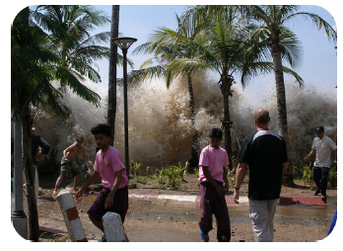
Introduction
Tsunamis, or the waves caused by earthquakes, are unusually large ocean waves. You can see an example of a tsunami in Figure 1.10. Because tsunamis are so big, they can cause incredible destruction and loss of life. The tsunami in the figure crashed into Thailand, sending people close to shore running for their lives. The height of a tsunami or other wave is just one way of measuring its size. You’ll learn about this and other ways of measuring waves in this lesson.
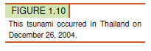
Wave Amplitude and Wavelength
The height of a wave is its amplitude. Another measure of wave size is wavelength. Both wave amplitude and wavelength are described in detail below. Figure 1.11 shows these wave measures for both transverse and longitudinal waves.
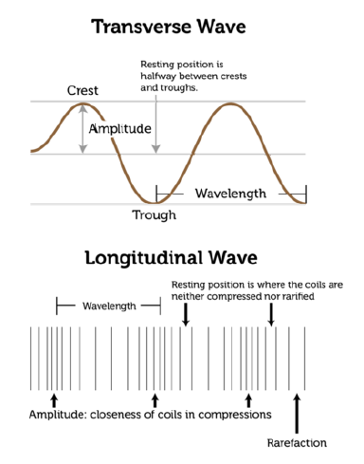
Wave Amplitude
Wave amplitude is the maximum distance the particles of a medium move from their resting position when a wave passes through. The resting position is where the particles would be in the absence of a wave.

In a transverse wave, wave amplitude is the height of each crest above the resting position. The higher the crests are, the greater the amplitude.

In a longitudinal wave, amplitude is a measure of how compressed particles of the medium become when the wave passes through. The closer together the particles are, the greater the amplitude.

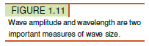
What determines a wave’s amplitude? It depends on the energy of the disturbance that causes the wave. A wave caused by a disturbance with more energy has greater amplitude. Imagine dropping a small pebble into a pond of still water. Tiny ripples will move out from the disturbance in concentric circles, like those in Figure 1.1. The ripples are low-amplitude waves. Now imagine throwing a big boulder into the pond. Very large waves will be generated by the disturbance. These waves are high-amplitude waves.

Wavelength
Another important measure of wave size is wavelength. Wavelength is the distance between two corresponding points on adjacent waves (see Figure 1.11). Wavelength can be measured as the distance between two adjacent crests of a transverse wave or two adjacent compressions of a longitudinal wave. It is usually measured in meters. Wavelength is related to the energy of a wave. Short-wavelength waves have more energy than long-wavelength waves of the same amplitude. You can see examples of waves with shorter and longer wavelengths in Figure 1.12.

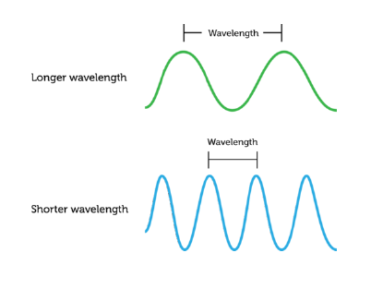

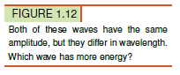

Wave Frequency and Speed
Imagine making transverse waves in a rope, like the waves in Figure 1.2. You tie one end of the rope to a doorknob or other fixed point and move the other end up and down with your hand. You can move the rope up and down slowly or quickly. How quickly you move the rope determines the frequency of the waves.

Wave Frequency
The number of waves that pass a fixed point in a given amount of time is wave frequency. Wave frequency can be measured by counting the number of crests or compressions that pass the point in 1 second or other time period. The higher the number is, the greater is the frequency of the wave. The SI unit for wave frequency is the hertz (Hz), where 1 hertz equals 1 wave passing a fixed point in 1 second. Figure 1.13 shows high-frequency and low-frequency transverse waves.

The frequency of a wave is the same as the frequency of the vibrations that caused the wave. For example, to generate a higher-frequency wave in a rope, you must move the rope up and down more quickly. This takes more energy, so a higher-frequency wave has more energy than a lower-frequency wave with the same amplitude.

Wave Speed
Assume that you move one end of a rope up and down just once. How long will take the wave to travel down the rope to the other end? This depends on the speed of the wave. Wave speed is how far the wave travels in a given amount of time, such as how many meters it travels per second. Wave speed is not the same thing as wave frequency, but it is related to frequency and also to wavelength. This equation shows how the three factors are related:

Speed = Wavelength X Frequency

The Medium Matters
The speed of most waves depends on the medium through which they are traveling. Generally, waves travel fastest through solids and slowest through gases. That’s because particles are closest together in solids and farthest apart in gases. When particles are farther apart, it takes longer for the energy of the disturbance to pass from particle to particle.

Summary
- Wave amplitude is the maximum distance the particles of a medium move from their resting positions as a wave passes through. Wavelength is the distance between two corresponding points of adjacent waves. Waves with greater amplitudes or shorter wavelengths have more energy.
- Wave frequency is the number of waves that pass a fixed point in a given amount of time. Higher frequency waves have more energy. Wave speed is calculated as wavelength multiplied by wave frequency. Wave speed is affected by the medium through which a wave travels.

