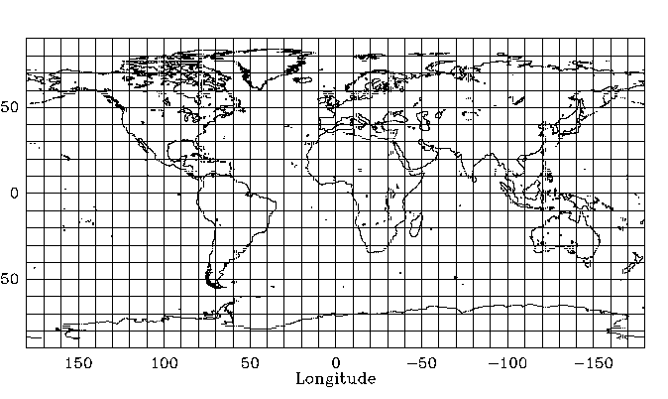
Name:______________________________ ___________________ Pd:______ Date:_____________________
Mapping Earthquakes & Volcanoes: Skills Lab

