WHEN LIGHT STRIKES AN OBJECT TRANSPARENT MATERIALS

- When light strikes an object, the light can be
  - _______________
  - _______________
  - _______________

- Materials can be classified as
  - _______________
  - _______________
  - _______________
- This is based on ____________________________________________________________________________________

Transmits ______________________ ______________________________

  - Light passes right through ___________ being _____________

  - ______________________________________________________

  - Examples = _________________ ___________________________

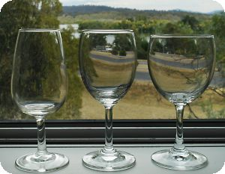

TRANSLUCENT MATERIALS OPAQUE MATERIALS

___________ or _________ all of the light that strikes it

  - ____________ see through because ________________ _______________________

  - Example = ______________ ________________________

Scatters _____________________
  - Usually ________________ something behind object, ______________________

  - Example = ______________ _______________________

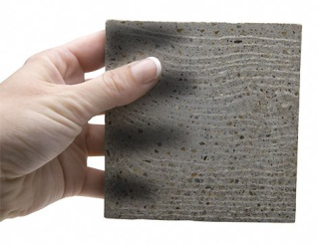
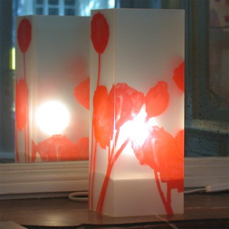
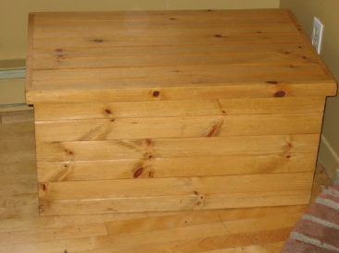
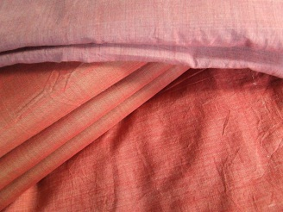

THE COLOR OF OBJECTS
If you know _____________________________ can explain why ____________________________
- Color of objects depends on
  - __________________________________________________

OPAQUE OBJECTS TRANSPARENT & TRANSLUCENT OBJECTS
- Depends on wavelengths of ________________________

- Every opaque object ___________ some wavelengths of light and ____________ others

- ____________________________________________________________________________________

- Allow ______________ of light to pass through them

- ___________________ other colors

- ________________________________________________________________________________________________________________

COMBINING COLORS
_______________ = three colors that can combine to make any other color
_______________ = two primary colors combined in equal amounts

MIXING COLORS OF LIGHT
Primary colors = ________________
  - When ___________________ _________, the 3 primary colors of light ______________
  - If mixed in ________________ can produce other colors
    - Example = ____________ ______________
  - Secondary colors of light =
    - __________, __________, ______________

MIXING PIGMENTS
_____________ = colored substances that are used to color other materials
  - _________ some color, but __________ others
  - __________________________________________________________

Mixing pigments __________________ from mixing colors of light
  - As pigments are _______ together, __________ of light are _________ and more are ___________
  - the more pigments combined, ____________ ____________________
  - _______, __________, __________ primary colors of pigments
  - Combine in equal amounts to produce ___________
  - Can combine primary pigments in different amounts to get secondary colors of _______, ___________, _________

