Lasting Impressions—Counting Stomata
CLASS SET DO NOT MARK, RETURN TO INSTRUCTOR

Introduction
Ever been on a stoma hunt? Where do you find them? Are they in predictable places?

Biological Concepts • Stoma • Guard cells • Plant gas exchanges

Background
Plant tissue, just like animal tissue, is composed of specialized cells to perform specific functions. Plants have an epidermis layer, an outer skin-like layer, just like animals. Animal skin contains specialized “holes” or pores for specific body regulatory functions. Plant epidermis likewise has “pores.” A single pore in plant epidermis is called a stoma.

The location and density of these numerous pores is interesting and relates to plant genetics and niche adaptations. Stomata are most numerous on the leaves of plants. They occur on both the upper and lower epidermis of the leaves in some species (alfalfa, corn), exclusively on the upper epidermis in some plants (water lily), and are absent altogether on submerged leaves of aquatic plants. Stomata are very numerous, ranging from about 1,000 to more than 1.2 million per
cm². An average-sized sunflower leaf has about 2 million stomata on its lower epidermis.

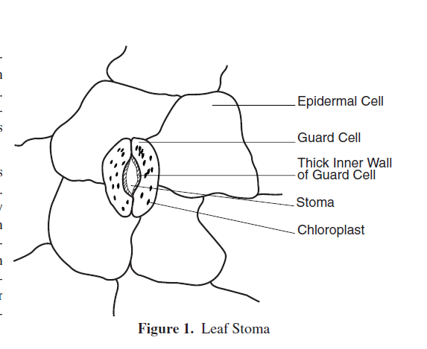
Each stoma is bordered by two sausage-shaped cells that are usually smaller than surrounding epidermal cells. These small cells are called guard cells and, unlike other cells in the epidermis, contain chloroplasts. See Figure 1.

The photosynthesis that takes place in the guard cells aids in the functioning of these cells, i.e., the opening and closing of the stomata openings. This regulated opening and closing of the pores permits gas exchange between the interior of the leaf and the outside atmosphere. The opening and closing of the stomata also helps regulate the water balance inside the plant as water can more easily escape when the stomata are open.

It is the unique structure of the guard cells that allows the opening and closing to occur. Internal micro-fibrils and thicker inner walls of the guard cells cause these guard cells to “bulge” when osmotic pressure builds up inside them. When the water content of the guard cells is high the stoma is open and when the water content is low the stoma is closed. (With fresh epidermal tissue this open and closing can be viewed under the microscope by applying different water concentrations).

Materials Plant leaves Microscope Clear fingernail polish Microscope slides
Clear cellophane tape (clear package sealing tape) Scissors
Procedure
- Your instructor obtained a study leaf and painted a thick patch of clear nail polish on the underside of the leaf. This patch should have been at least one square centimeter.
- The nail polish was allowed to dry completely.
- You will tape a piece of clear cellophane tape to the dried nail polish patch. (The tape must be clear. Do not use Scotch® Tape or any other opaque tape. Clear carton-sealing tape works well.)
- Gently peel the nail polish patch from the leaf by pulling on a corner of the tape and “peeling” the fingernail polish off the leaf and tape it to a microscope slide.
- Start at the lowest power and examine the leaf impression under a light microscope, increase to 400X.
- Scan the slide until you find a good area where you can see the stomata. Each stoma is bordered by two sausage-shaped cells that are usually smaller than surrounding epidermal cells. These small cells are called guard cells and, unlike other cells in the epidermis, contain chloroplasts.
- Sketch. Label the Stoma, Guard Cells, Epidermal Cells, and Chloroplasts.
- Estimate the number of stomata on your sample. From this estimate the number of stomata on the bottom of a leaf your instructor used.
Name: _________________________ Period: ______ Date: _____________ Page: _______3/4
Drawing (Label the Stoma, Guard Cells and if possible the Epidermal Cells and Chloroplast).

Estimated number of stomata in your sample: ________________
Estimated number of stomata from the leaf your instructor used: ________________
Analysis questions:
- What are the 2 main functions of the stomata?

- The teachers have done this lab in the spring and the fall. We think there is a difference in the amount of stomata seen in the two seasons. Can you infer why there may be a difference between the stomata in the fall and spring leaves? Support your answer.

- What do you think you would see if you examined the leaf on a bright sunny day compared to a leaf on that had been in a dark room for several days?

- What part of the human body can you compare the guard cells to? Explain your answer.

