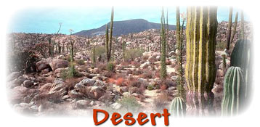
Types of Deserts
Believe it or not, deserts come in several varieties. The two major classifications are hot and cold. Most of the information in this web site pertains to hot deserts. The main form of precipitation in a hot desert is rain. But that's only ten inches or less of rain per year. The main form of precipitation in a cold desert is snow or fog.
Where Are Deserts Located?
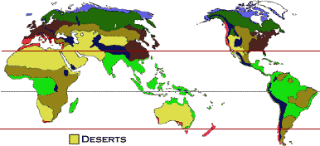
Many deserts are found in bands along 30 degrees latitude north and 30 degrees latitude south (between the red lines on the map).
Some deserts located by mountains and are caused by the "rainshadow" effect. As air moves up over a mountain range, it gets cold and loses the ability to hold moisture -- so it rains or snows. When the air moves down the other side of the mountain, it gets warmer. Warm air can hold lots of moisture, so it doesn't rain as much, and a desert is formed.
World's Largest Deserts
Desert | Location | Square  Miles | Square  Kilometers
Sahara | North Africa | 3,500,000 | 9,065,000
Gobi | Mongolia-China | 500,000 | 1,295,000
Kalahari | Southern Africa | 225,000 | 582,000
Great Victoria | Australia | 150,000 | 338,500
Great Sandy | Australia | 150,000 | 338,500
Deserts of the World
The table below compares the sizes of the world's largest deserts. See Types of Deserts for more information about individual deserts throughout the world.
Deserts of North America
Deserts of North America
Name  Location | Size | Physical  Features | Some Plants & Animals | Special Facts
Chihuahuan  North Central Mexico and Southwestern United States (Arizona, New Mexico, Texas) | 175,000 mi²  455,000 km² | High plateau covered by stony areas and sandy soil. Many mountains and mesas. | cacti, chihuahuan flax, creosote bush, lechuguilla, mesquite, mexican gold poppy  coyote, diamondback rattlesnake, javelina, kangaroo rat, roadrunner | Largest North American desert. Big Bend National Park located here; more species of birds seen in Big Bend than in any other National Park in the U.S.
Great Basin  Western United States (Idaho, Nevada, Oregon, and Utah) | 158,000 mi²  411,000 km² | Covered by sand, gravel, and clay.  Many moutains ranges, basins, and large expanses of salt flats. | greasewood, sagebrush, shadscale  bighorn sheep, jackrabbit, pocket mouse, poor-will, pronghorn antelope, sage thrasher, side-blotched lizard | Great Salt Lake located here.
Mojave  Southwestern United States (Arizona, California, Nevada) | 25,000 mi²  65,000 km² | Covered by sandy soil, gravelly pavement, and salt flats. | creosote bush, desert sand verbena, joshua tree, mesquite  bighorn sheep, chuckwalla, coyote, jackrabbit, sidewinder, zebra-tailed lizard | Death Valley located in this desert.
Sonoran  Southwestern United States (Arizona, California) and parts of Mexico (Baja Peninsula, Sonora) | 120,000 mi²  312,000 km² | Covered by sand, soil, and gravelly pavement. Gets more rain than any other North American desert. | agave, coulter's globemallow, creosote bush, desert mariposa lily, mesquite, ocotillo, paloverde, saguaro  coati, elf owl, gila monster, kangaroo rat, pack rat, roadrunner, sidewinder, tarantula | Most complex animal-plant community of any desert.

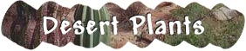
Deserts are the home to many living things. In fact, deserts are second only to tropical rainforests in the variety of plant and animal species that live there.
How do you think plants grow in a place that is very, very dry?
Many of the fascinating features of desert plants are adaptations -- traits that help the plant survive in its harsh environment. Desert plants have two main adaptations:
Ability to collect and store water
Features that reduce water loss
Desert plants often look different than plants in any other biome. Click on the questions to your left to learn more about desert plants and see their pictures.
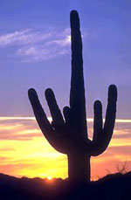
Saguaro
The stem of the Saguaro Cactus stores all of its water. The stem is green. Photosynthesis occurs in the top layer of the stem instead of in leaves. This plant has another adaptation that is hidden from us. This is its large net of roots -- that extend far away from its trunk. How would these roots help a desert plant? The roots collect water after rain. Stored in the pleated expandable stem, the water keeps the saguaro alive until the next rain. Saguaro fruit is used in jam and woody skeletons are used in building materials. The Saguaro only grows in the Sonoran Desert.
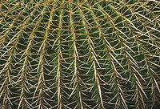
Barrel Cactus
The pleated shape of the Barrel Cactus allows it to expand when it rains and store water in its spongy tissue. It shrinks in size during dry times as it uses the stored water.
Dragon Tree
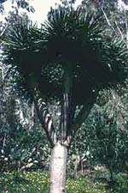
The Dragon Tree is not from the American deserts. It is from the Canary Islands. It has a sap that hardens to a dark red. People call the sap "Dragon's Blood." The sap is sometimes used as a fake stone in jewelry.
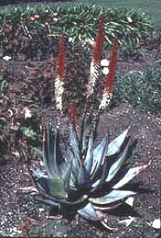
Aloe
The waxy surface of the aloe plant acts like a plastic wrapper, keeping precious water inside. For centuries, the juice of the aloe plant has been used by Native Americans as a medicine. Today, doctors recognize the healing properties of the Aloe plant. Many people keep an aloe plant in their kitchen. Its juice is helpful to soothe the pain of burns.
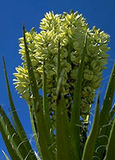
Yucca
The Yucca is an amazingly hardy plant. Not only does it grow in the desert, but it can grow in a wide variety of other climates. Perhaps you have one growing somewhere near you.
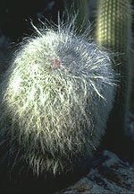
Old Man Cactus
The white hairy surface of the Old Man Cactus helps the plant reflect the hot desert sun.
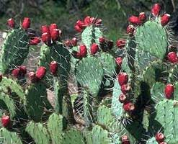
Prickly Pear Cactus
Since many desert plants store water in their spongy tissue, animals will eat them for the moisture. The thorns keep them safe from many animal predators. You can find lots of Prickly Pear Cactus in the Chihuahuan desert.
Fish Hook Cactus
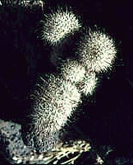
The fish hook shaped spines of the Fish Hook Cactus help divert heat and shade the growing tip of the plant. Many cacti lean further toward the sun as they grow. Some may eventually uproot themselves.

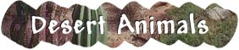
Animals in the desert must survive in a hostile environment. Intense heat, searing sun, and lack of water are just a few of the challenges facing desert animals.
Animals that live in the hot desert have many adaptations. Some animals never drink, but get their water from seeds (some can contain up to 50% water) and plants. Many animals are nocturnal, sleeping during the hot day and only coming out at night to eat and hunt. Some animals rarely spend any time above ground. Spadefoot toads spend nine months of every year underground!
Cactus Wren
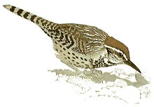
Class: Aves: Birds | Diet: Insects
Order: Passeriformes: Perching birds
Size: body:18 - 22 cm (7 - 8 1/2 in)
Family: Troglodytidae: Wrens | Conservation Status: Non-threatened
Scientific Name: Campylorhynchus brunneicapillus | Habitat: desert, arid scrubland
Range: Southwestern U.S.A. to central Mexico
The largest North American wren, the cactus wren has a distinctive white stripe over each eye and a longer-than-usual tail, which it does not normally cock up. Cactus wrens frequent areas with thorny shrubs, cacti and trees and forage mostly on the ground around vegetation for insects, such as beetles, ants, wasps, and grasshoppers, and occasionally lizards or small frogs. Some cactus fruit and berries and seeds are also eaten. The wrens can run swiftly but usually fly if traveling any distance. Nests are made for roosting in at night and for shelter in bad weather. The breeding season begins in March or April, and there may be two or three broods. The nest is a bulky, domed structure, made of plant fibers, twigs and dead leaves, with a tubelike side entrance that can be up to 15 cm (6 in) long; it is lined with fur or feathers. The nest is situated on a prickly cholla cactus or amid the sharp leaves of a yucca or other thorny bush. From 3 to 7 eggs, usually 4 to 5, are laid and then incubated by the female for about 16 days.
Dingo
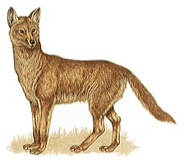
Class: Mammalia: Mammals | Diet: Large mammals
Order: Carnivora: Carnivores
Size: body:about 1.5 m (5 ft), tail: about 35 cm (13 3/4 in)
Family: Canidae: Dogs, Foxes | Conservation Status: Non-threatened
Scientific Name: Canis dingo | Habitat: sandy desert to wet and dry sclerophyll forest
Range: Australia
The dingoes are descended from domesticated dogs introduced by the aboriginal human inhabitants of Australia many thousands of years ago. In anatomy and behavior, dingoes are indistinguishable from domestic dogs, but the two have interbred for so long that there are now few pure dingoes. They live in family groups but may gather into bigger packs to hunt large prey. Originally they fed on kangaroos, but when white settlers started to kill off the kangaroos, dingoes took to feeding on introduced sheep and rabbits. A litter of 4 or 5 young is born in a burrow or rock crevice after a gestation of about 9 weeks. The young are suckled for 2 months and stay with their parents for at least a year.
Sidewinder
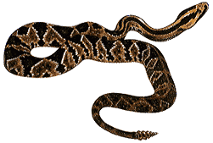
Class: Reptilia: Reptiles | Diet: Small mammals
Order: Squamata: Lizards and Snakes
Size: body:43 - 82 cm ( 17 - 32 1/4 in)
Family: Crotalidae: Pit Vipers | Conservation Status: Non-threatened
Scientific Name: Crotalus cerastes | Habitat: desert, rocky hillsides
Range: Southwestern U.S.A.: Southern California, Nevada and Utah, south to Mexico
A small agile snake, the sidewinder has a distinctive hornlike projection over each eye. It is chiefly nocturnal and takes refuge in the burrow of another animal or under a bush during the day. At night it emerges to hunt its prey, mainly small rodents, such as pocket mice and kangaroo rats, and lizards. A desert inhabitant, this snake moves with a sideways motion, known as sidewinding, thought to be the most efficient mode of movement for a snake on sand. It throws its body into lateral waves, only two short sections of it touching the ground. All the snake's weight, therefore, is pushing against the ground at these points, and this provides the leverage to move it sideways. As it travels, the snake leaves a trail of parallel J-shaped markings. An ideal form of movement in open, sparsely vegetated country, sidewinding has the advantage of reducing contact between the snake's body and the hot sand. Sidewinders mate in April or May, and the female gives birth to 5 to 18 live young about 3 months later.
Gila Monster
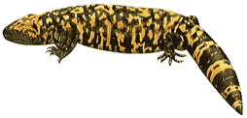
Class: Reptilia: Reptiles | Diet: Small mammals, eggs
Order: Squamata: Lizards and Snakes
Size: body:45 - 61 cm (17 3/4 - 24 in)
Family: Helodermatidae: Gila Monster | Conservation Status: Vulnerable
Scientific Name: Heloderma suspectum | Habitat: arid and semiarid areas with some vegetation
Range: Southwestern U.S.A.: Southern Utah, Arizona to New Mexico; Mexico
This formidable, heavy-bodied lizard has a short, usually stout tail, in which it can store fat for use in periods of food shortage. It is gaudily patterned and has brightly colored beadlike scales on its back. The gila lives on the ground and shelters under rocks or in a burrow, which it digs itself or takes over from another animal. It is primarily nocturnal but may emerge during the day in spring. The two members of the gila monster family are the only venomous lizards. The venom is produced in glands in the lower jaw and enters the mouth via grooved teeth at the front of the lower jaw; it flows into the victim as the lizard chews. The gila also eats the eggs of birds and reptiles. Gila monsters mate in the summer, and the female lays 3 to 5 eggs some time later, in the autumn or winter.
Fat Sand Rat
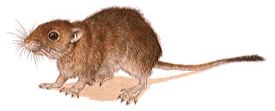
Class: Mammalia: Mammals | Diet: Seeds, vegetation
Order: Rodentia: Rodents
Size: body:14 - 18.5 cm (5 1/2 - 7 1/4 in), tail: 12 - 15 cm (4 3/4 - 6 in)
Family: Gerbillinae: Gerbils | Conservation Status: Non-threatened
Scientific Name: Psammomys obesus | Habitat: sandy desert
Range: Algeria, east to Saudi Arabia
The fat sand rat overcomes the problem of the unpredictability of desert food supplies by laying down a thick layer of fat all over its body when food is abundant. It then lives off this fat when food is short. Active day and night, this gerbil darts about collecting seeds and other vegetation which it carries back to its burrow. In early spring, a brood chamber is made and lined with finely shredded vegetation, and the first litter of the year is born in March. There are usually 3 to 5 young in a litter, and the breeding season continues until late summer.
Great Jerboa
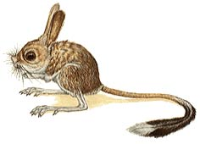
Class: Mammalia: Mammals | Diet: Seeds, insects
Order: Rodentia: Rodents
Size: body:19 - 15 cm (3 1/2 - 6 in), tail: 16 - 22 cm (6 1/4 - 8 1/2 in)
Family: Dipodidae: Jerboas | Conservation Status: Non-threatened
Scientific Name: Allactaga major | Habitat: Allactaga major
Range: Russia: Ukraine, east to China
The great jerboa and 8 of the 9 other species in the genus Allactaga have five toes on each hind foot. Great jerboas feed on seeds and insects, which they find by combing through the sand with the long slender claws on their front feet. They are nocturnal, spending the day in burrows; they also hibernate in burrows. One or two litters are produced each year.

