Introduction to the Microscope

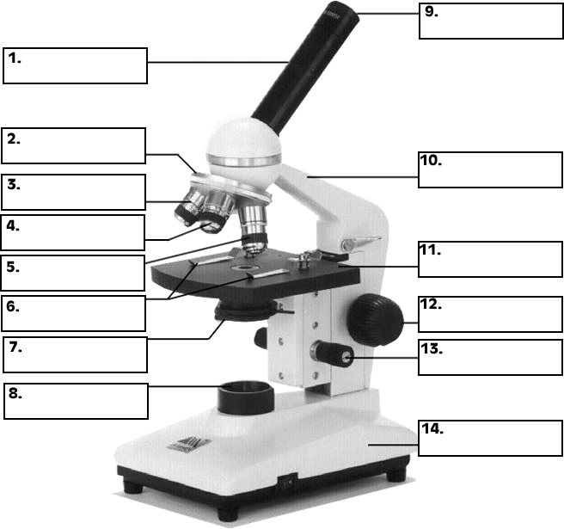
How to focus a microscope:
- Always set scope to low power
- Visually line the slide up with the lens
- Focus on low power using the coarse adjustment
- Move slide so object is in the center of the field of vision
- Change to medium power and refocus using fine adjustment
- Make sure object is in the center of your field of vision.
- Change to high power and refocus using the fine adjustment

How to determine the total magnification:
- Simply multiply the eye piece lens magnification by the objective magnification
- The eye piece lens of our microscopes have a ___ magnification.
- The objective lens have ___,___ and ____ magnification.
- Example: ____ x ___ = ____ total magnification

