The majority of flowering plants have “perfect” flowers which contain both male and female reproductive structures although some species produce “imperfect” flowers with only female or male structures.
The majority of tree fruit and nut crops grown in California have perfect flowers which contain both male and female reproductive structures within each flower. A plant species with both female and male reproductive structures on the same individual is monoecious. Monoecious plant species can have either perfect flowers (Figure 3a), or male and female imperfect flowers on the same individual (Figure 3b).
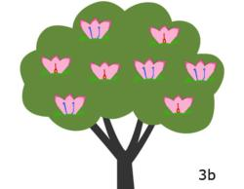
All fruit and nut crops in the genus Prunus (almond, apricot, cherry, nectarine, peach, plum and prune) are monoecious with perfect flowers. Walnut and chestnut are monoecious with imperfect male and female flowers on the same tree (see Summary Table). In contrast, a plant species with female and male reproductive structures on separate individuals is dioecious (kiwi vine tree, persimmon)(Figure 3c).
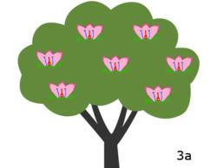

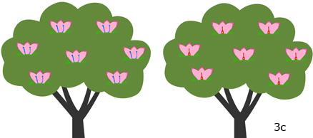

Pollination, the movement of pollen from anthers to stigma, is required for seed and fruit development in almost all fruit and nut crops.
The distance between male and female reproductive structures determines the distance pollen must travel to intercept a stigma of the same species. As the distance between anthers and stigma increases, the likelihood that an individual pollen grain will successfully fertilize an ovule decreases. The minimum distance pollen must travel between male and female structures vary substantially among monoecious species with perfect flowers, monoecious species with imperfect flowers, and dioecious species (Figure 4).
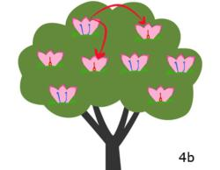
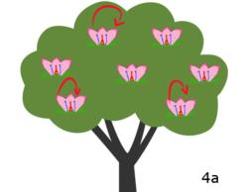

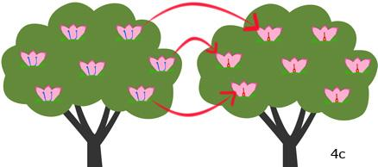

Study tip:
“Mono-” means one in Latin and “- ecious” means house. A “monoecious” plant species has both sexes in one “house”, or individual. “Di-” means two in Latin. A “dioecious” plant species has both sexes split across two “houses”, or individuals.

