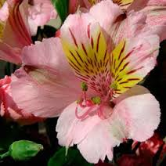
Flower Dissection

Objectives:
To learn the parts of the flower.
To compare male and female flower anatomy

Procedure:
- You and your partner will be given one Alstroemeria flower. This flower resembles a miniature lily.

- In Figure 1, draw your flower. Write down the flower color. Label the sepals and petals. Note: You may not be able to see the sepals, they may have fallen off. Your figure should cover half of the page.

- Take your flower to your teacher who will use a scalpel or blade to carefully make a vertical incision to open up the flower.

- Take your flower back to your desk.

- Gently pull apart the flower.

- In Figure 2, draw your flower spread open. Be sure to label: Sepals (if present), Anther, Stamen, Filament, Pistil, Stigma, Style, Ovary, baby seeds. This figure should cover half of your page.

Data:
Figure 1(Below): Drawing of Alstroemeria Flower (half page)

Color: __________________

Figure 2(below): Alstroemeria Flower Pinned Open (half page)

Analysis:
Name the female parts of your flower.

Name the male parts of your flower.

Conclusion:
Write 3-5 sentences on what you learned.

Elaboration:
Pollen doesn’t have legs. How does pollen mover from anthers to stigma?

Based on the information on flower anatomy (the extra reading) draw a diagram of how the farmer should plant 24 dioecious kiwi or persimmon trees to allow maximum reproduction. Justify your diagram.

