___________ = the ___________ of ________________of electromagnetic waves

Light Prisms
These are tools that use ___________________ to spread out the different ________________ which make up white light.
White Light
White light is all the colors of visible light __________________ ____________________.
Colors of Light
Each wavelength creates a different ______________
  - This means that each color of light bends at a different ___________________
Two factors determine the color of an object:
  - Wavelengths that the object _________________ or _________________
  - Wavelengths present in light that ________________ on object
Primary Colors of Light:
______________
______________
______________

Electromagnetic Spectrum
The range of all electromagnetic ___________________
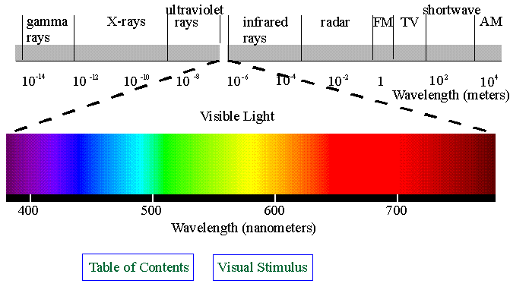
Usually represented in a diagram.
Visible Light
The part of the electromagnetic spectrum that _____________ ____________ can see
Longest wavelengths are ____________ and the shortest are ______________
Seven Colors of Visible Light: _____________ ____________ ____________ ______________ ____________ _____________ _____________
Reflection and Absorption
Visible light can either be reflected or absorbed
- If it is _______________ then the wave bounces back after striking the object
- If it is _______________ then the wave is taken in by the object and its energy is changed to _________________ __________.

