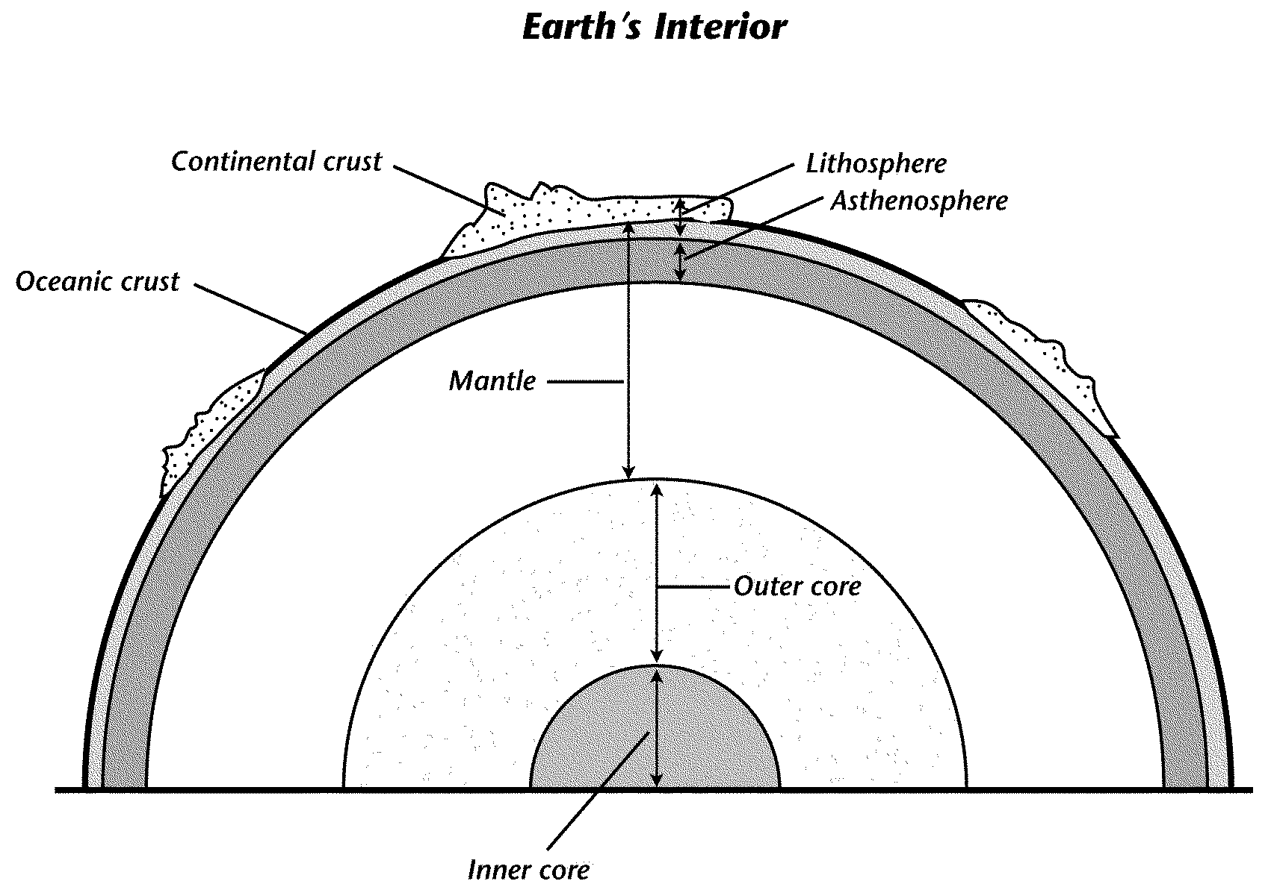
Video 1 – The Earth’s Structure
Lithosphere
Continental crust

Asthenosphere
Oceanic Crust

Mantle

Outer Core

Inner Core
Lithosphere vs. Asthenosphere  Lithosphere – includes crust and upper most part of mantle  Asthenosphere – below the lithosphere; upper most part of the mantle; | How is the lithosphere divided?  Large pieces called tectonic plate
Describe what moves the lithosphere.  Currents within the mantle circulate that move the lithosphere | Where do most earthquakes & volcanos occur?  Along the colliding edges of most plates

Video 2 – Plate Tectonics
Explain Plate Tectonics  Explains how the forces within the earth move the plates around | As the mantle circulates… (three responses)  Crust slides around, pulls apart, pushes together, and reshapes land
The boundary between the two tectonic plates in the Atlantic Ocean form…

The Mid-Atlantic Ridge; pulling continents apart

What is created here? Volcanoes
Where is most volcanic activity found?  At plate boundaries of tectonic plates | What can result when plates collide together?  mountains
Video 3 – How the Inner Structure of Planet Earth Affects Plate Tectonics
Explain why the tectonic plates are moving.

Moving at about 1-2 inches a year
Material in the mantle is circulating because of the heat. Mantle material moves lithosphere

Identify, describe, and draw the three types of plate movement.
Describe Drawing
1. Divergent boundary | Moving apart
2. Convergent boundary | Colliding; coming together
3.Transform boundary | Slide past

Explain the difference between magma and lava.  Magma – under the surface of earth  Lava – on surface of earth | Determine where new plate material is created  At mid-ocean ridges
Determine where plate material is destroyed. Create a drawing. When this occurs, what is it called?

At convergent boundaries; diving plate consumed back into mantle (subduction occurs); takes place at subduction zones

Video 4 – Plate Tectonics, Volcanoes, and Earthquakes
Explain the theory of plate tectonics.  Earth’s surface divided into plates; float on mantle; currents within mantle cause plates to move | Define a rift and what occurs here.  Found at mid-ocean ridges; a rift is a boundary between plates; magma seeps through rift creating new crust
What forms at convergent boundaries?  Land buckles upward forming mountains | Describe how a volcano forms at a convergent boundary.  Magma forces way through cracks in crust; pressure builds up until it can push through surface of earth
What causes earthquakes (think stress)?  Rock bends (under stress) as plates move under pressure; when pressure too great, releases energy in form of waves causing the earth to shake | What is the name of the fault where scientists are studying?  San Andres Fault in California

