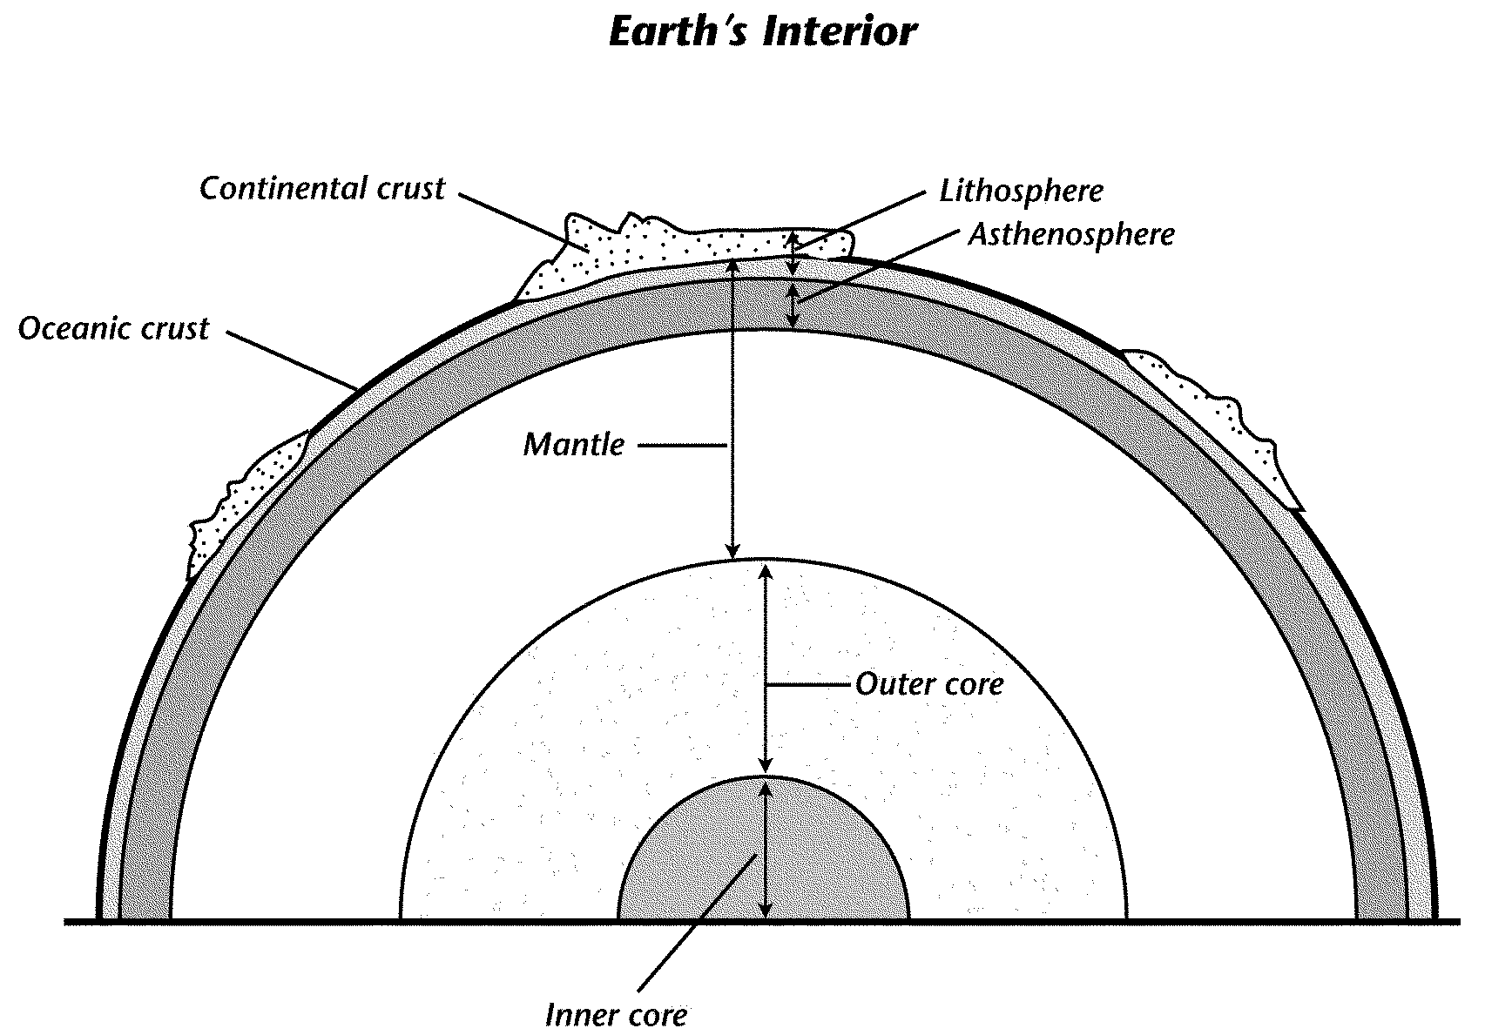
Video 1 – The Earth’s Structure

Lithosphere vs. Asthenosphere | How is the lithosphere divided?
Describe what moves the lithosphere. | Where do most earthquakes & volcanos occur?

Video 2 – Plate Tectonics
Explain Plate Tectonics | As the mantle circulates… (three responses)
The boundary between the two tectonic plates in the Atlantic Ocean form…

What is created here?
Where is most volcanic activity found? | What can result when plates collide together?
Video 3 – How the Inner Structure of Planet Earth Affects Plate Tectonics
Explain why the tectonic plates are moving.

Identify, describe, and draw the three types of plate movement.
Describe Drawing
1. ____________ boundary
2. _____________ boundary
3. ____________ boundary

Explain the difference between magma and lava. | Determine where new plate material is created
Determine where plate material is destroyed. Create a drawing. When this occurs, what is it called?

Video 4 – Plate Tectonics, Volcanoes, and Earthquakes
Explain the theory of plate tectonics. | Define a rift and what occurs here.
What forms at convergent boundaries? | Describe how a volcano forms at a convergent boundary.
What causes earthquakes (think stress)? | What is the name of the fault where scientists are studying?

