Why do you need food?
The main reason you need to eat is to get energy. Food is your body's only supply of energy. However, this energy must be converted from pizza (or any other food you eat) into an energy source that your body can use. The process of getting energy from your food is called cellular respiration.
What is Cellular Respiration?
How does the food you eat provide energy? When you need a quick boost of energy, you might reach for an apple or a candy bar. But cells do not "eat" apples or candy bars; these foods need to be broken down so that cells can use them. Through the process of cellular respiration, the energy in food is changed into energy that can be used by the body's cells. Initially, the sugars in the food you eat are digested into the simple sugar glucose, a monosaccharide. Recall that glucose is the sugar produced by the plant during photosynthesis. The glucose, or the polysaccharide made from many glucose molecules, such as starch, is then passed to the organism that eats the plant. This organism could be you, or it could be the organism that you eat. Either way, it is the glucose molecules that hold the energy.
ATP
Specifically, during cellular respiration, glucose is converted into ATP (Figure below). ATP, or adenosine triphosphate, is chemical energy the cell can use. It is the molecule that provides energy for your cells to perform work, such as moving your muscles as you walk down the street. But cellular respiration is slightly more complicated than just converting glucose into ATP. Cellular respiration can be described as the reverse or opposite of photosynthesis. During cellular respiration, glucose, in the presence of oxygen, is converted into carbon dioxide and water. The process can be summarized as: glucose + oxygen → carbon dioxide + water. During this process, the energy stored in glucose is converted into ATP.
Energy is stored in the bonds between the phosphate groups (PO₄⁻) of the ATP molecule. When ATP is broken down into ADP (adenosine diphosphate) and inorganic phosphate, energy is released. When ADP and inorganic phosphate are joined to form ATP, energy is stored. During cellular respiration, about 36-38 ATP molecules are produced for every 1 glucose molecule.
The structural formula for adenosine triphosphate (ATP). During cellular respiration, energy from the chemical bonds of the food you eat must be converted into ATP.
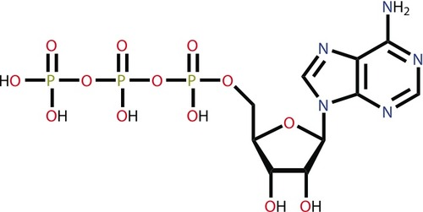
Summary
Through the process of cellular respiration, the energy in food is converted into energy that can be used by the body's cells.
During cellular respiration, glucose and oxygen are converted into ATP, carbon dioxide, and water.

How do trees help you breathe?
Recall that trees release oxygen as a byproduct of photosynthesis. And you need oxygen to breathe. Do you know why? So your cells can perform cellular respiration.
Connecting Cellular Respiration and Photosynthesis
Photosynthesis and cellular respiration are connected through an important relationship. This relationship enables life to survive as we know it. The products of one process are the reactants of the other. Notice that the equation for cellular respiration is the direct opposite of photosynthesis:

- Cellular Respiration: C₆H₁₂O₆ + 6O₂ → 6CO₂ + 6H₂O
- Photosynthesis: 6CO₂ + 6H₂O → C₆H₁₂O₆+ 6O₂
Photosynthesis makes the glucose that is used in cellular respiration to make ATP. The glucose is then turned back into carbon dioxide, which is used in photosynthesis. While water is broken down to form oxygen during photosynthesis, in cellular respiration oxygen is combined with hydrogen to form water. While photosynthesis requires carbon dioxide and releases oxygen, cellular respiration requires oxygen and releases carbon dioxide. It is the released oxygen that is used by us and most other organisms for cellular respiration. We breathe in that oxygen, which is carried through our blood to all our cells. In our cells, oxygen allows cellular respiration to proceed. Cellular respiration works best in the presence of oxygen. Without oxygen, much less ATP would be produced.
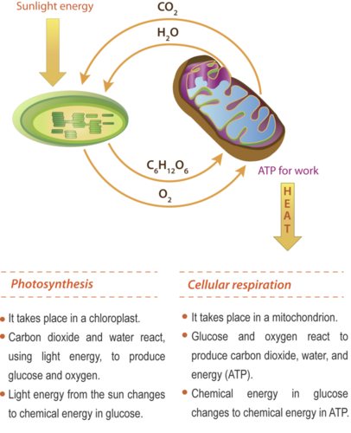
Cellular respiration and photosynthesis are important parts of the carbon cycle. The carbon cycle is the pathways through which carbon is recycled in the biosphere. While cellular respiration releases carbon dioxide into the environment, photosynthesis pulls carbon dioxide out of the atmosphere. The exchange of carbon dioxide and oxygen during photosynthesis (Figure below) and cellular respiration worldwide helps to keep atmospheric oxygen and carbon dioxide at stable levels.
Cellular respiration and photosynthesis are direct opposite reactions. Some of the ATP made in the mitochondria is used as energy for work, and some is lost to the environment as heat.

Summary
The equation for cellular respiration is the direct opposite of photosynthesis.
The exchange of carbon dioxide and oxygen thorough photosynthesis or cellular respiration worldwide helps to keep atmospheric oxygen and carbon dioxide at stable levels.

