What Are Grasslands Like?
Grasslands are big open spaces. There are not many bushes in the grassland. Trees are found only by rivers and streams. The grassland seems like an endless ocean of grass.
Grasslands receive about 10 to 30 inches of rain per year. If they received more rain, the grasslands would become a forest. If they received less, they would become a desert. Grasslands are often located between deserts and forests.
Grassland soil tends to be deep and fertile. The roots of perennial grasses usually penetrate far into the soil. In North America, the prairies were once inhabited by huge herds of bison and pronghorns who fed on the prairie grasses. These herds are almost gone now, and most of the prairies have been converted into the richest agricultural region on earth. Crops grow well in the rich soil.
The Three Types of North American Grasslands
Tall Grass Prairie | The Tall Grass Prairie lies mainly in the eastern portion of the Midwest. The grasses here often grow to be five feet tall. The annual rain totals here approach 30 inches.
Mixed Grass Prairie | The Mixed Grass Prairie lies mainly in the middle portion of the Midwest. The grasses here often grow to be two and three feet tall. Typically, there are 15 to 25 inches of rain per year. This is the prairie where the buffalo once roamed.
Short Grass Prairie | The Short Grass Prairie lies mainly in the western portion of the Midwest, hugging the coast of the deserts and the Rocky Mountains into Canada. The grasses here grow to be no more than two feet tall. There is usually little more than ten inches of rain per year in these short grass prairies. Prairie Dogs are common in this area.
In the United States and Canada there are three types of grasslands (or prairies):
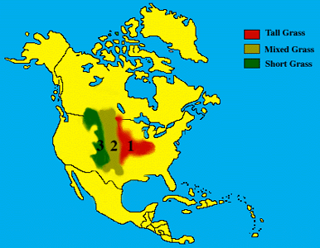

Grasslands of the World
Grasslands are found on either side of two desert belts that circle the earth. About one quarter of the earth's land is in the grasslands.
- Tropical grasslands -- those closest to the equator -- are hot all year.
- Temperate grasslands are farther from the equator -- such as the U.S. prairies -- and have both hot summers and harsh winters.
Temperate grasslands once covered much of the interior of North America, and they were common in Eurasia and South America as well. They are highly productive when they are first converted to agricultural uses because the organic material in the soil comes from hundreds of thousands of years of decomposition.
In North America, the prairies were once inhabited by huge herds of bison and pronghorns, which were hunted by wolves, bears, and other predators. Where U.S. prairies have been converted to farmland, the large herds and predators that followed them are gone now.
In addition to the prairies of the U.S. Midwest, the world has other grasslands which go by different names. In South America, grasslands are called "pampas"; in Europe, "steppes"; in Africa, "savannas".
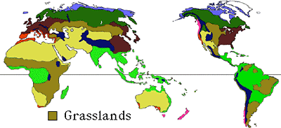
What are some of the most beautiful prairie flowers?
The prairie blazingstar is one of the most beautiful flowers on the tallgrass prairie. It has magenta colored flowers arranged along a spike at the top of a long stalk up to 5 feet high. Many kinds of butterflies are attracted to this flower.
The purple coneflower is used by many people in their gardens at home. This is the part of the flower which produces seeds after the purple petals fall off. Birds like goldfinches love to eat these seeds.
Are any prairie plants harmful to people?
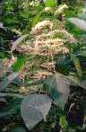
Sure! This stinging nettle plant is very attractive when it's in flower like this - but be careful! This plant causes a painful sting when it touches your bare skin. It grows to 3 feet tall in moist shady woods. This adaptation helps the plant protect itself from grazers and people, too!
Poison ivy is found at the edge of the prairie.

I've always thought that there weren't any trees on the prairie - that they were just wide open spaces - is that right?
Well, you're partly right... the prairies are full of wide open spaces. However there are many kinds of trees that can be found in and around a prairie field. These leaves are from a box elder tree, which is a member of the maple family.
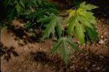
Pictured to the left are leaves of a silver maple tree. Its seeds fall in late spring and are fun to watch as they float in the air in spiraling motion.
Shown to the right are flowers from a red bud tree. This small tree is actually in the pea family! The fruit is shaped like a pea pod, but is flat.
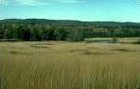
What does a prairie look like when it's not in bloom?
Prairies are famous for their beautiful flowers and grasses that bloom in the springtime.
In Autumn the prairie takes on a different kind of beauty. Leaves of the tall grasses turn beautiful shades of yellow, orange, and tan.

Grasslands lack the trees and heavy bush to hide many creatures. Because of the open landscape and the widely spaced trees, grasslands are home to large herds of grazing mammals such as the zebra and bison. Annual rainfall in the grasslands is between 10 to 30 inches, there is a seasonal drought every year. Many animals are active only during the rainy season.
African Elephant
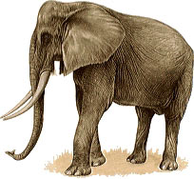
Class: Mammalia: Mammals | Diet: Leaves
Order: Proboscidea: Elephants
Size: body:6 - 7.5 m (19 3/4 - 24 1/2 ft), tail: 1 - 1.3 m (3 1/4 - 4 1/4 in)
Family: Elephantidae: Elephants | Conservation Status: Vulnerable
Scientific Name: Loxodonta africana | Habitat: forest, savanna
Range: Africa, south of the Sahara
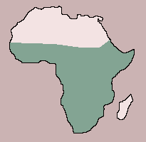
The huge, majestic elephant is perhaps the most imposing of all the African mammals. It has larger ears and tusks than the Asian species and two finger-like extensions at the end of its trunk. Females are smaller than males and have shorter tusks. Elephants rest in the mid-day heat and have one or two periods of rest at night but are otherwise active at any time, roaming with their swinging, unhurried gait in search of food. Depending on its size, an elephant may consume up to 200 kg (440 lb) of plant material a day, all of which is grasped with the trunk and placed in the mouth. The diet includes leaves, shoots, twigs, roots and fruit from many plants, as well as cultivated crops on occasion. Elephants are social animals, particularly females, and are known to demonstrate concern for others in distress. A troop usually comprises several females and their young of various ages. As they mature, young males form separate troops. Old males may be shunned by the herd when they are displaced by younger males. Breeding occurs at any time of year, and a female in heat may mate with more than one male. The gestation period is about 22 months, and usually only 1 young is born. The female clears a secluded spot for the birth and is assisted by other females. The calf is suckled for at least 2 years and remains with its mother even longer. She may have several calves of different ages under her protection and gives birth only every 2 to 4 years.
Giraffe
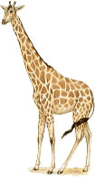
Class: Mammalia: Mammals | Diet: Leaves, buds, fruits
Order: Artiodactyla: Even-toed Ungulates
Size: body:3 - 4 m (9 3/4 - 13 ft), tail: 90 cm - 1.1 m (35 1/2 in - 3 1/2 ft)
Family: Giraffidae: Giraffes | Conservation Status: Lower risk - Conservation dependent
Scientific Name: Giraffa camelopardalis | Habitat: savanna
Range: Africa, south of the Sahara
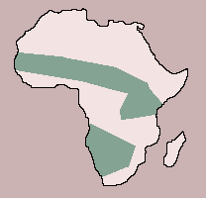
The giraffe, with its long legs and its amazingly long neck, when erect stands up to 3.3 m (11 ft) at the shoulder and nearly 6 m (19 1/2 ft) at the crown. Its characteristic coloration of a light body and irregular dark spots is very variable, both geographically and between individuals; some animals may be almost white or black, or even unspotted. Both male and female have skin-covered horns, one pair on the forehead and sometimes a smaller pair farther back, on the crown. Some animals have yet another small horn, or bump, between these pairs. The tail ends in a tuft of long hairs. Gregarious animals, giraffes usually live in troops of up to 6, sometimes 12, and may occasionally gather in larger herds. A troop consists of females and their offspring, led by a male. Males fight for possession of females, wrestling with their heads and necks. The troop ambles around its territory, feeding mostly in the early morning and afternoon on the foliage, buds, and fruits on the top of acacia and thorn trees. The giraffes may also eat grass, other plants, and grain crops. At midday, giraffes rest in shade and at night lie down for a couple of hours or rest standing. Females give birth to a single offspring, rarely twins, after a gestation of over a year -- usually 400 to 468 days. Births invariably occur at first light. The young is suckled for 6 to 12 months and continues to grow for 10 years.
Bison
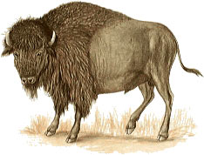
Class: Mammalia: Mammals | Diet: Grass
Order: Artiodactyla: Even-toed Ungulates
Size: body:2.1 - 3.5 m (6 3/4 - 11 1/2 ft), tail: 50 - 60 cm (19 3/4 - 23 1/2 in)
Family: Bovidae: Bovids | Conservation Status: Lower risk - Conservation dependent
Scientific Name: Bison bison | Habitat: prairie, open woodland
Range: N. America
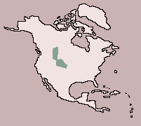
Although there were once millions of bison roaming the North American grasslands, wholesale slaughter by the early European settlers brought them almost to extinction by the beginning of the twentieth century. Since then, due largely to the efforts of the American Bison Society, herds have steadily been built up in reserves, where they live in a semiwild state, and it is estimated that there are now some 20,000 animals.
The male may be as much as 2.9 m (9 1/2 ft) at the shoulders, which are humped and covered with the shaggy, brownish-black fur that also grows thickly on the head, neck and forelegs. The female looks similar to the male but is smaller; young are more reddish-brown. Both sexes have short, sharp horns. Primarily grazers, bison live in herds that vary from a family group to several thousand; huge numbers formerly made seasonal migrations in search of better pasture. They feed morning and evening. During the day, they rest, chewing the cud or wallowing in mud or dust to rid themselves of parasites. During the mating season, bulls (males) fight for cows (females), which give birth to a single calf, away from the herd, after a gestation of 9 months. Within an hour or two, mother and calf rejoin the herd. The calf is suckled for about a year and remains with its mother until it reaches sexual maturity at about 3 years old.
Warthog
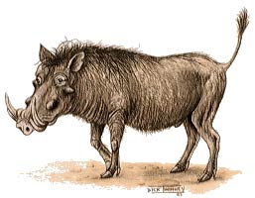
Class: Mammalia: Mammals | Diet: Grass
Order: Artiodactyla: Even-toed Ungulates
Size: body:1.1 - 1.4 m (3 1/2 - 4 1/2 ft), tail: 35 - 50 cm (13 3/4 - 19 3/4 in)
Family: Suidae: Pigs | Conservation Status: Non-threatened
Scientific Name: Phacochoerus aethiopicus | Habitat: savanna, treeless open plains
Range: Africa: Ghana to Somalia, south to South Africa: Natal
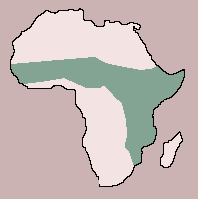
The warthog has long legs, a large head and a broad muzzle that bears tusks derived from the canine teeth. On each side of the big head are two wartlike protuberances -- the origin of the animal's common name. Its bristly coat is sparse, but there is a mane of long bristles running to the middle of the back, and there are whiskers on the lower jaw. The female is smaller than the male and has shorter tusks. Generally gregarious, warthogs live in family groups in a territory that may be shared by more than one family. They prefer to have water for drinking and wallowing within their range and also some form of shelter, such as aardvark burrows or holes among rocks, where they rest in the heat of the day and at night. As well as grazing on short grass, warthogs feed on fruit and, in dry spells, will probe the ground with their tusks to obtain bulbs, tubers and roots. They occasionally prey on small mammals and will take carrion. Timing of the breeding season tends to be associated with the local rainy seasons. The female gives birth to 2 to 4 young after a gestation of 170 to 175 days. The young suckle for up to 4 months but, after a week, start to leave the burrow in which they are born to feed on grass.

Greater Prairie Chicken
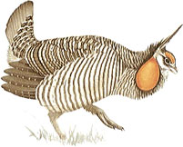
Class: Aves: Birds | Diet: Plants
Order: Galliformes: Gamebirds
Size: body:42 - 46 cm (16 1/2 - 18 in)
Family: Tetraonianae: Grouse | Conservation Status: Vulnerable
Scientific Name: Tympanuchus cupido | Habitat: prairie
Range: Central North America
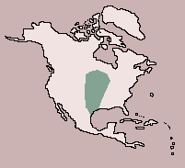
This increasingly rare bird was once common over a large area of North America. Male and female birds look similar, but females have barred tail feathers and smaller neck sacs. Prairie chickens feed on plant matter, such as leaves, fruit and grain, and in the summer they catch insects, particularly grasshoppers. Male birds perform spectacular courtship displays, inflating their orange neck feathers. They give booming calls and stamp their feet as they posture, to make the display even more impressive. Female birds lay 10 to 12 eggs and incubate them for 21 to 28 days.

Black-tailed Prairie Dog
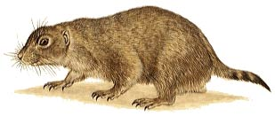
Class: Mammalia: Mammals | Diet: Grass
Order: Rodentia: Rodents
Size: body: 28 - 32 cm (11 - 12 1/2 in), tail: 8.5 - 9.5 cm (3 1/4 - 3 3/4 in)
Family: Sciuridae: Squirrels | Conservation Status: Lower risk - Near threatened
Scientific Name: Cynomys ludovicianus | Habitat: grassland (prairie)
Range: Central USA
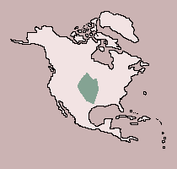
The prairie dog derives its common name from its stocky, terrierlike appearance and from its sharp, doglike bark, which it utters to herald danger. One of the most social rodent species, prairie dogs live in underground burrows, called towns, containing several thousand individuals. They emerge by day to graze on grass and other vegetation and can often cause serious damage to cattle ranges. Feeding is regularly interrupted for bouts of socializing, accompanied by much chattering. Females give birth to litters of up to 10 young during March, April or May, after a 4-week gestation. After being weaned at 7 weeks, the young disperse to the edge of the town. Prairie dogs are commonly preyed on by eagles, foxes and coyotes.

