Biome Project Name: _____________________
My EXPERT Biome: _____________________
Answer the following questions about the Biome that you are going to become an ‘Expert’ on. You will use this information to report back to your ‘Home Base’ group.
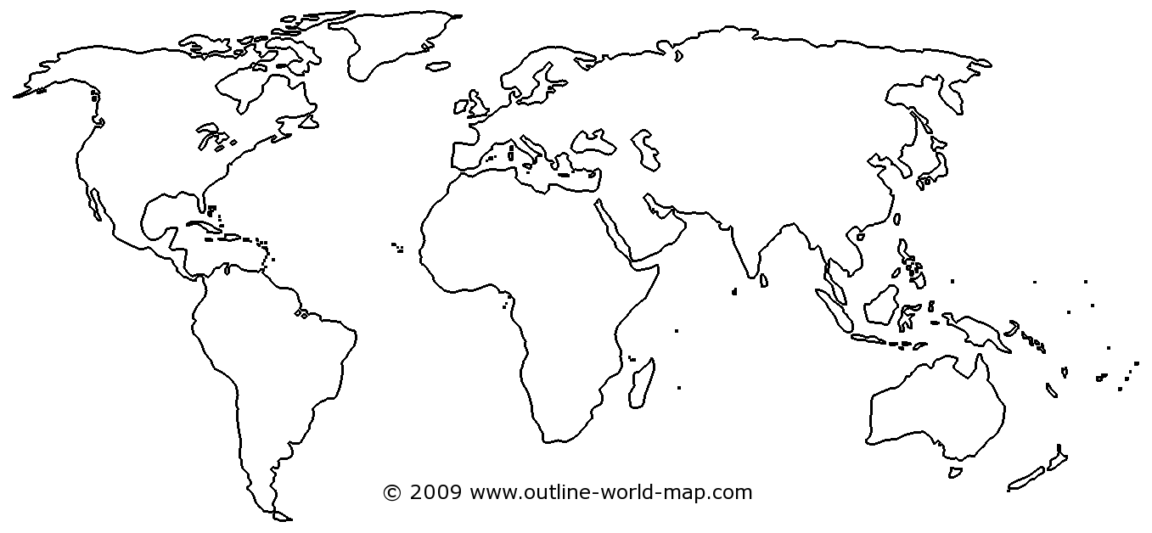
- Where is the biome located? Use the world map to identify the parts of the Earth that your Biome covers.

- Describe the biome’s annual rainfall and temperatures. __________________________________________________________________________________________________________________________________________________________________________________________________________________________________________

- Describe the typical plants and animals (choose two of each) of the biome and explain how they are adapted for life in the biome.
Plant 1: | Plant 2:
Adaptations | Adaptations
Animal 1: | Animal 2:
Adaptations | Adaptations

- After reading about the different types of plants and animals, what can you infer about the impact that the rainfall, temperature, and other abiotic factors have on animal and plant survival?
_____________________________________________________________________________________________________________________________________________________________________________________________________________________________________________________________________________________________________________________________________

- Explain any threats that your biome is facing due to the environment or human impact on the biome.
_____________________________________________________________________________________________________________________________________________________________________________________________________________________________________________________________________________________________________________________________________
Biomes Around the World
After you have gained information on your ‘Expert’ Biome, go back to your Home Base group and learn about the other Biomes Around the World. Complete the chart as each person in your group is presenting their information.

Name of Biome:

Average Temperature and Rainfall | Examples of Plants | Examples of Animals
Describe how plants and animals have adapted in this Biome in order to survive:

Name of Biome:

Average Temperature and Rainfall | Examples of Plants | Examples of Animals
Describe how plants and animals have adapted in this Biome in order to survive:

Name of Biome:

Average Temperature and Rainfall | Examples of Plants | Examples of Animals
Describe how plants and animals have adapted in this Biome in order to survive.

Biome Group Project Rubric
Group Member | Expert Biome

As a group, create a poster that describes each biome you have researched. Your poster should include the following things for each biome:
- Name of the biome and description of where it is located.
- Types of plants and animals found within the biome and descriptions.
- Average rainfall, temperature and other abiotic factors within the biome.
- Description of how plants and animals adapt to survive to their surroundings.

Your group poster will be evaluated using the following rubric.
Criteria | Possible Points | Points Earned
Included an accurate description and location for each biome | 10
Included abiotic factors (rainfall, temperature, etc.) for each biome. | 20
Described plants and animals found within each biome. | 20
Described how plants and animals adapt to their abiotic surroundings. | 40
The group poster is neat and organized. | 10
Total | 100

