Name ________________________________________________ Pd:_______ Date:__________________________

**Best Flying Paper Airplane**

**Problem:** How can we make a paper airplane travel farther?

**Prelab Questions**

1. Make a list of modifications we could make to a “regular” paper airplane to make it go farther (example: weight—could make it heavier or lighter). **List at least 5**. **(5 points)**
2. Pick **ONLY ONE** of the modifications (variables) to test. Which one are you choosing? Describe how you will make modifications for this variable. (For example if you choose to change the weight, how will you add or subtract weight?) This variable is called your **___________________________**; it is the ONE thing you change in the experiment. Pick an independent variable that you can increase and decrease (for example make heavier or lighter). **(10 points)**
3. The purpose of running trials is to determine how far the plane is able to fly. This distance is what you will measure. In an experiment what you are measuring is called the **______________________________**, because the distance it flies is *dependent* on the *independent* variable you are changing. Because you won’t get the same distance every time, you will need to run a series of trials. You should do your best to **use the** **same technique every time**. These are called “constants.” **Constants** are the ways you keep the environment and methods the same so they won’t influence your results. What are constants you will use to help keep the trials the same? **(10 points)**
4. A **___________________________** is a statement that describes a connection between your independent variable and dependent variable. For example, “If I increase the weight of my plane, it will fly farther.” What is your hypothesis for your experiment? **(5 points)**
5. If your hypothesis is correct, what do you predict will happen? Which trials (control, experimental group #1 or #2) will fly the farthest? Which trial will fly the shortest distance? **(10 points)**

**Procedure:**

1. Pick **ONE** paper airplane style and construct it.
2. Give your plane a name using the [aviation alphabet](http://en.wikipedia.org/wiki/NATO_phonetic_alphabet). (Example N 831 FE represents November 831 Foxtrot Echo. Identification numbers and letters must not exceed 7; and the identification must begin with **N**, which stands for the United States). Record your name on the data sheet.
3. Create a geometric design on each wing of your plane. You will then determine the area of each shape. Record this on your data sheet.
4. Tall people usually have an advantage in flying paper airplanes: they launch their planes from a greater height. To make this contest a little more fair, you won’t just measure how far your plane flies. You’re going to calculate your plane’s ***glide ratio***—the horizontal distance the plane flew divided by the launch height. The plane with the best glide ratio wins!
5. Determine who is going to be the “launcher” of the airplane. Measure the distance from the ground to the top of their shoulder. Use the string to measure the distance. Use the meter stick to measure the string. Record this on your data sheet.
6. Run 8 trials of this airplane. This is the airplane WITHOUT modifications. For each trial, record how far the airplane flies. Take any other notes about that trial in the data table. For example, if the plane hits the wall or ceiling, record this. Remember to measure your launching height.
7. Introduce a **low level** of your independent variable. This is called your experimental group #1. Run 8 trials with this variable (Hint: Think about your controls here; something should remain the same). DON’T FORGET TO CALCULATE YOUR LAUNCH HEIGHT!
8. **Increase the level** of your independent variable again, and run 8 more trials for experimental group #2.
9. Calculate mean, median, mode, and range for the control and experimental groups.

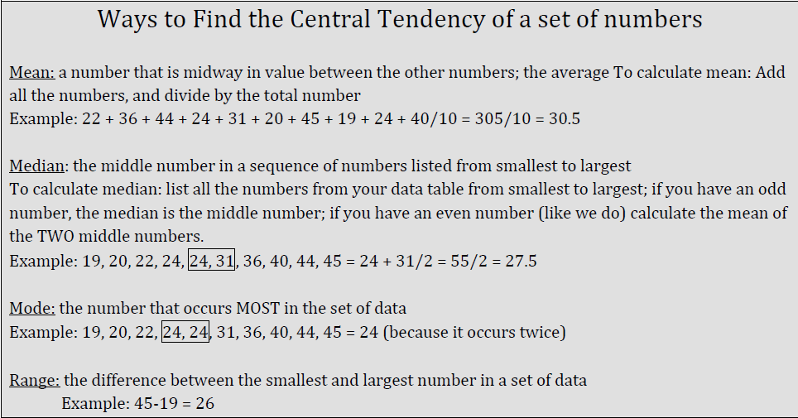

**Post Lab Questions**

1. Which of the central tendency calculations most accurately describe the three sets of data? Why? [Use this calculation to answer the following post lab questions.] **(5 points)**
2. Which group did you predict would go the farthest? (From prelab question #5.) Were you correct? Why do you think that is? Explain. **(10 points)**
3. Which group did you predict would go the shortest distance? (From prelab question #5.) Were you correct? Why do you think that is? Explain. **(10 points)**
4. Was your hypothesis supported? Explain. **(5 points)**
5. How confident are you that the independent variable (what you changed) influenced the dependent variable (how far it flew)? Is there a strong or weak connection? Explain. **(5 points)**
6. How reliable (consistent) were your data? Why is that? **(5 points)**
7. Were there things you could have kept constant that you didn’t? If you were to perform the experiment again, how would you change your methods to improve the reliability of your data? **(10 points)**
8. Describe another way to test your independent variable. Why might this have resulted in better or different results? **(10 points)**

**Aviation Alphabet**

**Aviation Alphabet**

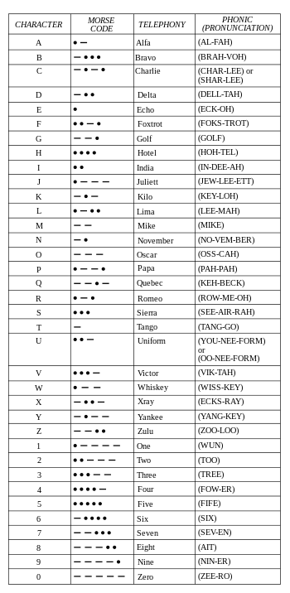

**Plane Name:__________________________ Design Area (cm):_____________________________**

**Launcher Height (cm):_________________________**



**Paper Airplane Data Table**

|  |  |  |  |
| --- | --- | --- | --- |
| **Trials** | **Control Trials**  **Airplane without modifications**  **(cm)** | **Experimental Group #1 Airplane with**  **____________________**  **(cm)** | **Experimental Group #2 Airplane with**  **______________________**  **(cm)** |
| **1** |  |  |  |
| **2** |  |  |  |
| **3** |  |  |  |
| **4** |  |  |  |
| **5** |  |  |  |
| **6** |  |  |  |
| **7** |  |  |  |
| **8** |  |  |  |
| **(Total)** |  |  |  |
| **Mean** |  |  |  |
| **Median** |  |  |  |
| **Mode** |  |  |  |
| **Range** |  |  |  |